First Name:___________________________ Last Name:______________________________

Physics 30 – Unit A: Momentum – L03 – Impulse Graphs 2

The graph below depicts the forces acting on an initially stationary 10kg mass. Use this information to answer the questions below.
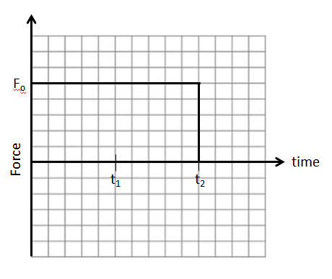
Q1: If the 10kg mass is initially stationary, and is travelling at 5m/s at t = t₁, how fast is the object travelling at t = t₂? Record your answer to two-digits.

The graph below depicts the forces acting on an initially stationary 10kg mass. Use this information to answer the questions below.
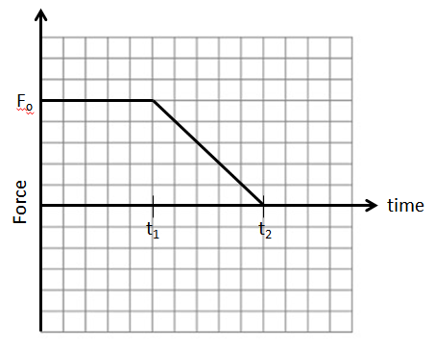

Q2: If the 10kg mass is initially stationary, and is travelling at 5m/s at t = t₁, how fast is the object travelling at t = t₂? Record your answer to two-digits.

The graph below depicts the forces acting on an initially stationary object of unknown mass. Use this information to answer the questions below.
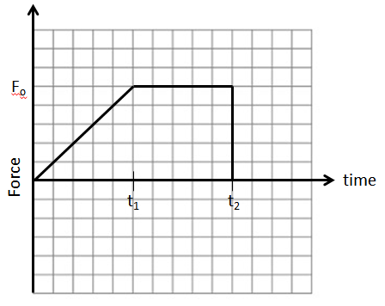
Q3: If the unknown mass is initially stationary, and is travelling at 8m/s at t = t₁, how fast is the object travelling at t = t₂? Record your answer to two-digits.

The graph below depicts the forces acting on an initially stationary object of unknown mass. Use this information to answer the questions below.
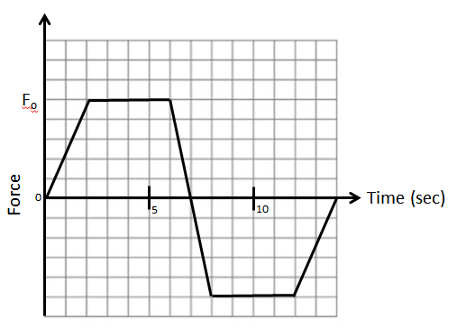
Q4: At what time is the object travelling the fasted? Record your answer to two-digits.

