First Name:______________________________ Last Name:______________________________

Worksheet – Unit 1 (Momentum) Basics /12 marks

Q1: A 1247kg Honda Civic DX Sedan is travelling at 100 km/h. What is its momentum?
- 1.25 x 10⁴ kg*m/s
- 3.46 x 10⁴ kg*m/s
- 1.25 x 10⁵ kg*m/s
- 4.49 x 10⁵ kg*m/s

Q2: A boy and his bicycle has a combined mass of 50.0kg and are travelling at 8.50 m/s. Upon applying the brakes, it takes the boy 3.25 seconds to come to a complete stop. What is the force of friction acting on the bicycle, in Newtons?
(Record your three digit answer in the Numerical Response boxes below)

Use the following information to answer Q3:
An initially stationary 50g object experiences the following impulse:
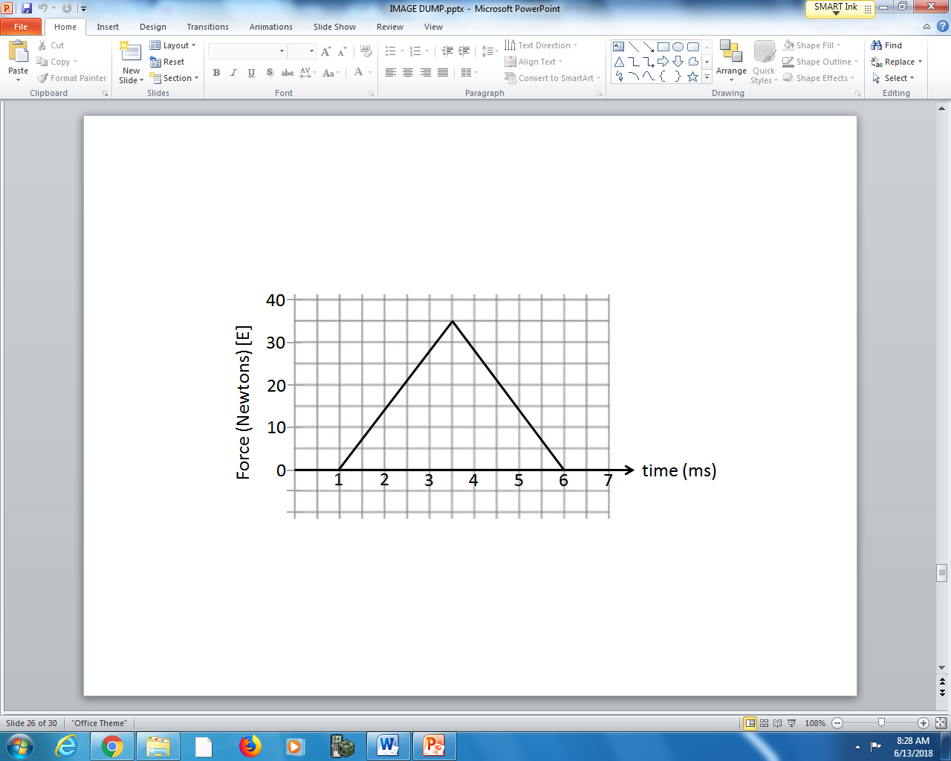

Q3: The final velocity of the 50g object is ____ m/s.
(Record your three digit answer in the Numerical Response boxes below)

Use the following information to answer Q4:
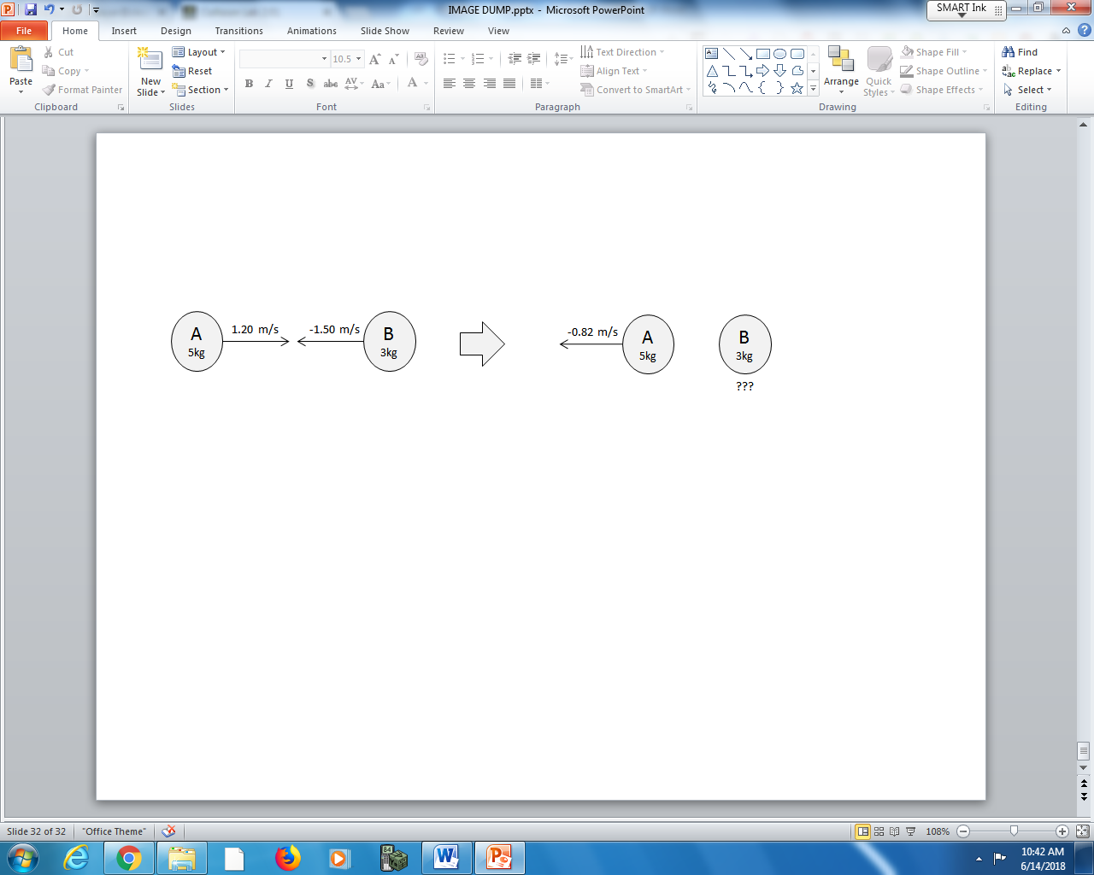

Q4: The final velocity of Object B is ____ m/s [R].
(Record your three digit answer in the Numerical Response boxes below)

Use the following information to answer Q5:
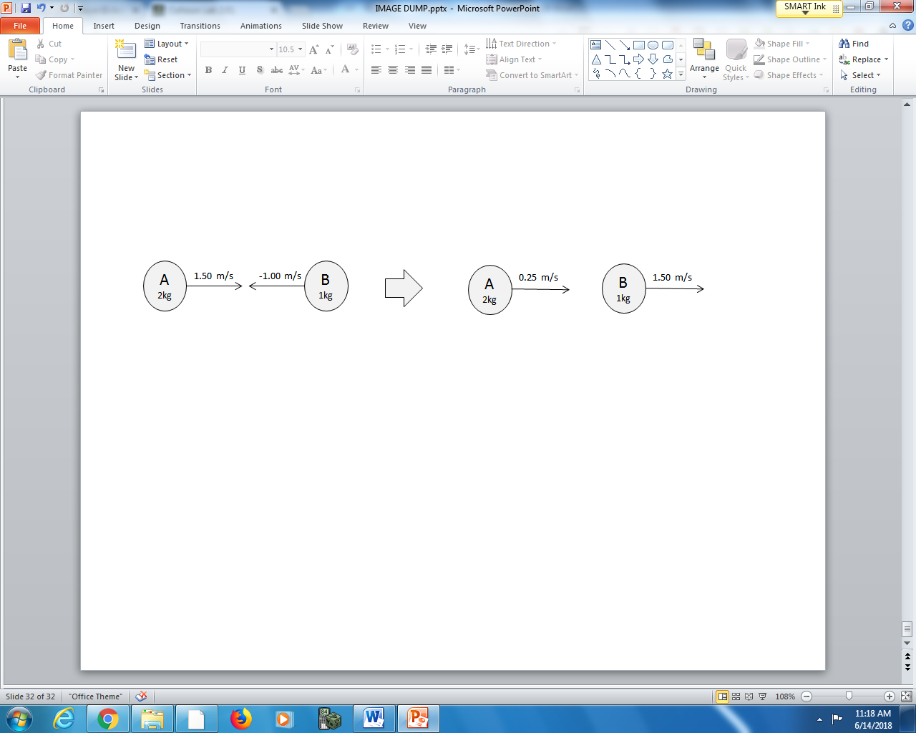

Q5: Which of the following statements is correct?
- Momentum is conserved and the collision is elastic.
- Momentum is conserved and the collision is not elastic.
- Momentum is not conserved and the collision is elastic.
- Momentum is not conserved and the collision is not elastic.

Q6: A 50.0kg skateboarder is travelling at 5.00 m/s when he picks up a stationary 4.50kg backpack. What is his final velocity, in m/s?
(Record your three digit answer in the Numerical Response boxes below)

Use the following information to answer Q7:
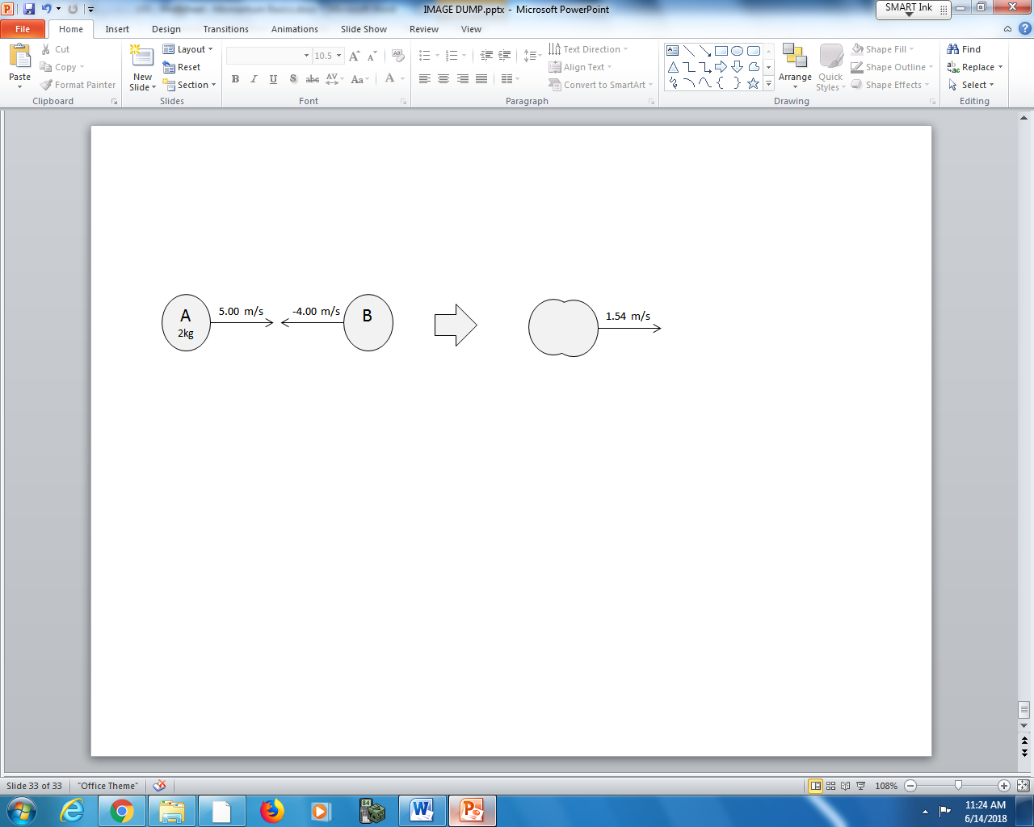

Q7: What is the mass of Object B, in kg?
(Record your three digit answer in the Numerical Response boxes below)

Use the following information to answer Q8:
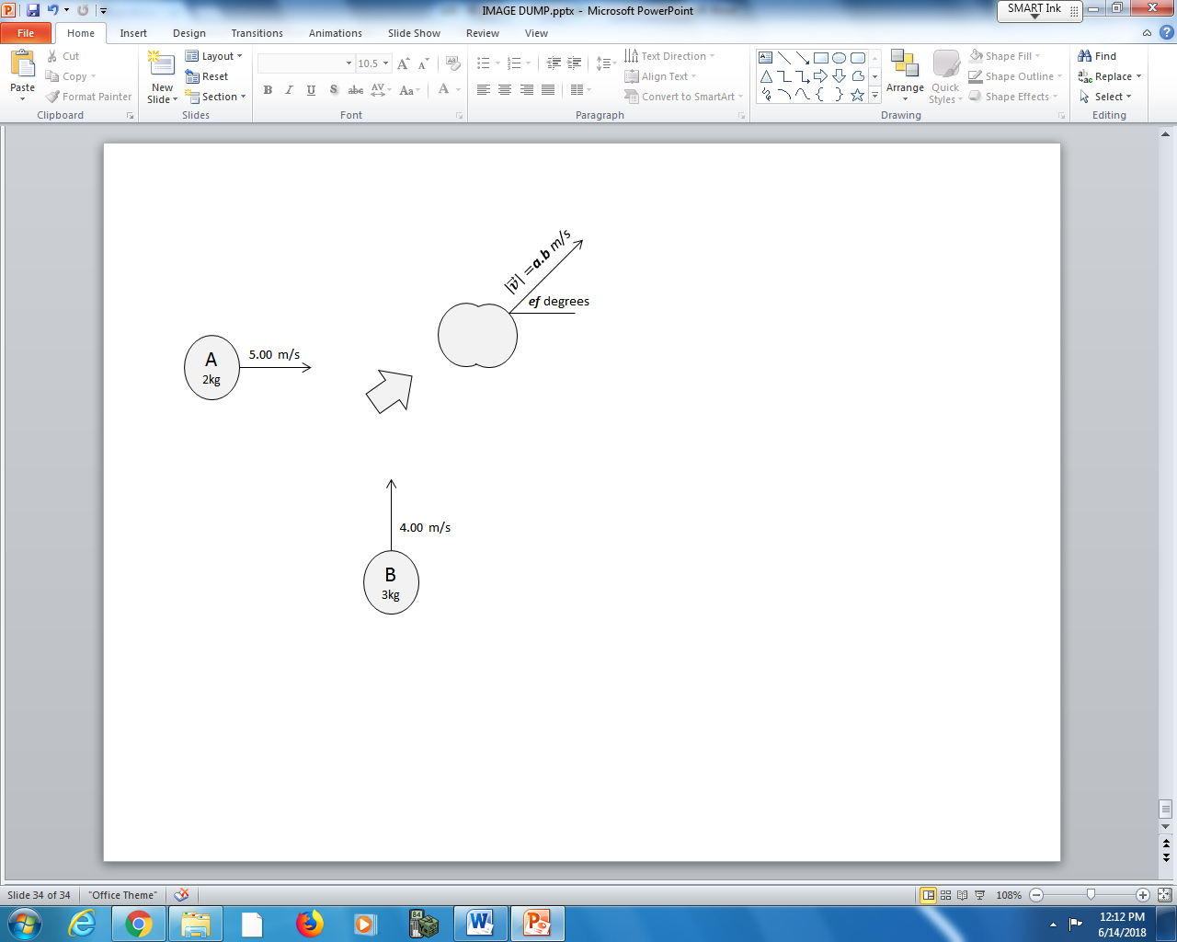

Q8: The combined object moves at a.b m/s [ef ⁰ N of E], where the values of a, b, e, and f are ___, ___, ___, and ___.
(Record your four digit answer in the Numerical Response boxes below)

Use the following information to answer Q9:
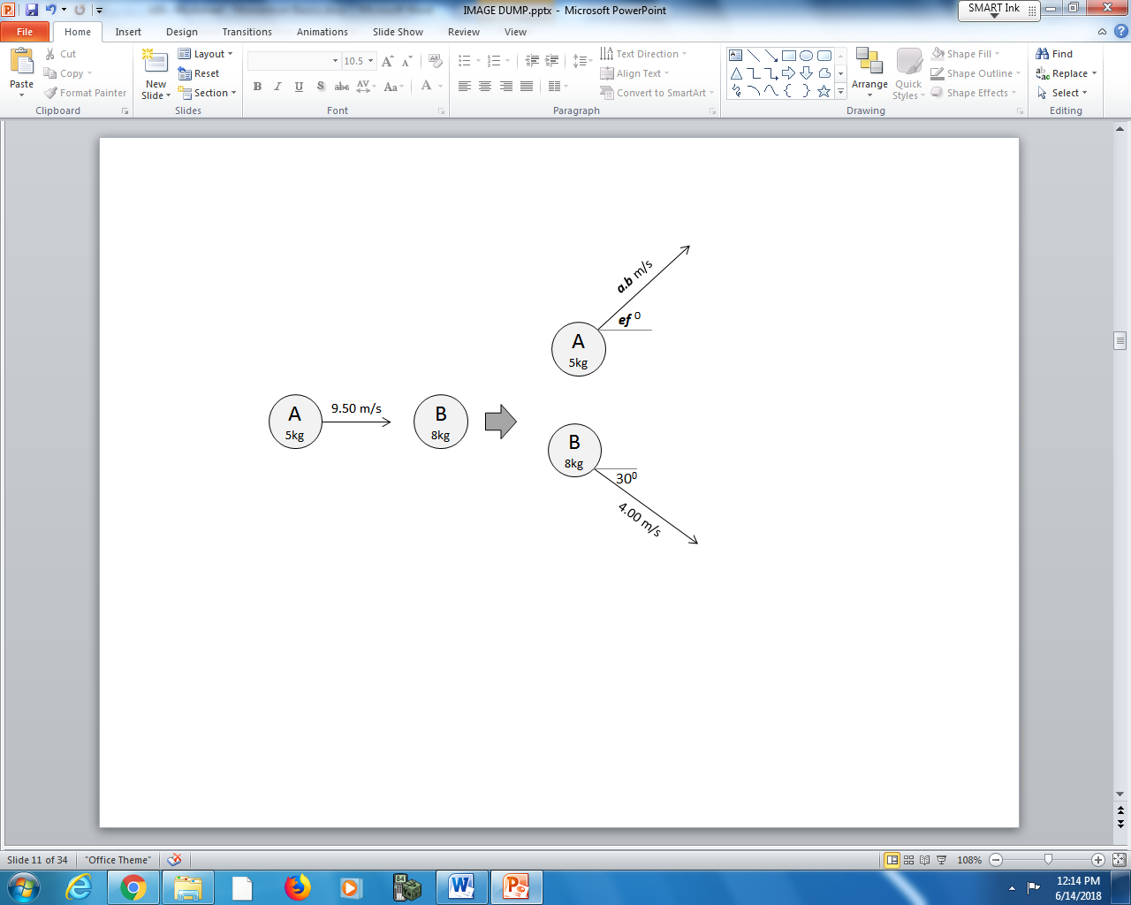

Q9: Object A moves at a.b m/s [ef ⁰ N of E], where the values of a, b, e, and f are ___, ___, ___, and ___.
(Record your four digit answer in the Numerical Response boxes below)

Use the following information to answer Q10:
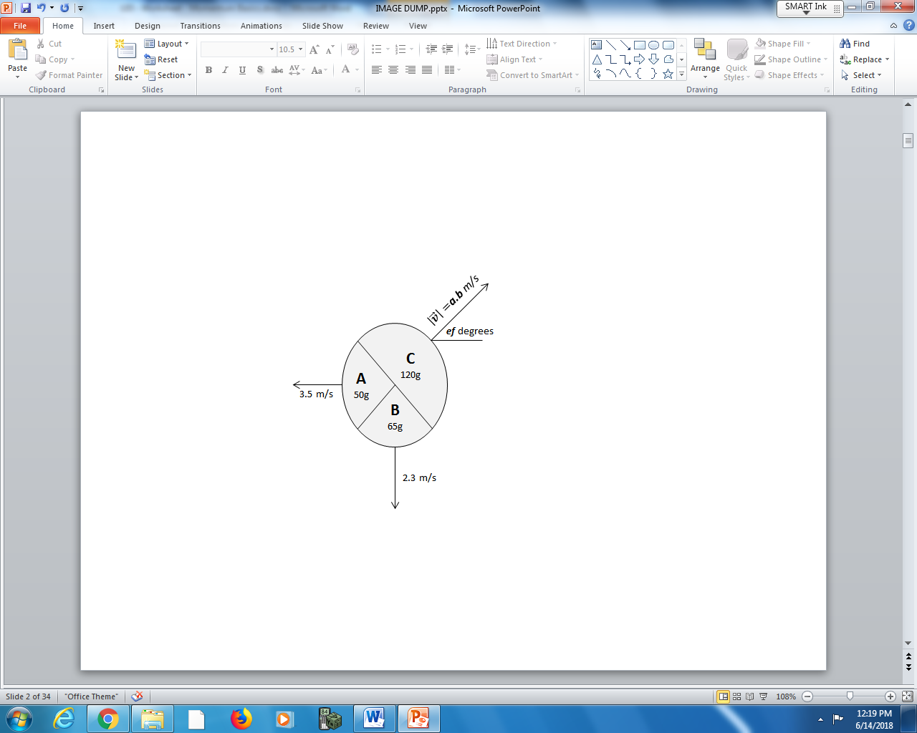

Q10: An initially stationary object explodes. Object C moves at a.b m/s [ef ⁰], where the values of a, b, e, and f are ___, ___, ___, and ___.
(Record your four digit answer in the Numerical Response boxes below)

Use the following information to answer Q11-Q12:
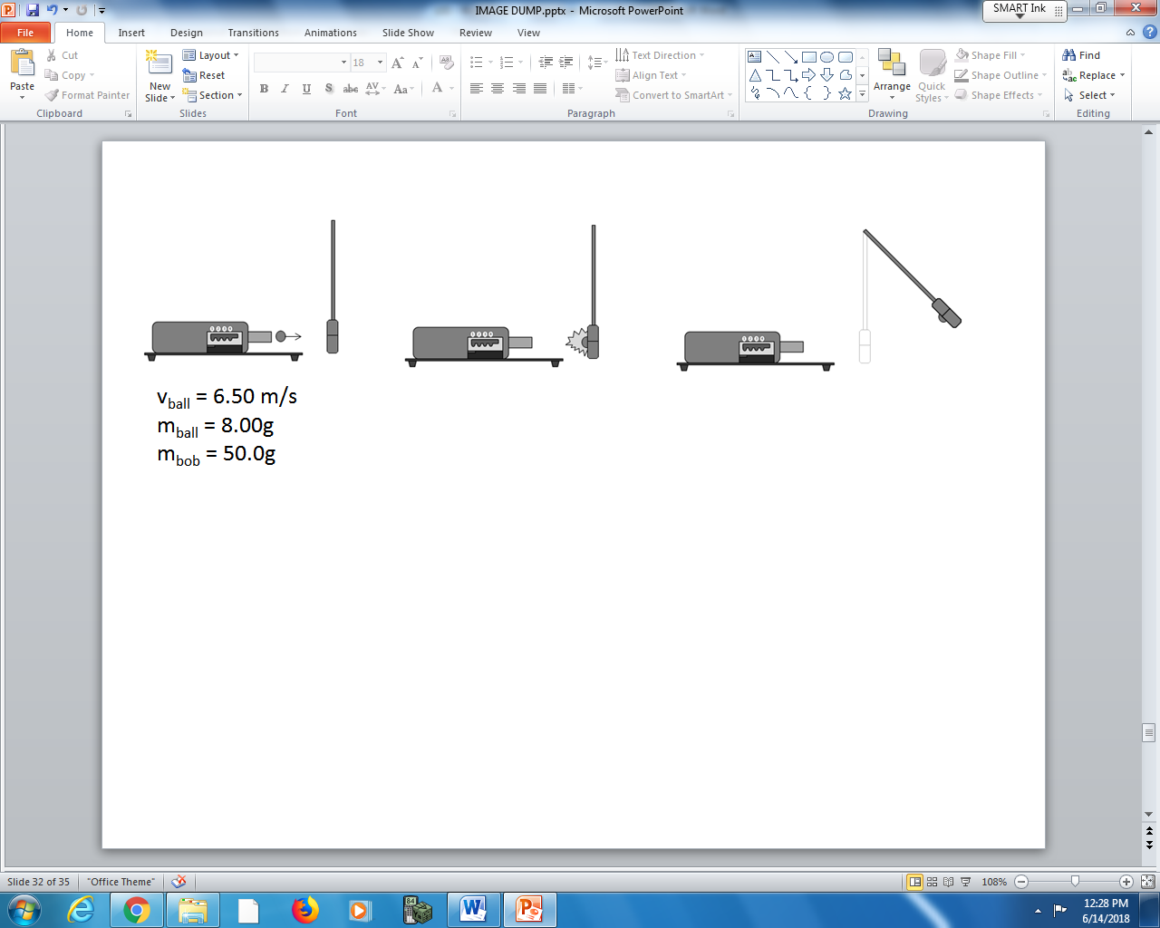

Q11: The ballistic pendulum rises to a height of a.bc x 10^{-d} m, where a, b, c, and d are ___, ___, ___, and ___.
(Record your four digit answer in the Numerical Response boxes below)

Q12: What two Physics Principles are used to calculate the answer to Q11, listed in the order you used them?
(Record your two digit answer in the Numerical Response boxes below)

