First Name:_____________________________ Last Name:______________________________

L03 – Worksheet – Position-Time Graphs, Velocity-Time Graphs

Use the following information to answer Q1-Q6:
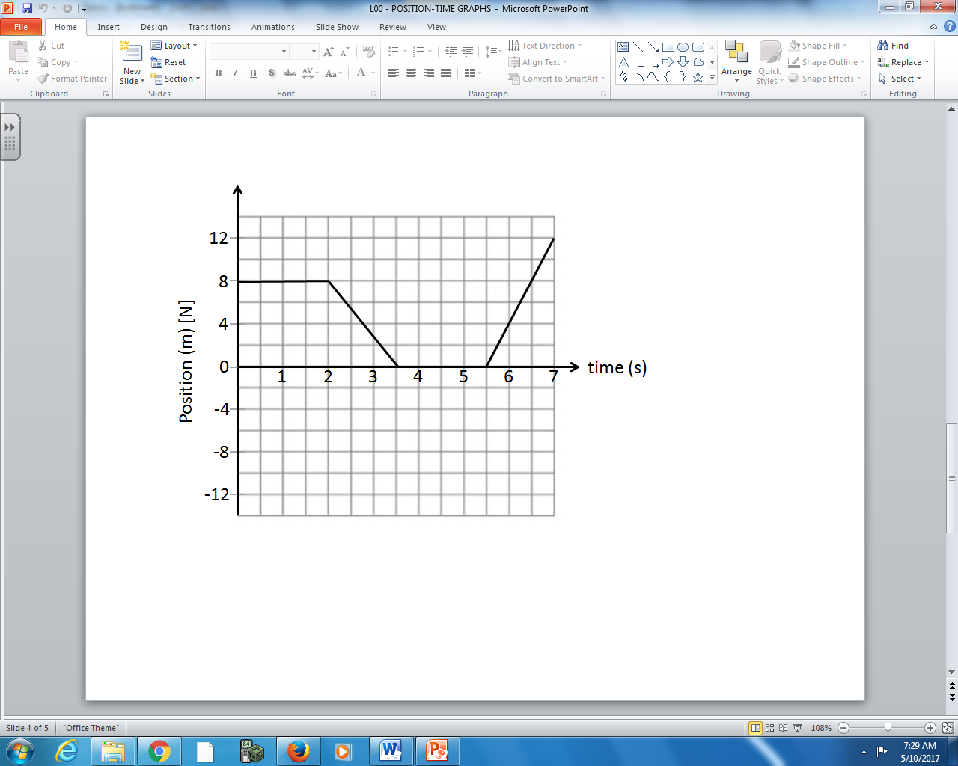

Q1: What is the velocity of the object between 0 and 2 seconds?

Q2: What is the velocity of the object between 2 and 3.5 seconds?

Q3: What is the velocity of the object between 5.5 and 7 seconds?

Use the following information to answer Q1-Q6:

Q4: What is the displacement of the object between 0 and 3.5 seconds?

Q5: What is the object moving north?

Q6: When is the object north of the origin?

Use the following information to answer Q7-Q12:
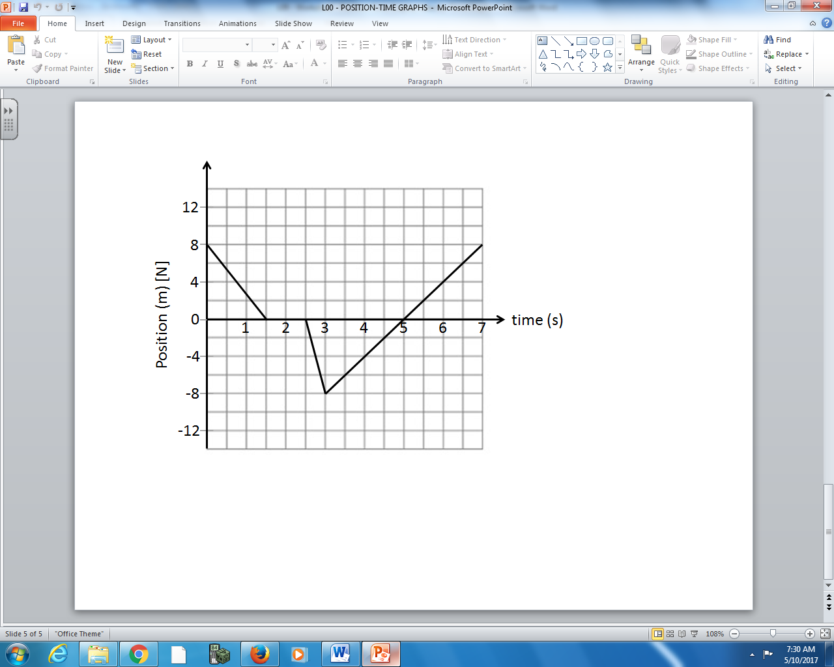

Q7: What is the velocity of the object between 0 and 1.5 seconds?

Q8: What is the velocity of the object between 3 and 5 seconds?

Q9: What is the velocity of the object between 5 and 7 seconds?

Use the following information to answer Q7-Q12:

Q10: What is the displacement of the object between 3 and 7 seconds?

Q11: When is the object moving north?

Q12: When is the object north of the origin?

Use the following information to answer Q13-Q18:
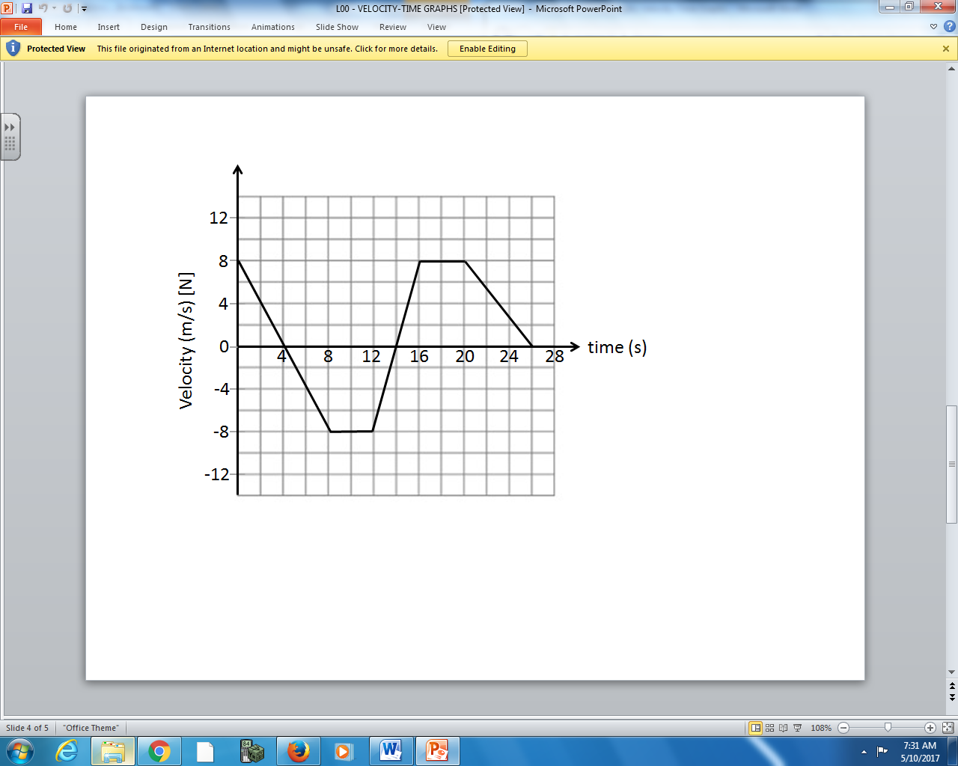

Q13: What is the acceleration of the object between 0 and 8 seconds?

Q14: What is the velocity of the object at 16 seconds?

Q15: When is the object moving with constant velocity?

Use the following information to answer Q13-Q18:

Q16: When is the object stationary?

Q17: When is the object decelerating?

Q18: What is the displacement of the object between 0 and 12 seconds?

Use the following information to answer Q19-Q24:
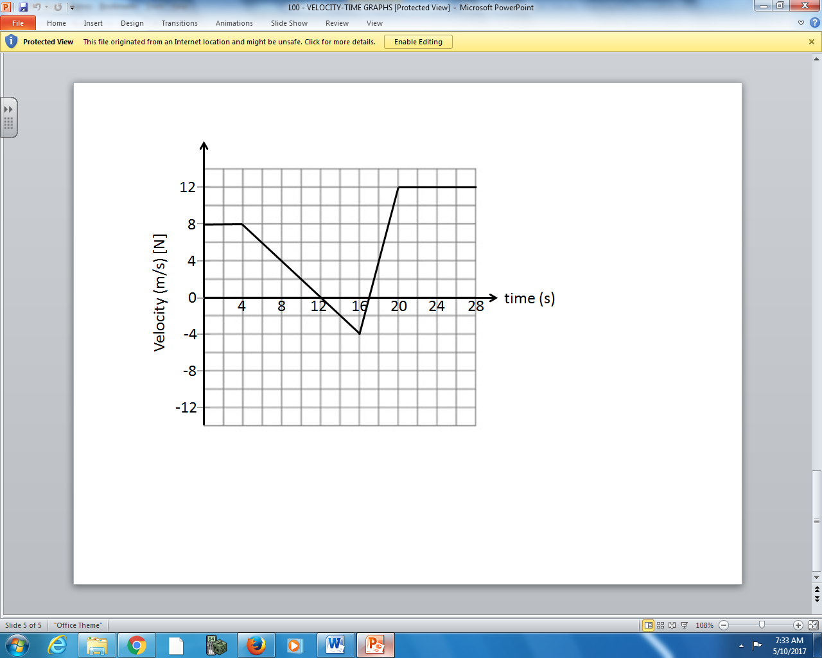

Q19: What is the acceleration of the object between 4 and 16 seconds?

Q20: What is the velocity of the object at 16 seconds?

Q21: When is the object moving with constant velocity?

Use the following information to answer Q19-Q24:

Q22: When is the object stationary?

Q23: When is the object decelerating?

Q24: What is the displacement of the object between 0 and 12 seconds?

