First Name:______________________________ Last Name:______________________________
L03 – Worksheet – Reflection Ray Diagrams
Textbook Questions
Pg 665 #4: Compare “virtual” images with “real” images.
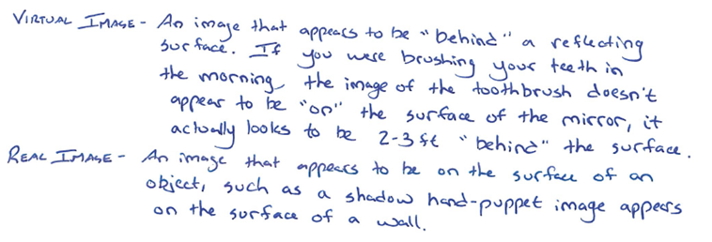
Pg 665 #5: Compare “converging” and “diverging” mirrors.
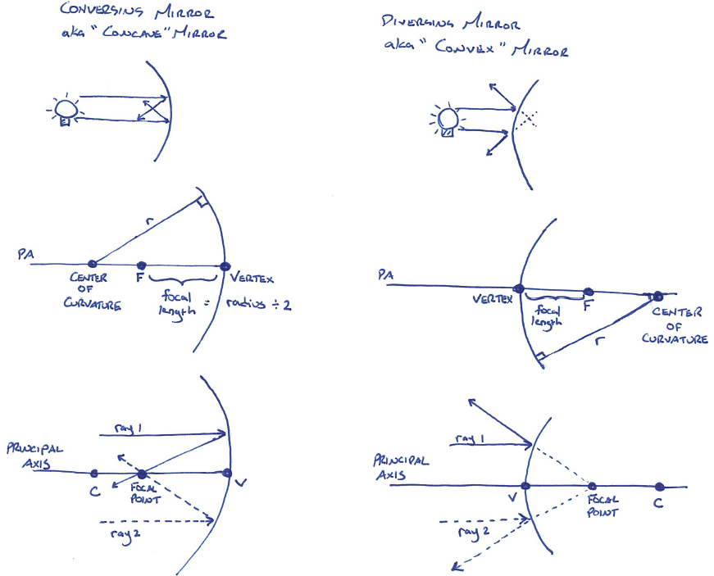
Pg 665 #6: Describe the path of the three rays that can be used to determine the characteristics of an image formed in a curved mirror.
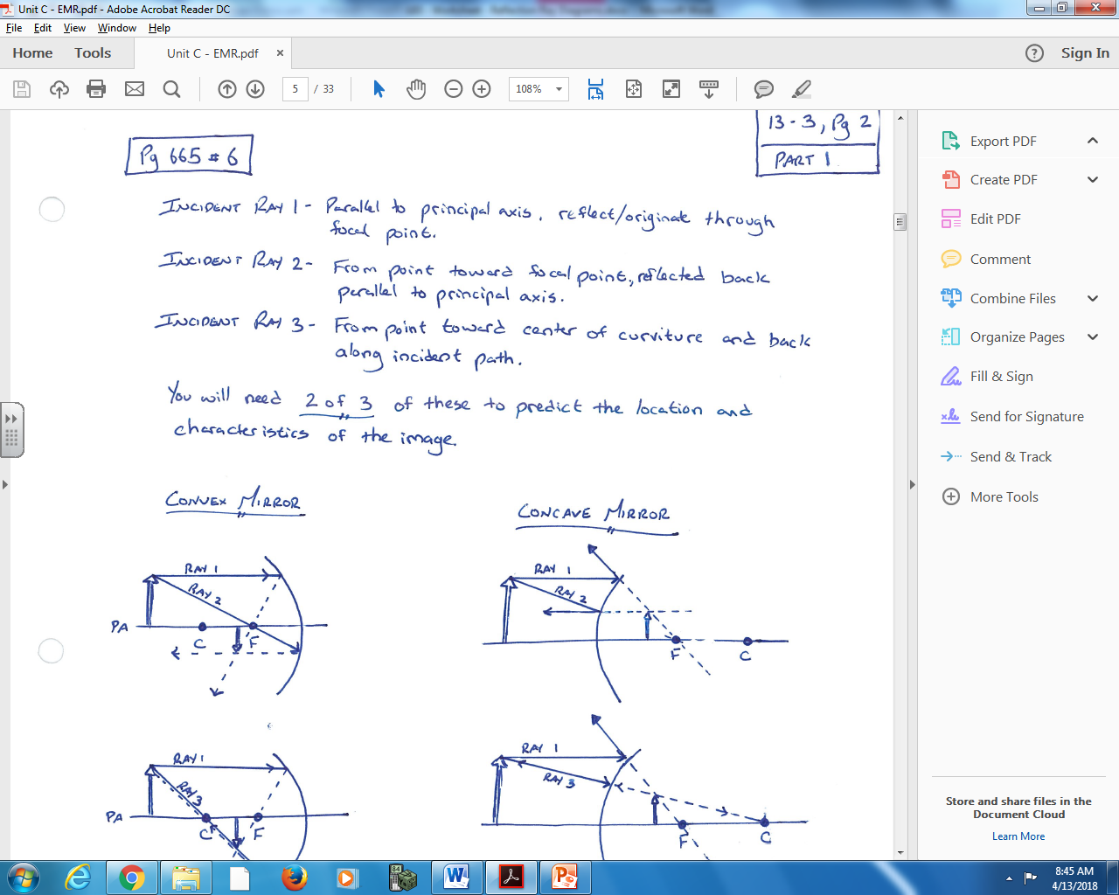
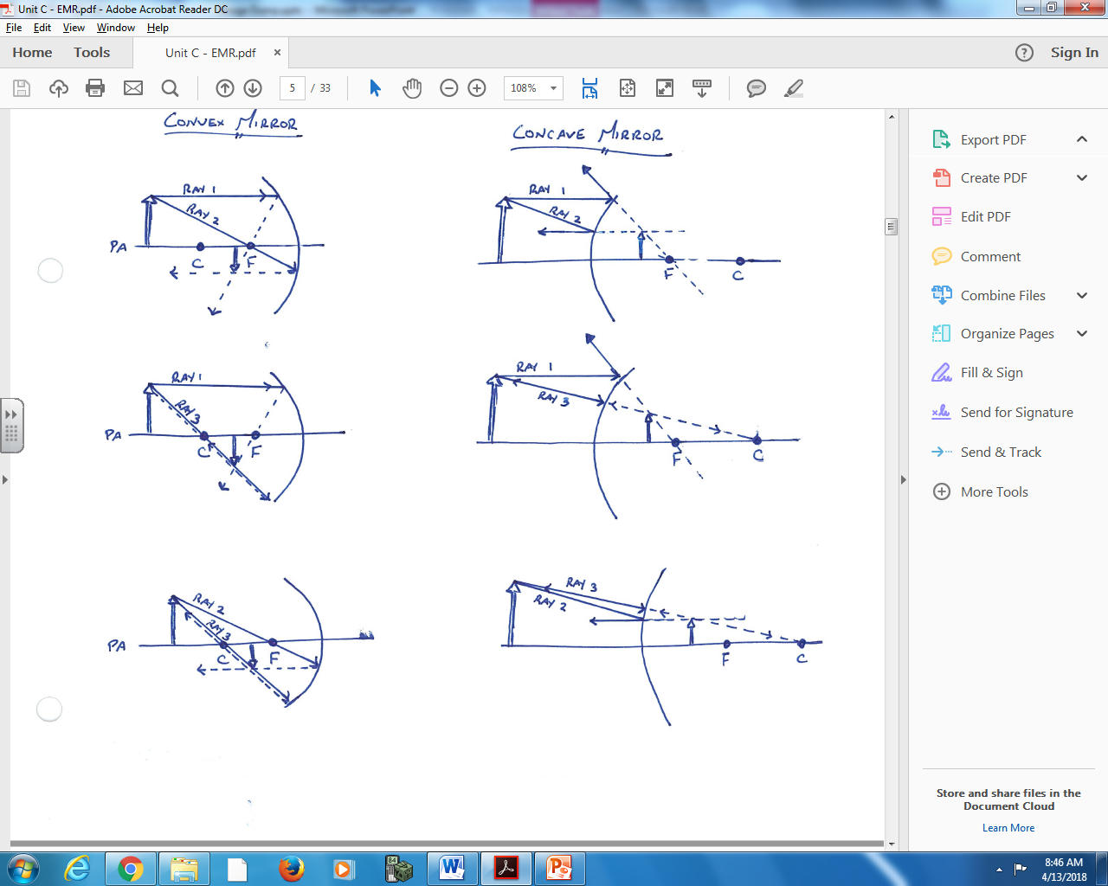
Pg 665 #9: Draw a ray diagram for a converging mirror and determine the image characteristics when the object is located at:
- 2.0 f
- 0.50 f
- 3.0 f
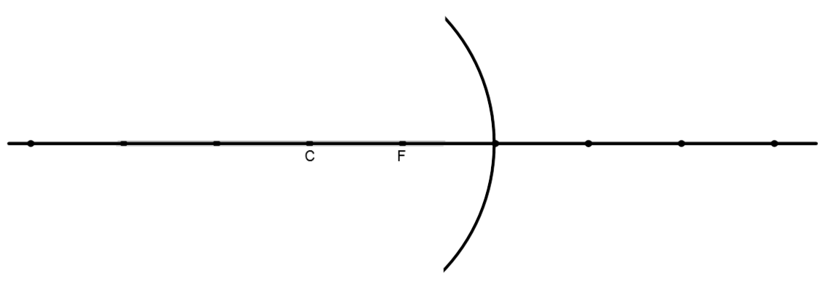
Pg 665 #10: Draw a ray diagram for a diverging mirror and determine the image characteristics when the object is located at:
- 0.50 f
- 1.0 f
- 1.5 f

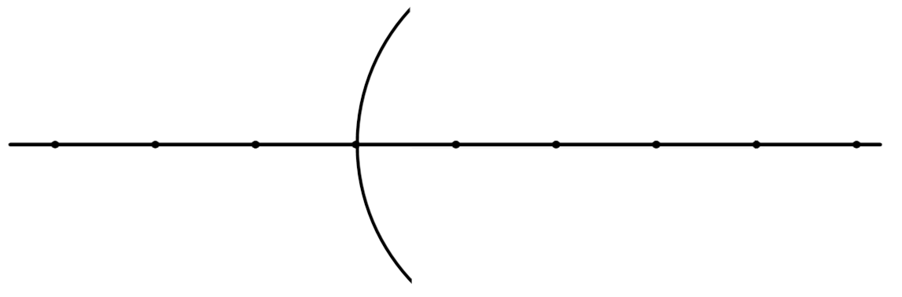
Diploma Worksheet Questions – Reflection Ray Diagrams (Plane Mirrors)
Use the following information to answer Q502:
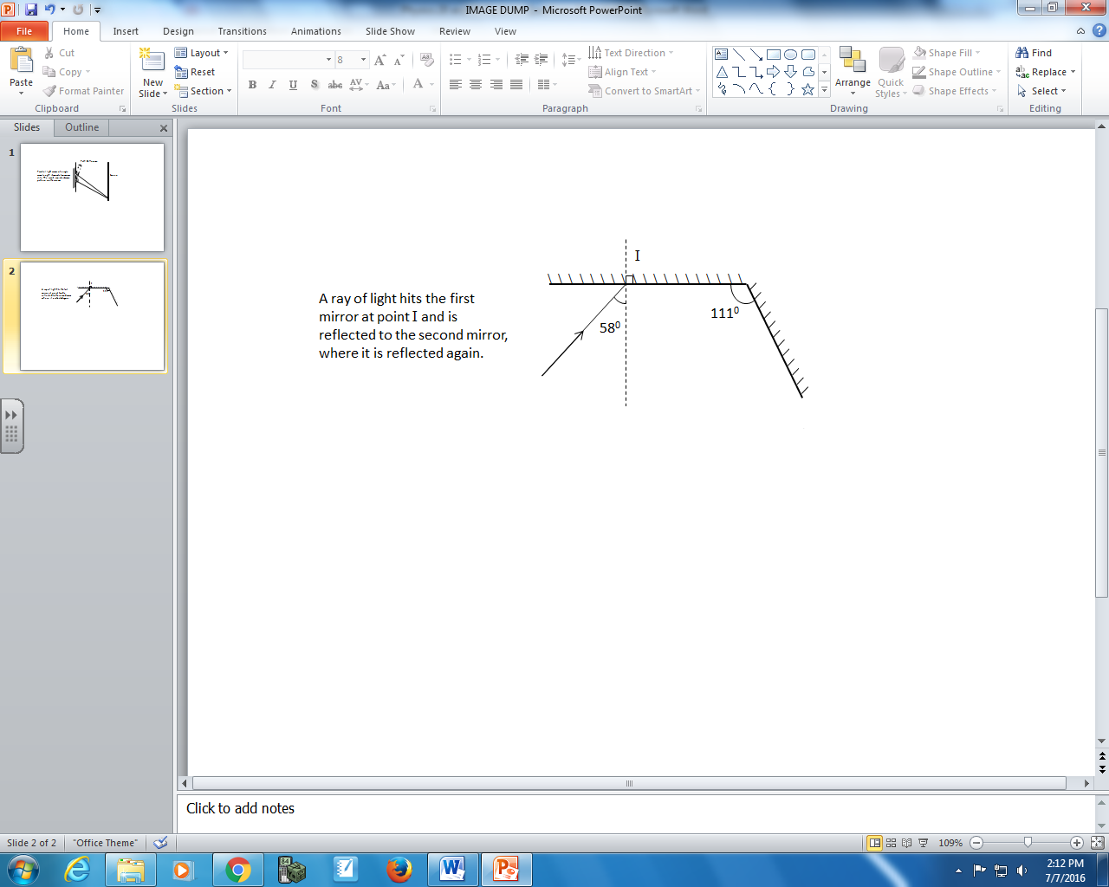

Q502: If the angle of incidence is 58⁰ and the angle between the mirrors is 111⁰, then the angle between the final reflected ray and the secondary mirror is
- 53⁰
- 37⁰
- 32⁰
- 11⁰

Use the following information to answer Q504:
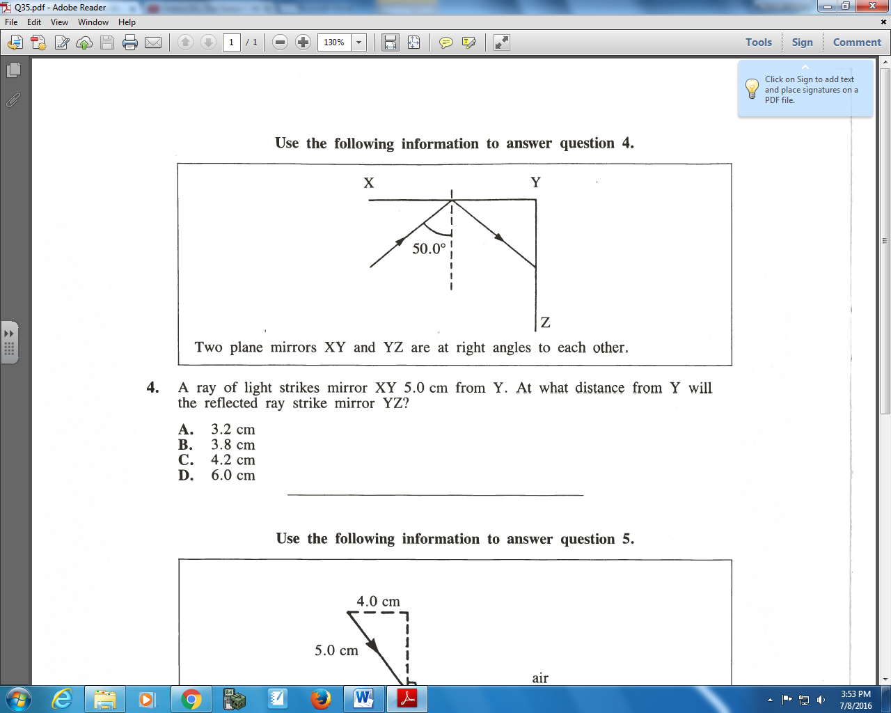

Q504: A ray of light strikes mirror XY 5.0 cm from Y. At what distance from Y will the reflected ray strike mirror YZ?
- 3.2 cm
- 3.8 cm
- 4.2 cm
- 6.0 cm

Cumulative Review from Previous Units
Use the following information to answer Q1:
Two Object Collision
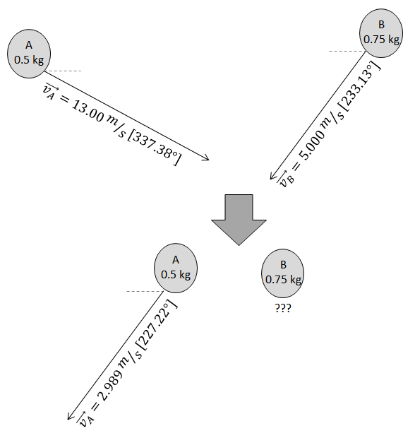

Q1: What is the final velocity, in polar coordinates, of Object B?

