First Name:______________________________ Last Name:______________________________
L03 – Worksheet – The Nucleus and Discrete Energy Levels
Textbook Questions
Pg 780 #6: A helium-neon laser produces photons of wavelength 633 nm when an electron in a neon atom drops from an excited energy state to a lower state. What is the energy difference between these two states? Express your answer in electron volts.

Pg 780 #11ab: When an atom’s energy levels are closely spaced, the atom “de-excites” by having one of its electrons drop through a series of energy levels. This process is called fluorescence and is often seen when a high-energy photon, such as an X-ray or UV photon, excites an atom, which then de-excites through a series of longer-wavelength emissions. A common example of fluorescence occurs in the colors produced when rocks and minerals containing mercury and many other elements are illuminated by UV photons. Below is the energy level diagram for some of the energy levels in mercury (Hg). The ground state has been assigned an energy of 0 eV.
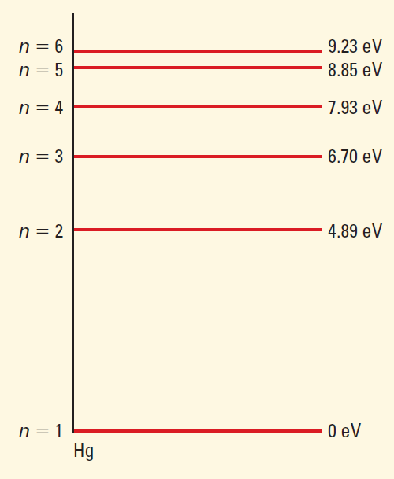
(Continued on next page)
- Determine the wavelength of the photon needed to excite the mercury atom from its ground state to the n = 5 energy level.

- The longest wavelength of photon that will be emitted as the mercury atom de-excites.

L03 – The Nucleus and Discrete Energy Levels (Rutherford Basic Concepts)
Q802: The concept of the nuclear atom is supported by the results of
- Cathode ray experiments
- Oil drop experiments
- Photoelectric experiments
- Scattering experiments

Q803: Results of a Rutherford-type scattering experiment can be used to determine the
- Size of a nucleus
- Mass of a nucleus
- Wave properties of alpha particles
- Particle properties of alpha waves

Q805: Alpha particles are scattered by gold foil. The evidence that most of the mass of the atom is concentrated in a small nucleus is that
- All alpha particles experience slight deflection
- Some alpha particles are absorbed by the gold foil
- Some alpha particles are deflected through large angles
- All alpha particles pass through the foil with no deflection.

Q806: The observation of large scattering angles in Rutherford’s experiment led to the inference that
- Electrons and protons are oppositely charged
- Nuclei of atoms have relatively large volumes
- Electrons have a large volume but a small mass
- The mass of an atom is concentrated at its center

Use the following information to answer Q810:
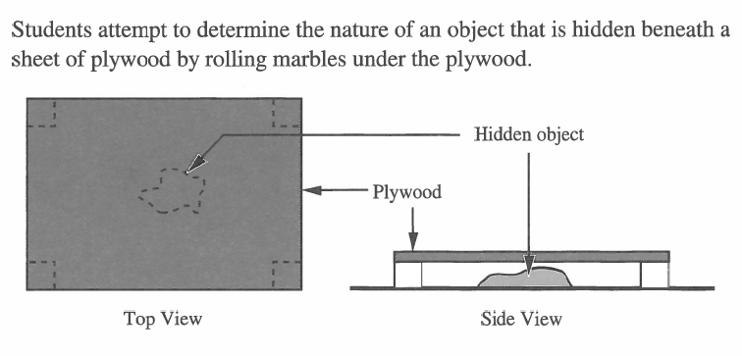

Q810: This exercise would help a student appreciate the difficulties encountered by
- Compton in this work on wave-particle theory
- Einstein in his work on the photoelectric effect
- Rutherford in his work on the nucleus of the atom
- Thomson in his work on cathode rays
L03 – The Nucleus and Discrete Energy Levels (Rutherford Detailed Questions)
Use the following information to answer Q812:
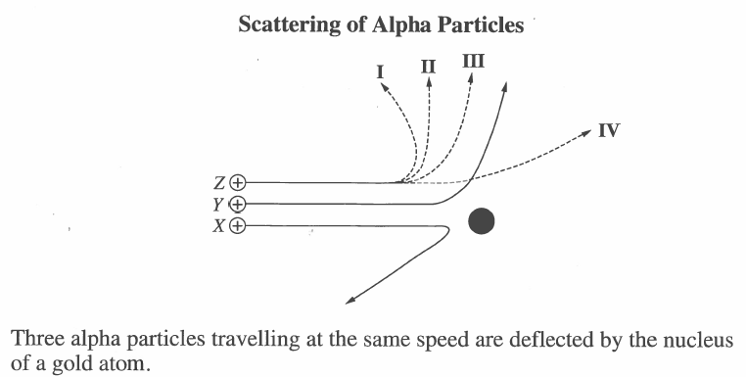

Q812: If particles X and Y are deflected as shown, particle Z will take path
- I
- II
- III
- IV
Use the following information to answer Q813:
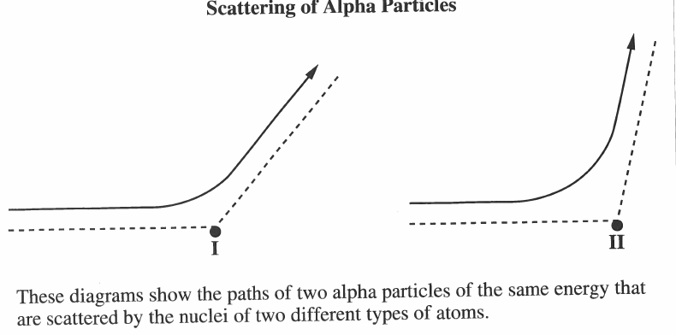

Q813: What statement correctly explains the difference in the deflection of the alpha particle?
- The size of nucleus II is greater than the size of nucleus I.
- The mass of nucleus II is greater than the mass of nucleus I.
- The charge on nucleus II is greater than the charge on nucleus I.
- The charge on the particle scattered by nucleus II is greater than the charge on the particle scattered by nucleus I.

L03 – The Nucleus and Discrete Energy Levels (Bohr Basic Concepts)
Q821: A fluorescent light tube contains a gas mixture at low pressure. When a current is passed through the tube, it gives off light energy because the
- Electron orbitals of the gas atoms decay according to Maxwell’s Laws
- Electrons of the gas atoms are initially excited to higher energy levels
- Electrical energy transforms to vibrational energy in the atomic band
- Electrical current is scattered by the nuclei of the gas atoms

Q822: A group of hydrogen atoms are in the excited n = 4 state. As they drop to the ground state, the maximum number of different wavelengths of photons that could be emitted is
- 1
- 2
- 4
- 6

Q823: Scientists believe that chemical compounds found in far regions of space are the same as those found on Earth. Evidence for this has been provided in studies of
- Spectra
- Electricity
- Gravitation
- Magnetism

Q824: When white light passes through a cool gas and then into a spectroscope, the spectrum produced is
- A continuous spectrum
- An absorption spectrum
- A bright-line spectrum
- An emission spectrum

Use the following information to answer Q825:
The different colors seen in exploding fireworks are produced using different elements.
Predominant
Element Color
Strontium Red
Barium Green
Copper Blue-Green
Sodium Yellow-Orange

Q825: The colors are emitted by electrons that are
- Undergoing transitions to higher energy levels
- Undergoing transitions to lower energy levels
- Oscillating between energy levels
- Emitted by the nucleus

Q828: One of the reasons that Rutherford’s planetary model of the atom has been modified is that observations of the atom do not support the theory of electrons orbiting the nucleus in a manner similar to planets orbiting a star. However, according to Maxwell’s theory of electromagnetic radiation, such an orbiting electron should emit electromagnetic radiation because
- The electron is travelling at uniform speed
- The electron is accelerating toward the nucleus
- There is an electrostatic force of repulsion between the orbiting electrons
- There is an alternating electromagnetic diploe as the electron switches sides of the nucleus

L03 – The Nucleus and Discrete Energy Levels (Bohr Calculations)
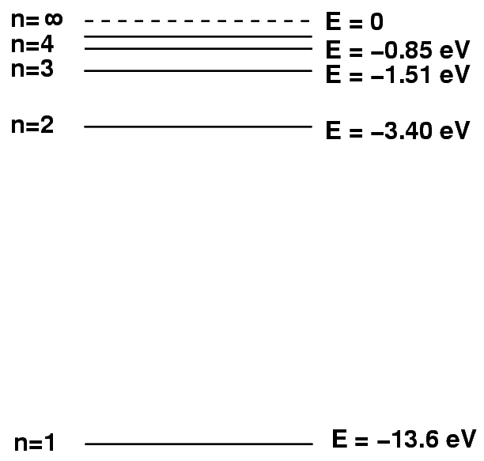
Use the following information to answer Q829 and Q830:
When white light is shone through hydrogen gas, a dark line in the absorption spectrum, corresponding to the red line in the emission spectrum, is observed. This red line is produced by the transition of an electron from the n=2 to the n=3 Bohr orbit.

Q829: The energy of the absorbed photon is
- 1.5 eV
- 1.9 eV
- 2.2 eV
- 3.4 eV
Use the following information to answer Q831:
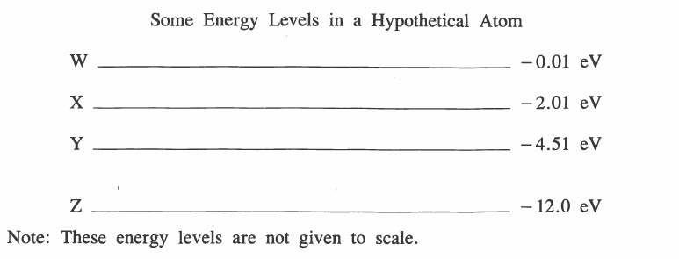

Q831: When the atom undergoes an electron transition from level W to level Y, the emitted photons have a wavelength of approximately
- 8.9 x 10⁻⁸ m
- 1.0 x 10⁻⁷ m
- 2.8 x 10⁻⁷ m
- 4.9 x 10⁻⁷ m
Use the following information to answer Q832:

Q832: A photon of energy 16.4 eV is incident upon an electron of a hydrogen atom in its first energy level. If the photon ionizes the hydrogen atom, what is the kinetic energy of the ejected electron?
- 2.80 eV
- 13.6 eV
- 16.4 eV
- 30.0 eV

Challenge Questions
Use the following information to answer Q1:
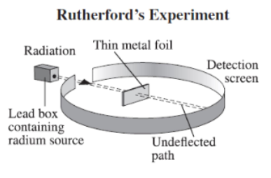

Q1: In Rutherford’s experiment, illustrated above, the type of radiation directed toward the metal foil was __i__. Based on the observations made using the detection screen, the atom contained __ii__.
The statements above are completed by the information in row
Row | I | Ii
A. | alpha | A small, dense, positively charged nucleus
B. | alpha | electrons in stable, circular orbits
C. | gamma | a small, dense, positively charged nucleus
D. | gamma | electrons in stable, circular orbits

Use the following information to answer Q2:
In Ruterhford’s experiment, the path of one of the particles in the radiation beams was deflected as shown below.
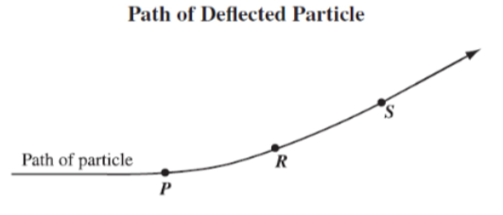

Q2: The particle experiences the greatest electrostatic force at
- Location P
- Location R
- Location S
- Location P and Location S

(Trick question… look at https://phet.colorado.edu/en/simulation/rutherford-scattering)

