First Name:____________________________ Last Name:______________________________

L04 – FQ – Coulomb’s Law in 2-D

Use the following information to answer Q1:
Charge by Induction
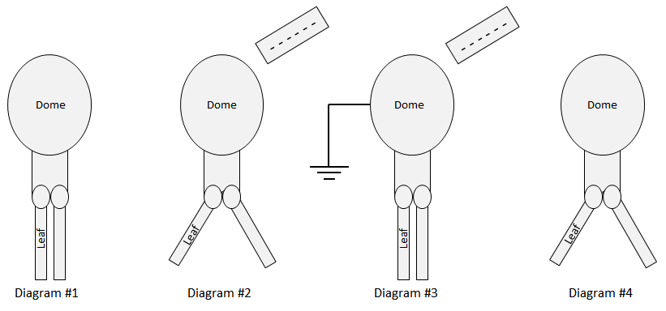
Nature of Charge
1 – Positive
2 – Negative
3 – Neutral

Q1: Match the numbers representing Nature of Charge with the regions given below.
Nature of Charge: ________ ________ ________ ________
Region: Dome in Leaves in Dome in Leaves in
Diagram #2 Diagram #2 Diagram #4 Diagram #4

(Record your four digit answer in the Numerical Response boxes below)

Use the following information to answer Q2-Q6:
Three Point Charges
Three point charges are arranged at a right angle according to the diagram below.
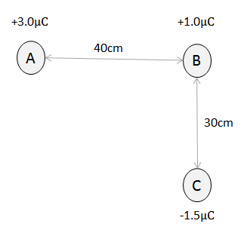
Directions
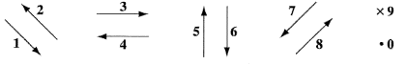

Q2: Use the vector directions above to fill in the blanks below.

Direction: __________ __________ __________
Description: Direction of Direction of Direction of
Force acting on Force acting on Net Force acting
Charge B due to Charge B due to on Charge B
Charge A Charge C

(Record your three-digit answer in the Numerical Response boxes below)

Q3: The magnitude of the electrostatic force acting between Charge A and Charge B is a.bc x 10^{-d} C, where a, b, c, and d are ___, ___, ___, and ___.
(Record your four-digit answer in the Numerical Response boxes below)

Q4: The magnitude of the electrostatic force acting between Charge B and Charge C is a.bc x 10^{-d} C, where a, b, c, and d are ___, ___, ___, and ___.
(Record your four-digit answer in the Numerical Response boxes below)

Q5: The magnitude of the net force acting on Charge B is a.bc x 10^{-d} C, where a, b, c, and d are ___, ___, ___, and ___.
(Record your four-digit answer in the Numerical Response boxes below)

Q6: In direction of the net force acting on Charge B, in polar coordinates, is _____ degrees.
(Record your three-digit answer in the Numerical Response boxes below)

MARKING:
Beginning 0.0 – 2.5
Progressing 3.0 – 4.0
Competent 4.5 – 5.5
Exemplary 6.0

