First Name:____________________________ Last Name:______________________________

L04 – FQ – Impulse and Impulse Graphs

Use the following information to answer Q1-Q2:
A Force-Time graph for a variable force acting on a 15g object is depicted below.
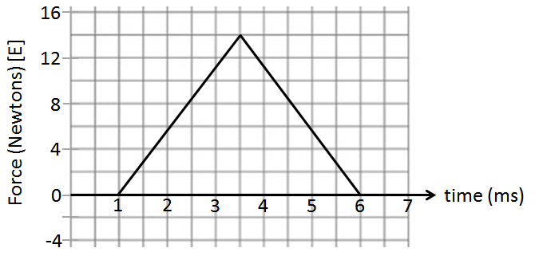

Q1: The magnitude of the impulse acting on the object is a.bc x 10^{-d} Ns, where a, b, c, and d are ___, ___, ___, and ___.
(Record your four digit answer in the Numerical Response boxes below)

Q2: If the object is initially stationary, the final speed of the object is _____ m/s [East].
(Record your three digit answer in the Numerical Response boxes below)

Use the following information to answer Q3:
A remote controlled toy car is travelling at top speed prior to braking. The breaks exert a variable stopping force on the car, bringing it to a stop, as depicted below.
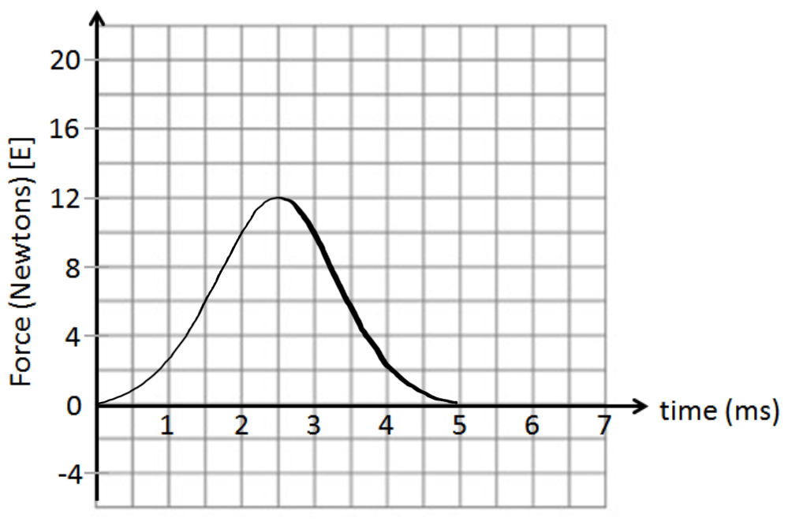

Q3: The car is again travelling at top speed prior to braking, but this time the breaks are applied with a different force, again bringing the car to a stop. Which graph best illustrates this situation?
- 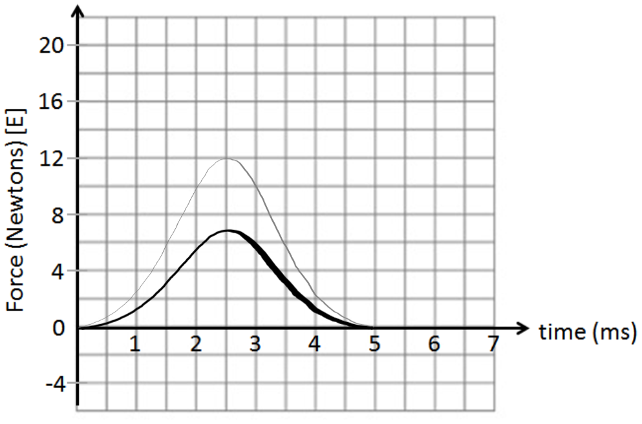 b. 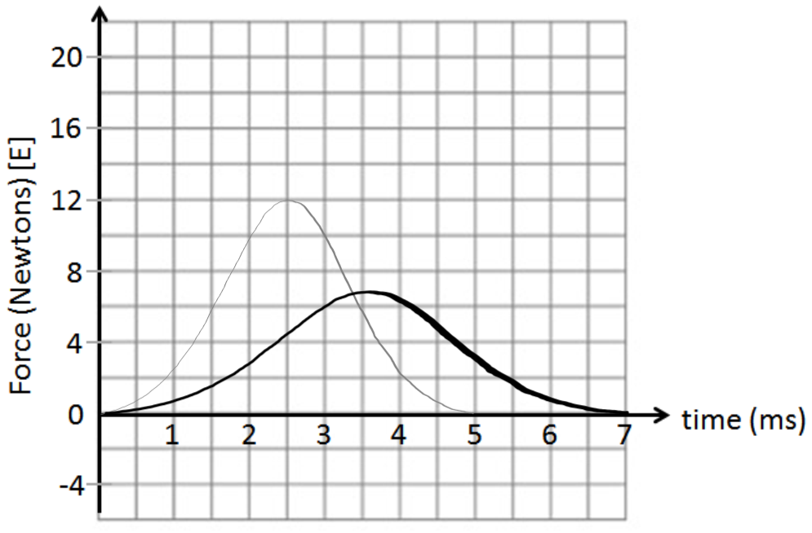
- 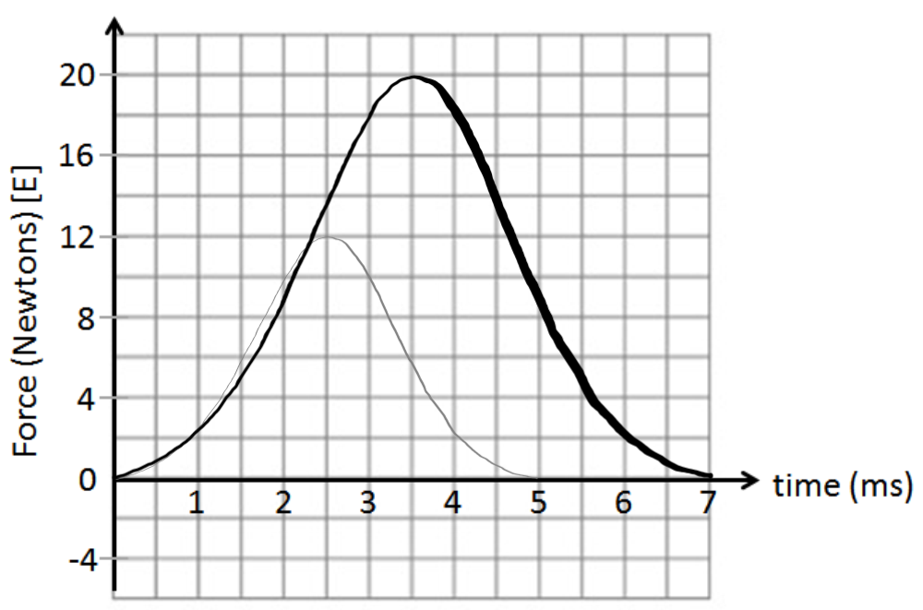 d.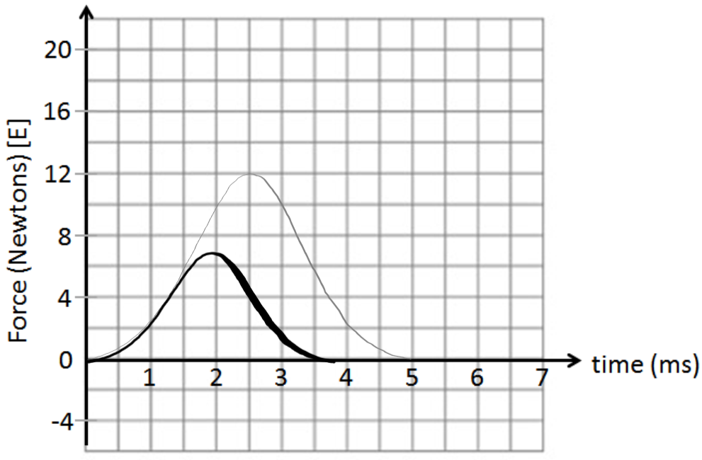
Use the following information to answer Q4-Q5:
Velocity of a 500g Toy Car.
A variable force is applied to the car between 2.25s and 3.50s, causing it to accelerate.
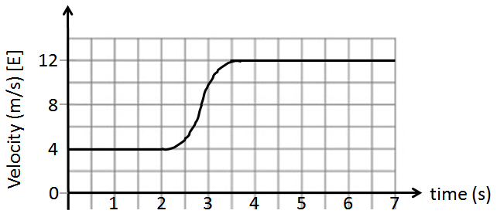

Q4: What is the magnitude of the impulse that acted on the car between 2.25 and 3.50 seconds?
(Record your three digit answer in the Numerical Response boxes below)

Q5: What is the magnitude of the average force acting on the car during this time, measured in Newtons?
(Record your three digit answer in the Numerical Response boxes below)

MARKING:
Beginning 0.0 – 2.0
Progressing 2.5 – 3.5
Competent 4.0 – 4.5
Exemplary 5.0

