First Name:___________________________ Last Name:______________________________

L04 - Formative Quiz – Reflection Ray Diagrams

Use the following information to answer Q1.
A ray is incident on a plane mirror, as depicted below.
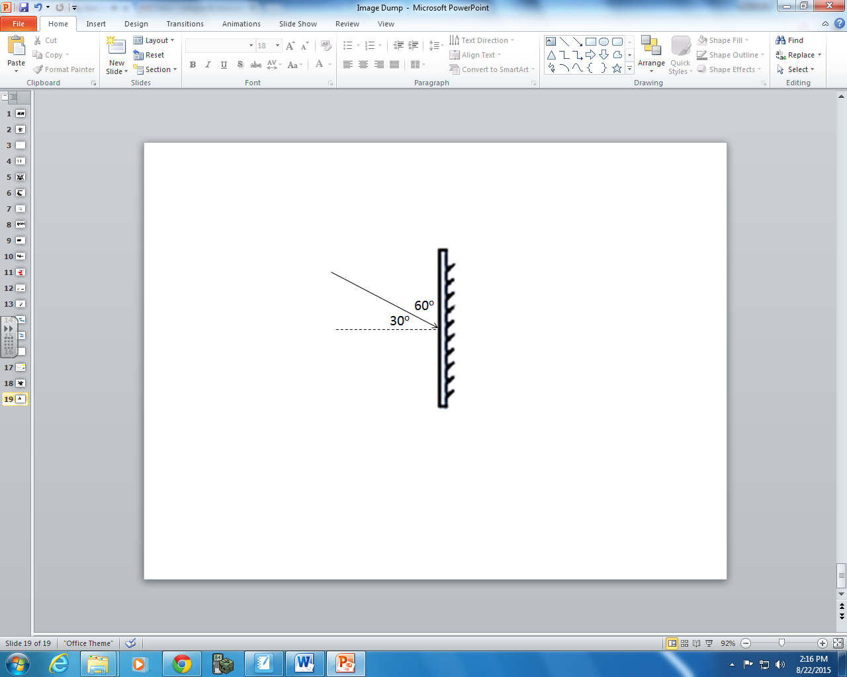

Q1: Which of the following rows depicts the correct information regarding the incident and reflected rays?
 | Angle of Incidence | Angle of Reflection
A. | 30⁰ | 30⁰
B. | 30⁰ | 60⁰
C. | 60⁰ | 30⁰
D. | 60⁰ | 60⁰

- A. b) B. c) C. d) D.

Q2: Which of the following statements is false?
- Convex mirrors always produce virtual images.
- Concave mirrors always produce real images.
- Image characteristics include magnification, attitude, position, and type.
- Only real images can be focused onto a screen.

FLIP THE PAGE TO CONTINUE
Q3: Draw a ray diagram for the following concave mirror. (1 mark)

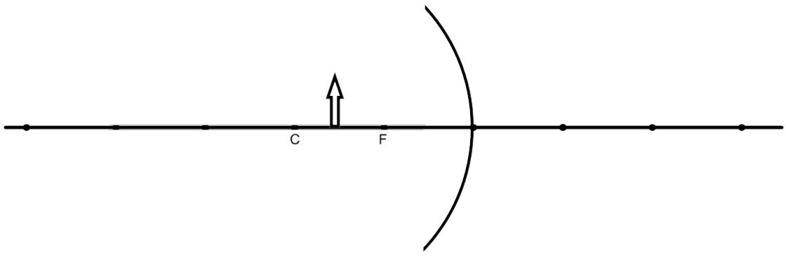

Q4: Draw a ray diagram for the following convex mirror. (1 mark)

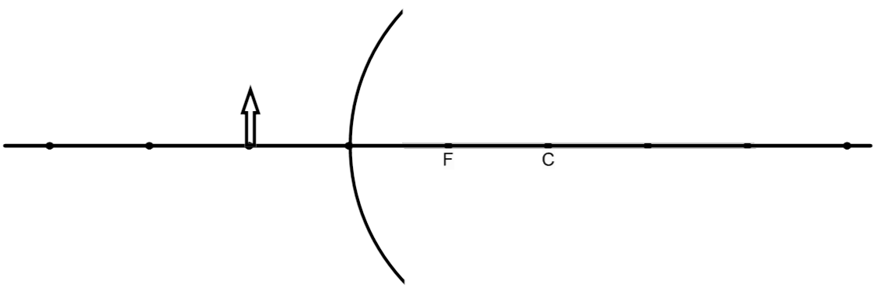

MARKING:
Beginning 0-1
Progressing 2
Competent 3
Exemplary 4

