First Name:____________________________ Last Name:______________________________

L04 - FQ – Rutherford Scattering and Emission Spectrum
Use the following information to answer Q1 and Q2:
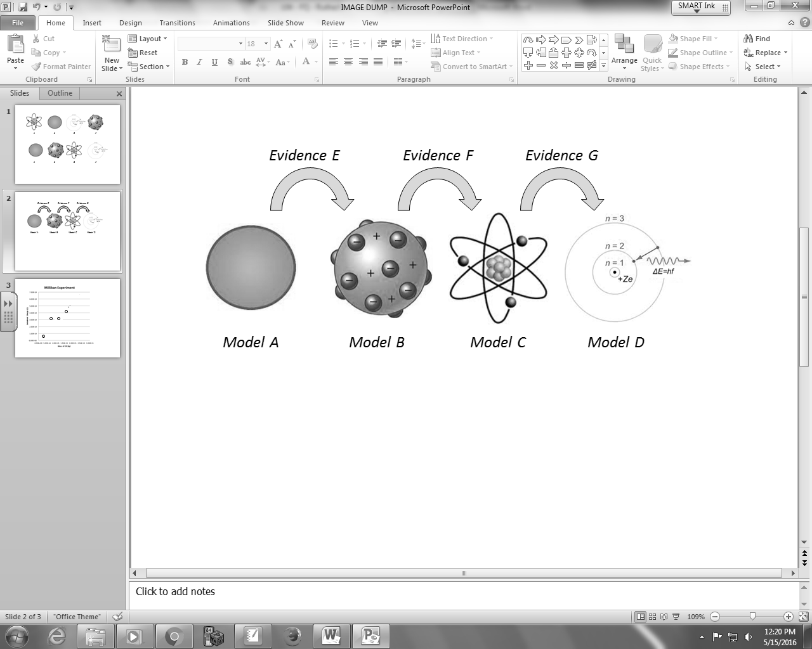
Common Names Credited to Evidence
1 – Billiard Ball 5 – Bohr 8 – Alpha particle scattering
2 – Bohr 6 – Rutherford 9 – Cathode ray experiments
3 – Planetary 7 – Thomson 0 – Emission Spectrums
4 – Plum Pudding

Q1: Using the numbers above, what are the Common Names for Model A through Model D?
________ ________ ________ ________
Model A Model B Model C Model D
(Record your four digit answer in the Numerical Response boxes below)

Q2: Using the numbers above, what evidence lead to the proposal of the next atomic model?
________ ________ ________
Evidence E Evidence F Evidence G
(Record your three digit answer in the Numerical Response boxes below)

Use the following information to answer Q3 and Q4:
Emission Spectrum for a Hydrogen Atom
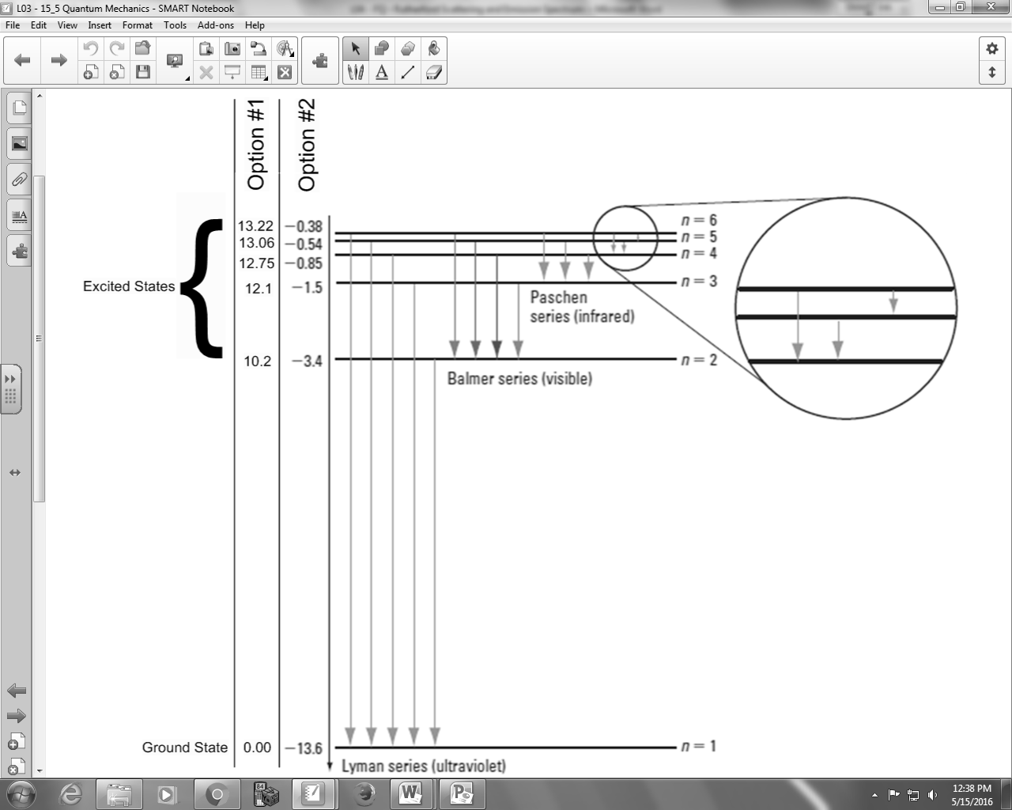

Q3: An electron transitions from n=3 to n=1. What is the frequency of the photon emitted?
- 2.92 x 10¹⁵ Hz
- 3.65 x 10¹⁵ Hz
- 1.83 x 10³⁴ Hz
- 2.28 x 10³⁴ Hz
Q4: How much energy is required to ionize a Hydrogen atom with a single electron in the ground state?
- 0.38 eV
- 10.2 eV
- 13.22 eV
- 13.60 eV
MARKING:
Beginning 0 – 1
Progressing 2
Competent 3
Exemplary 4

