First Name:_____________________________ Last Name:_____________________________

L04 – FQ – Wave Interference and Superposition

Use the following information to answer Q1:
Two Wave Interference
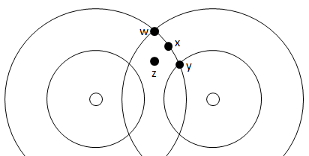

Q1: At what points will the waves interfere constructively?
- Points w and y
- Points w, x, and y
- Points x and z
- Points w, y, and z
Q2: Two waves interfere destructively. When the first wave is at a crest, the second wave
- Is at equilibrium
- Is at a crest
- Is at a trough
- There is not enough information given to be able to answer this question.

Use the following information to answer Q3:
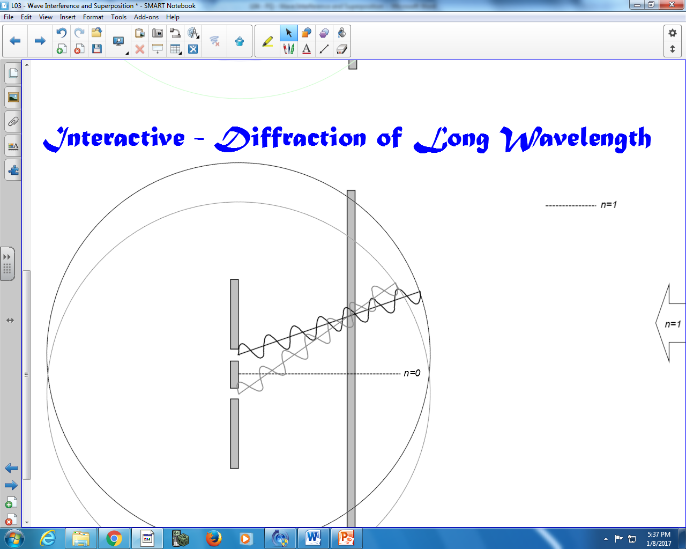

Q3: A light source is propagated through a double slit, as diagrammed above. Write two statements describing what occurs when they meet on the screen.

MARKING:
Beginning 0 – 1.5
Progressing 2 – 2.5
Competent 3 – 3.5
Exemplary 4

