Group Member #1:______________________ Group Member #2:______________________

L04 – Lab – Mechanical Energy and Thermal Energy Loss /24 marks

Students will run a roll of paper tape down a wooden ramp in the Physics Lab. If the purpose of the ramp is to convert Gravitational Potential Energy to Kinetic Energy, what is the efficiency of the ramp?
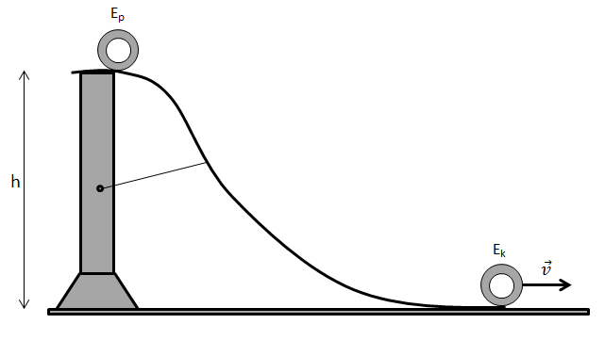
Student Notes (This section will not be marked)
Initiating and Planning
How are you going to measure your initial energy?
Procedure | Equipment
How are you going to measure your final energy?
Procedure | Equipment

 | Total | Multiplier | 3 | 2 | 1 | 0
Evaluate and select appropriate procedures and instruments for collecting evidence and information, including appropriate sampling procedures. |  | x3 | Student has included a detailed procedure and complete materials list. | Student has neglected minor steps or equipment, or has included an incorrect step in their procedure. | Student did not include important procedural steps or critical pieces of equipment necessary for the completion of the lab. | Not included in write-up.

Analyze and Interpret
What is the energy efficiency of the ramp?
Calculations
Conclusion

 | Total | Multiplier | 3 | 2 | 1 | 0
State a conclusion, based on experimental data; and explain how evidence gathered supports or refutes a hypothesis, prediction or theory. |  | x3 | Student is able to draw an educated conclusion that references both their hypothesis and their findings. | Student is able to draw a reasonable conclusion from their experiment. | Student's conclusion is vague or misses the main purpose of the experiment. | Not included in write-up.
What are your major and minor sources of error, and how did they impact your accuracy?
Sources of Error | Impact on Accuracy
Major (Specify):
Minor (Specify):

 | Total | Multiplier | 3 | 2 | 1 | 0
Identify and explain sources of error; and evaluate the relevance, reliability and adequacy of data and data collection methods. |  | x2 | Student is able to identify and categorize sources of error as either major or minor sources, and state their impact on accuracy. | Student is able to identify major sources of error only, and state their impact on accuracy. | Student is not aware of any significant sources of error that are indeed present, or is unable to state the impact on accuracy. | Not included in write-up.

