First Name:____________________________ Last Name:______________________________

L04 – Practice Quiz #1
Momentum and Net Force; Impulse and Impulse Graphs

PART 1 – MULTIPLE CHOICE (1 mark each; Possible half marks for work)
Q1: If the momentum of an object is quadrupled and the mass is halved while the direction changes from west to east, the velocity will have changed by a factor of

a. | negative eight. | c. | negative two.
b. | positive eight. | d. | positive two.

Q2: Calculate the velocity of an 85 g snowball thrown south with a momentum of 1.53 kg·m/s.

a. | 0.018 m/s [S]. | c. | 18 m/s [S].
b. | 20 m/s [S]. | d. | 28 m/s [S].

Q3: Canadian Olympic speed skater Catriona LeMay Doan set three Olympic records for the 500 m event, her current record being 37.30 s. If she had a mass of 68.9 kg and was travelling north at her average speed for that event, what was her momentum?

a. | 924 kg·m/s [N] | c. | 271 kg·m/s [N]
b. | 5.14 kg·m/s [N] | d. | 856 kg·m/s [N]

Q4: What is the difference in momentum between a 1430 kg pickup truck travelling at 50 km/h [E] on a city street and the same truck moving through a school zone at 30 km/h [E]?

a. | 7.9 x 10³ kg·m/s | c. | 2.0 x 10⁴ kg·m/s
b. | 2.9 x 10³ kg·m/s | d. | 1.2 x 10⁴ kg·m/s

Q5: The Hubble Space telescope has a mass of 11 600 kg and orbits Earth at an altitude of 600 km. Based on the information in the above narrative, if the telescope needed to have an increase in velocity of 1.24 m/s [forward] to maintain the proper orbit, what length of burn would be required from a rocket thruster that produces a force on the Hubble structure of 4000 N forwards?

a. | 3.60 s | c. | 0.278 s
b. | 2.34 s | d. | 0.428 s

Q6: Padding inside a hockey helmet not only makes it more comfortable to wear, but acts as a safety feature by _________, __________, and __________. (Fill in the blanks by selecting the correct statements.)
i. increasing the stopping time of the helmet during impact
ii. decreasing the stopping time of the helmet during impact
iii. increasing the stopping distance of the helmet during impact
iv. decreasing the stopping distance of the helmet during impact
v. increasing the area of the skull over which the force is exerted
vi. decreasing the area of the skull over which the force is exerted

a. | i, iii, v | c. | ii, iii, vi
b. | i, iii, vi | d. | i, iv, v
PART 2 – NUMERIC RESPONSE (2 marks each)

Use the following graph to answer Question #7-8.
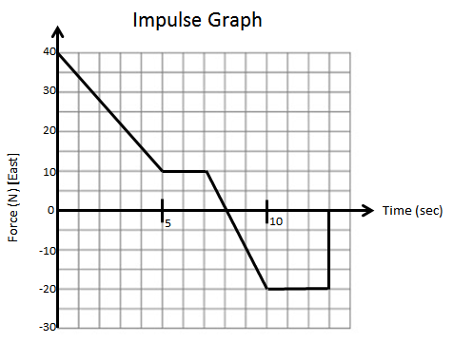
Q7: An object of mass 8kg experiences a varying force, as depicted above. The total impulse the object experiences is a.bc x 10^{d} kg m/s. The values of a, b, c, and d are ___, ___, ___, and ___.

Q8: If the object of mass 8kg was initially travelling at 2 m/s [West], it’s final velocity would be
______ x 10^{w} m/s. (Record your two digit answer in the numerical-response section below.)

