First Name:______________________________ Last Name:______________________________

L04 – Worksheet – Coulomb’s Law Examined Graphically

Textbook Questions
None
Diploma Worksheet Questions – Coulomb’s Law (Basic Definitions)
Q89: The relationship between the electrical force, F, on two small, charged objects and their distance of separation, r, is represented by
- F α r
- F α 1/r
- F α r²
- F α 1/r²
Diploma Worksheet Questions – Coulomb’s Law (Graphing)
Q123: Two positively charged objects are held close together on a frictionless surface. If one of the objects is released, the acceleration of the released object can be represented by graph
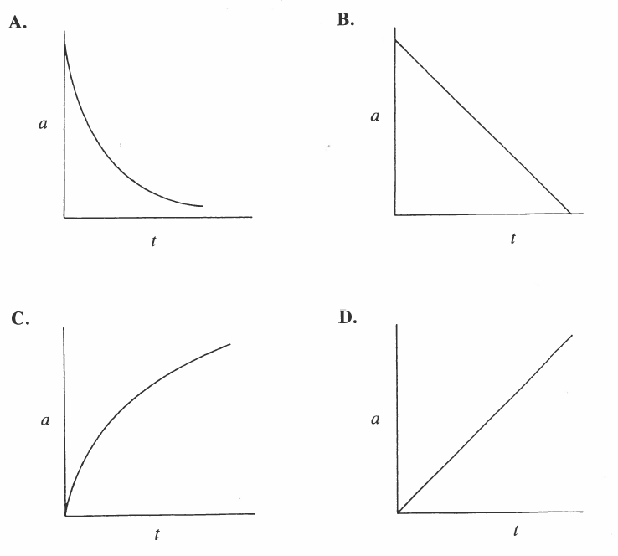
Use the following information to answer Q122:
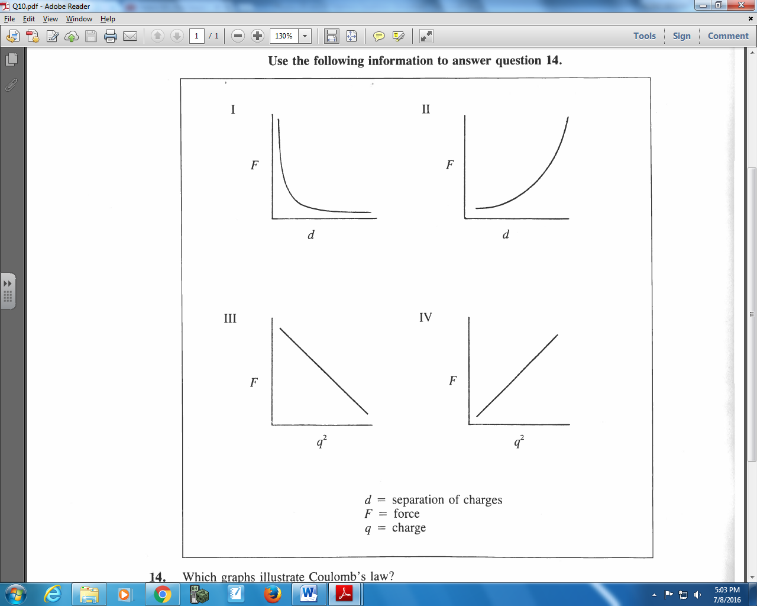

Q122: Which graph illustrates Coulomb’s law?
- I and II
- I and IV
- II and III
- III and IV

Diploma Worksheet Questions – Coulomb’s Law (Algebra)
Q132: Two charged bodies repel each other with a force of F. The charge on one is doubled, and the charge on the other is increased by a factor of 7/3. If the distance between them is then tripled, the final resulting force would be
- 42F
- 14F/3
- 14F/27
- F/9

Q141: The magnitude of the force between two charged particles that are a fixed distance apart is
3.80 x 10⁻⁴ N. If the distance between their centers is exactly doubled, then the magnitude of the force between the particles, expressed in scientific notation, is a.bc x 10^{-d} N. The values of a, b, c, and d are ___, ___, ___, and ___.
(Record your four digit answer in the Numerical Response boxes below)

Challenge Questions
Use the following information to answer Q1 and Q2:
Three Point Charges
Three point charges are arranged according to the diagram below. Charge 2 experiences a force due to the presence of Charge 1 and Charge 2.
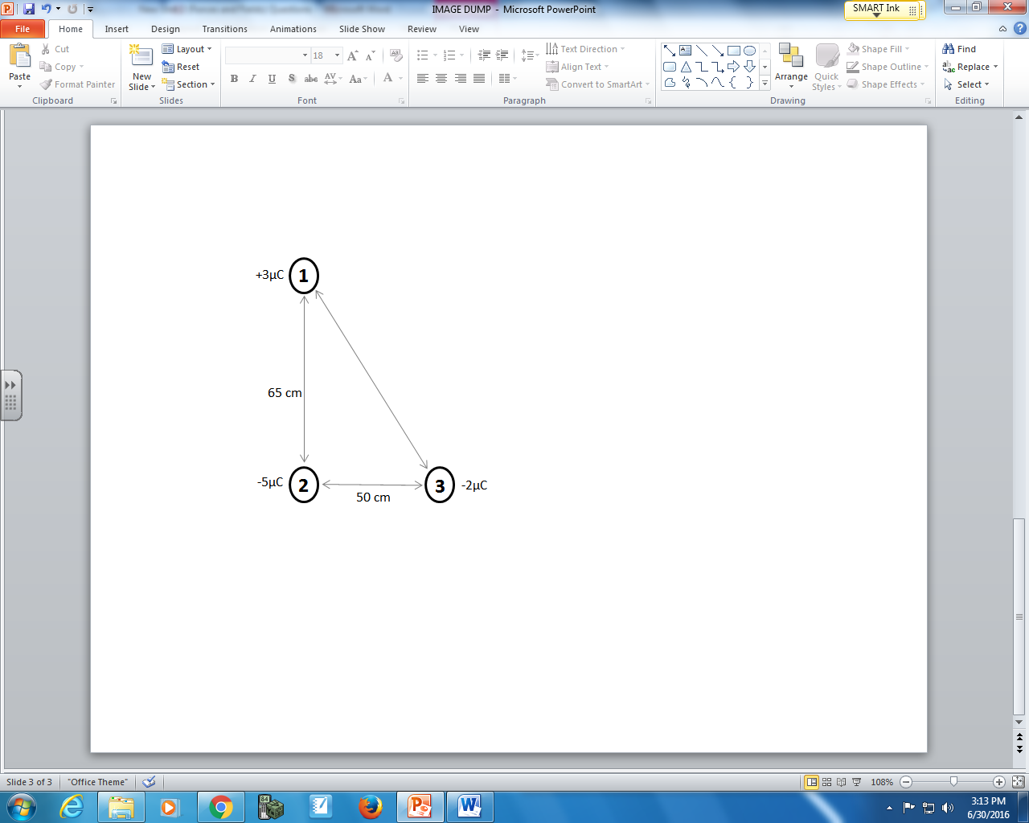
Directions
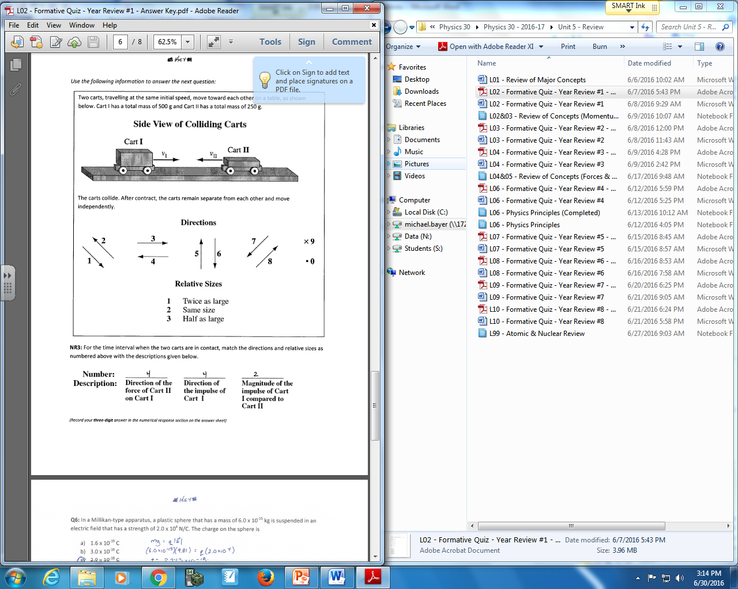

Q1: Use the vector directions above to fill in the blanks below.

Direction: __________ __________ __________
Description: Direction of Direction of Direction of
Force acting on Force acting on Net Force acting
Charge 2 due to Charge 2 due to on Charge 2
Charge 1 Charge 3

(Record your three-digit answer in the Numerical Response boxes below)

Q2: The magnitude of the net electrostatic force acting on Charge 2 is a.bc x 10^{-d} N, where a, b, c, and d are ___, ___, ___, and ___.
(Record your four-digit answer in the Numerical Response boxes below)

Use the following information to answer Q3:
A neutral Hydrogen atom contains a single proton and a single electron in the ground state. According to the Bohr model of the atom, the orbital radius of the electron is 0.0529nm.
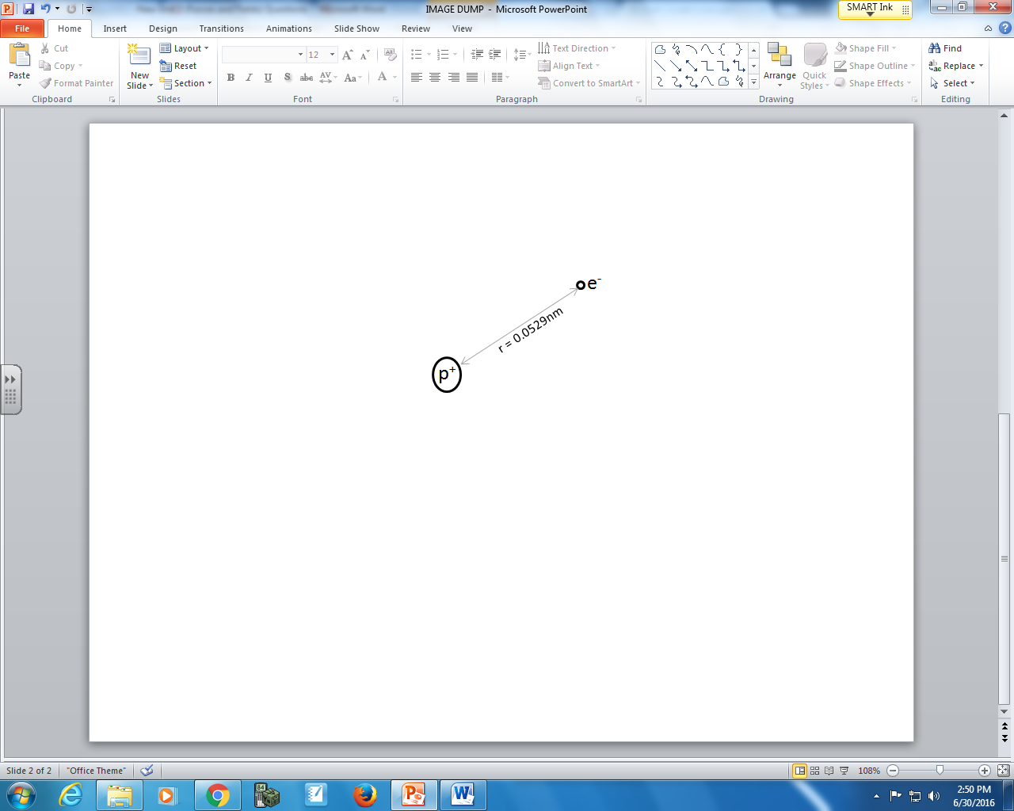
NOTE: The diagram is not drawn to scale.

Q3: The ratio of the electrostatic force to the gravitational force that an electron in the ground state around a Hydrogen atom experiences is a.b x 10^{cd} : 1, where a, b, c, and d are ___, ___, ___, and ___.
(HINT: Charges and masses can be found on your data sheet)
(Record your four- digit answer in the Numerical Response boxes below)

Use the following information to answer Q4:
Three charges are aligned at right angles, per the diagram below.
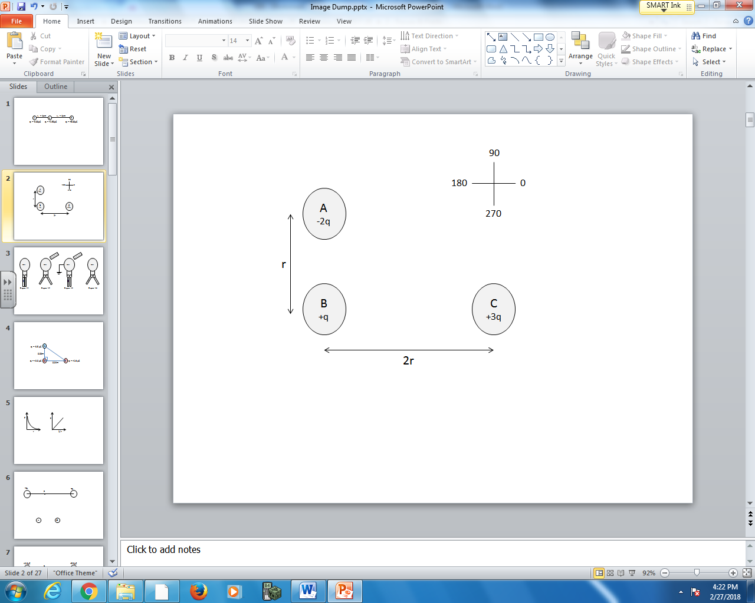

Q4: The net force acting on B will be at ____ degrees.
(Record your three digit answer in the Numerical Response boxes below)

Cumulative Review from Previous Units
Use the following information to answer Q1:
Two rolling lumps of clay collide on a frictionless surface. They stick together, and travel in the positive direction at 3.0m/s, as depicted below.
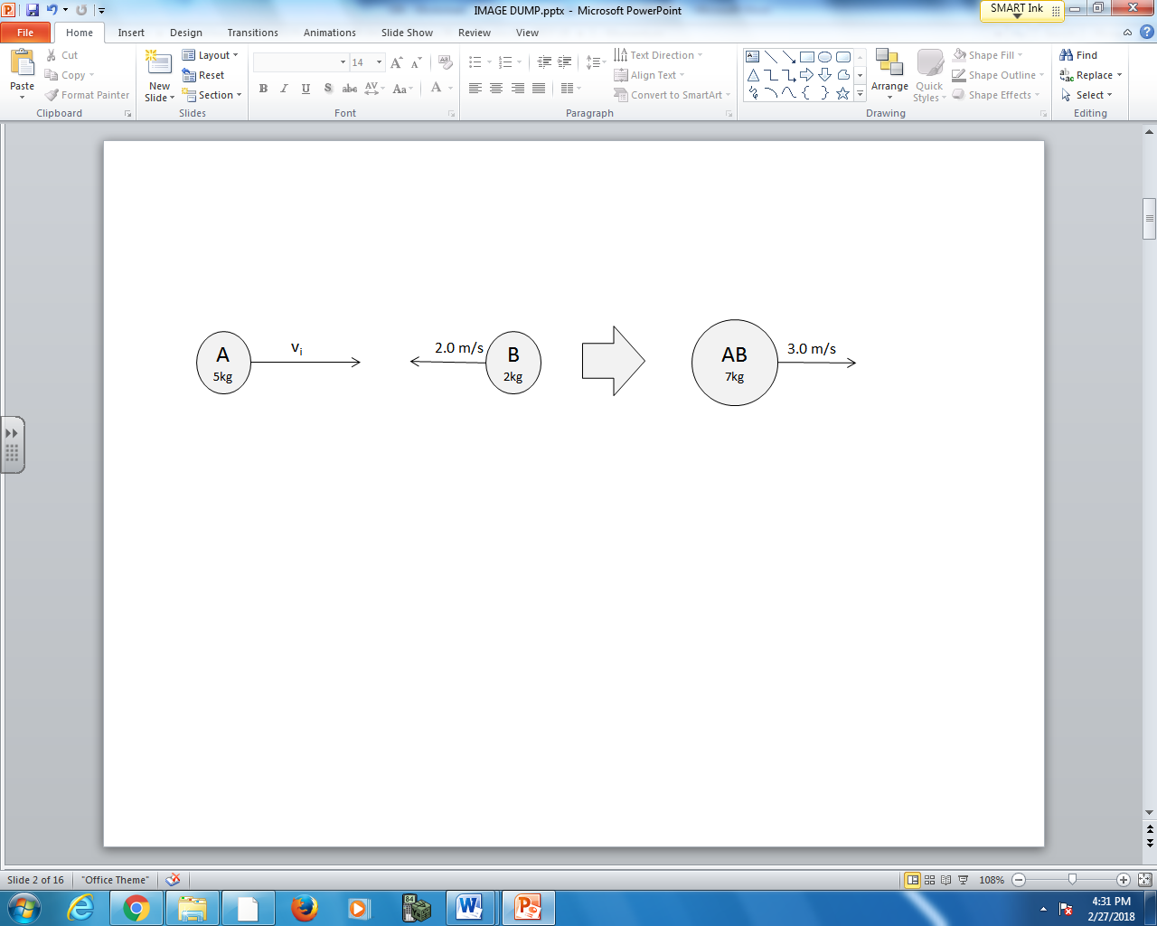

Q1: Object A has an initial speed of _____ m/s.
(Record your three digit answer in the Numerical Response boxes below)

