First Name:_____________________________ Last Name:_____________________________

L04 – Worksheet – Friction in 1-Dimension

Use the following information to answer Q1-Q9:
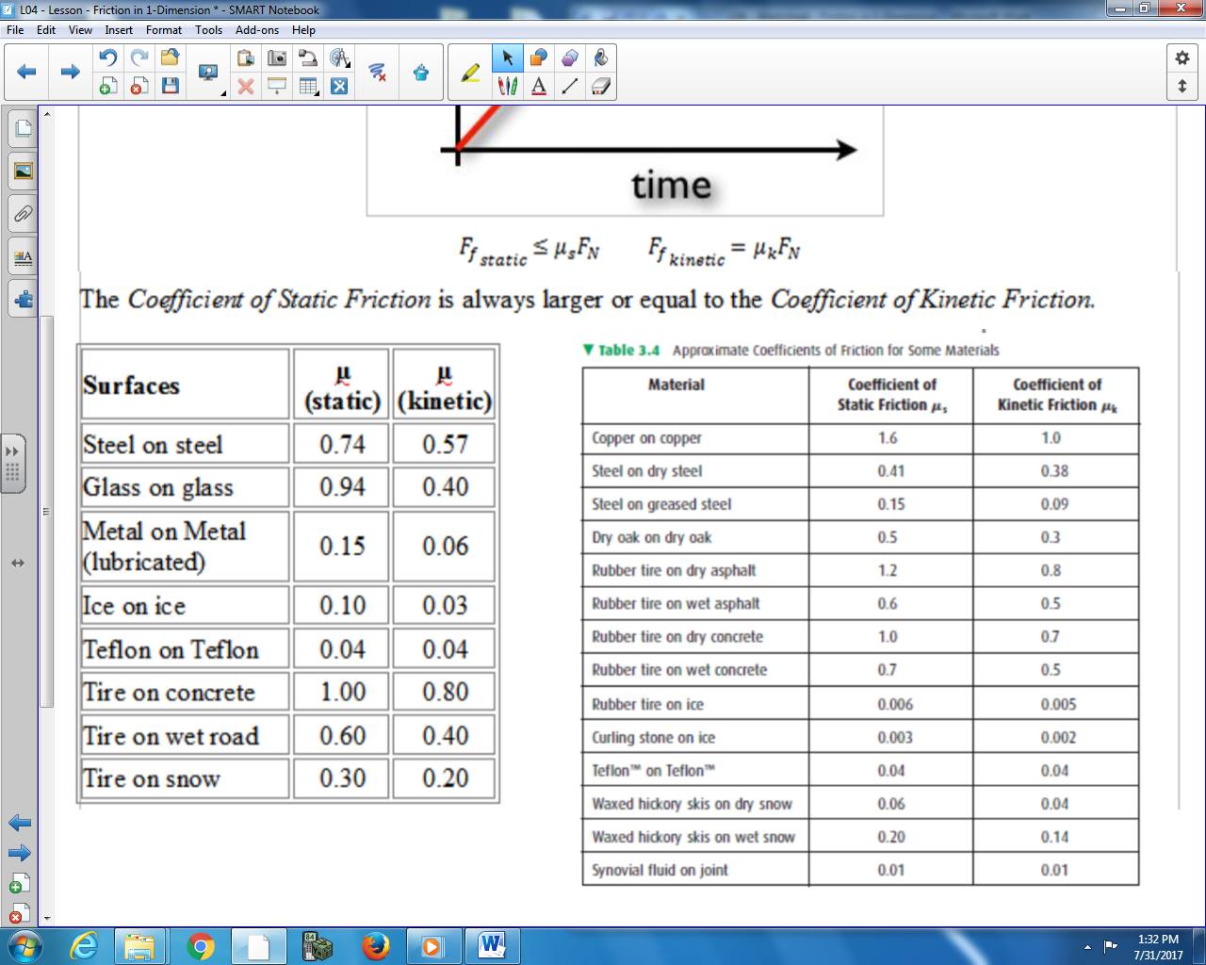

Text

Q1: A 15kg steel block is being dragged horizontally across a dry steel table. How much force is required to get the object moving?
- $F≤60.3315 N$
- $F=60.3315 N$
- $F≥60.3315 N$
- $F>60.3315 N$

Use the following additional information to answer Q2-Q3:
A 2kg dry oak plank is being dragged horizontally across a dry oak table with a force of 12 Newtons.

Q2: What is the magnitude of the frictional force acting on the plank?
- 0.60 N
- 5.89 N
- 9.81 N
- 19.62 N

Q3: The acceleration of the oak plank is _____ m/s²,
(Record your three-digit answer in the Numerical Response boxes below)

Use the following additional information to answer Q4-Q6:
An 18kg curling stone is thrown at 0.65 m/s across the ice. The curling stone moves 10 meters before hitting the walkway and stopping.

Q4: The force of friction acting on the curling rock is a.bc x 10^{-d} N, where a,b,c, and d are ___, ___, ___, and ___.
(Record your four-digit answer in the Numerical Response boxes below)

Q5: The deceleration of the rock is a.bc x 10^{-d} m/s², where a,b,c, and d are ___, ___, ___, and ___.
(Record your four-digit answer in the Numerical Response boxes below)

Q6: The speed of the curling stone prior to hitting the walkway is a.bc x 10^{-d} m/s, where a,b,c, and d are ___, ___, ___, and ___.
(Record your four-digit answer in the Numerical Response boxes below)

Use the following additional information to answer Q7-Q9:
A 2kg copper block is sitting on a copper bench. An increasing force is applied to the block.

Q7: Complete the following table:
Applied Force (N) | Magnitude of Frictional Force (N) | Net Force (N) | Acceleration (m/s²)
0
10
20
30
40
50
60

Q8: Graph the relationship between applied and frictional force.
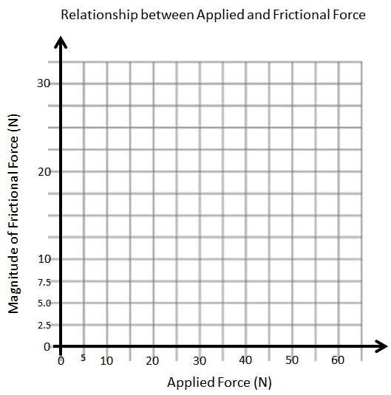
Q9: Graph the relationship between applied force and acceleration for a system with friction.
