First Name:_____________________________ Last Name:______________________________

L04 – Worksheet – Gravitational Forces and Fields /20 marks

Part 1: Gravitational Force in 1-Dimension
Q1: Given that the mass of Mars is 6.42 x10²³ kg and the radius is 3.40x10⁶m, then the force of gravity acting on a 150kg astronaut standing on the surface of Mars would be a.bc x 10^{d} N, where a, b, c, and d are ___, ___, ___, and ___.
(Record your four digit answer in the Numerical Response boxes below)

Use the following information to answer Q2:
From your Data Booklet, Earth has a radius of 6.37 x 10⁶ m, and a mass of 5.97 x 10²⁴ kg.
NOTE: This information would not be given to you on a test… you need to reference your Data Booklet for it.

Q2: A 150kg Astronaut is in orbit above the surface of Earth and experiences a gravitational force of 735N. For this to be true, then the Astronaut must be a.bc x 10^{d} m above the surface of the Earth, where a, b, c, and d are ___, ___, ___, and ___.
(Record your four digit answer in the Numerical Response boxes below)

Part 2: Gravitational Fields in 1-Dimension
Q3: If the mass of Mars is 6.42 x10²³ kg and the radius is 3.40x10⁶m, what is the gravitational field strength of the surface of the planet?
(Record your three digit answer in the Numerical Response boxes below)

Q4: If the acceleration due to gravity on the surface of Mercury is 3.703 m/s², then the force of gravity acting on a 150kg astronaut on the surface would be a.bc x 10^{d} N, where a, b, c, and d are ___, ___, ___, and ___.
(Record your four digit answer in the Numerical Response boxes below)

Part 3: Gravitational Forces and Fields in 2-Dimensions
Q5: If m_{A} = 80kg, m_{B} = 40kg, m_{C} = 10kg, r_{AB} = 0.5m, and r_{BC} = 0.2m, then object B will accelerate in what direction, using polar coordinates.
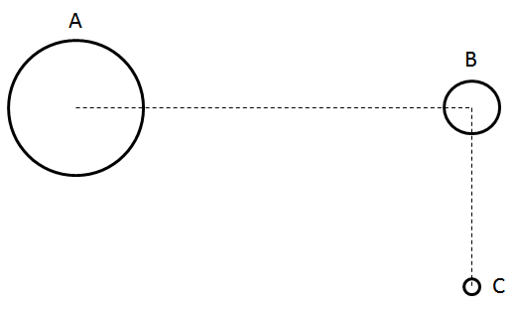
(Record your three digit answer in the Numerical Response boxes below)

Q6: What is the instantaneous acceleration (magnitude and direction) of the second mass, m₂? (3 marks)
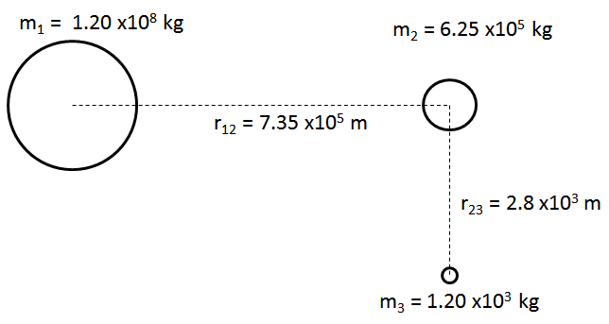

Part 4: r² Relationship

Q7: Two objects experience a gravitational force between them. If each object triples in mass, and the distance between them is doubled, then the gravitational force increases by a factor of $\frac{a}{b}$ , where $\frac{a}{b}$ is a reduced fraction. a and b are ___ and ___.
(Record your two digit answer in the Numerical Response boxes below)

Q8: The force of gravity between two objects is 250N. The mass of each object is tripled, and the distance between them is halved. What is the magnitude of the force of gravity acting on each object, in Newtons?
(Record your four digit answer in the Numerical Response boxes below)

Q9: If the force of gravity at point A is 100N, what is the force of gravity at point B?
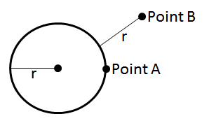
(Record your three digit answer in the Numerical Response boxes below)

Q10: If the gravitational field at Point B is 18 N/kg, what is the acceleration due to gravity on the surface of the planet?
(Record your three digit answer in the Numerical Response boxes below)

Q11: If the force of gravity at point B is 64N, what is the force of gravity at point A?
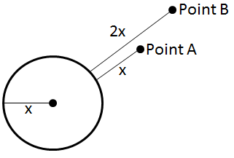
(Record your three digit answer in the Numerical Response boxes below)

Part 5: Multi-Step Questions
Q12: An object on Venus is dropped from 10m above the ground, and reaches the ground 1.505 seconds later. The gravitational force acting on a nearby 150kg astronaut would be a.bc x 10^{d} N, where a, b, c, and d are ___, ___, ___, and ___.
(Record your four digit answer in the Numerical Response boxes below)

Q13: If the gravitational field strength on the surface of Mercury is 3.703 N/kg, how long would it take a 10kg mass to drop 15m?
(Record your three digit answer in the Numerical Response boxes below)

Q14: Given: m_{A} = 6.0x10²⁰ kg, m_{B} = 2.5 x 10²⁰ kg, m_{C} = 8.5 x 10¹⁹ kg, r_{AB} = 2.3 x 10¹² m, and F_{NET} = 2.60 x 10⁶N [223°]. How far away from object B is object C? (3 marks)

Use the following information to answer Q15:
The Earth’s Moon has a mass of 7.35 x10²² kg and a radius of 1.74 x10⁶ m.

Q15: If an object were held 15m above the surface of the moon and dropped, how much time would it take for the object to hit the surface of the moon? (2 mark)

