First Name:______________________________ Last Name:______________________________
L04 – Worksheet – Quantum Mechanics
Textbook Questions
Pg 728 #1: What is the wavelength of a proton moving at 1.0 x 10⁵ m/s?

Pg 728 #2: What is the speed of an electron that has a wavelength of 420 nm?

Pg 736 #1: What is the wavelength of an electron that is moving at 20,000 m/s?

Pg 736 #2: Calculate the momentum of a 500-nm photon.

Pg 736 #5: In your television set, an electron is accelerated through a potential difference of 21,000 V.
- How much energy does the electron acquire?

- What is the wavelength of an electron of this energy?

Pg 736 #6: If an electron and a proton each have the same velocity, how do their wavelengths compare? Express your answer numerically as a ratio.

L04 – Quantum Mechanics (Basic Concepts)
Q861: Louis de Broglie is associated with the
- Uncertainty principle
- Momentum of photons
- Wave character of particles
- Explanation of the photoelectric effect
Use the following information to answer Q863:
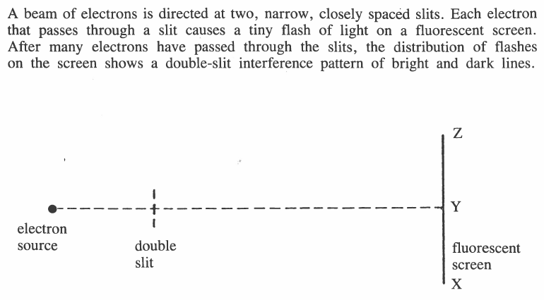

Q863: A probable distribution of flashes on the screen after the first 20 electrons have passed through the slits could be represented by
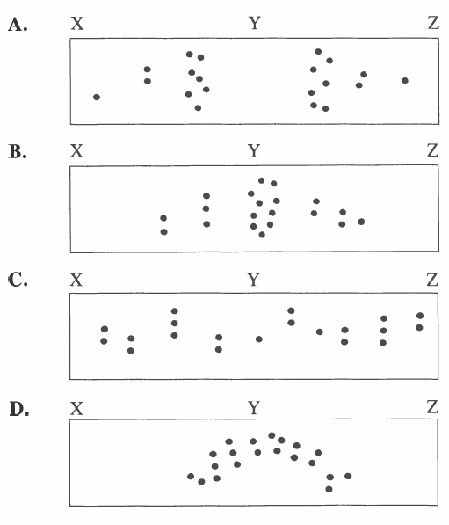
Q867: The concept that particles exhibit wave-like properties was proposed by
- De Broglie
- Compton
- Einstein
- Plank
Q869: Evidence of the wave-like properties of matter can be found in the
- Refraction of light
- Diffraction of electrons
- Compton scattering of X-ray photons
- Conservation of momentum of photons
L04 – Quantum Mechanics (Basic Concepts)
Q870: The de Broglie wavelength for an electron moving with a velocity of 2.0 x 10⁷ m/s is
- 2.7 x 10¹⁰ m
- 3.6 x 10⁻¹¹ m
- 1.8 x 10⁻²³ m
- 4.6 x 10⁻³⁸ m

Q874: An alpha particle and an electron are travelling at the same speed. The de Broglie wavelength for the alpha particle is
- Longer because of the greater mass of the alpha particle
- Shorter because of the greater mass of the alpha particle
- Longer because of the greater charge of the alpha particle
- Shorter because of the greater charge of the alpha particle

Q875: The speed of an electron that has the same momentum as a photon with a wavelength of 5.10 x 10⁻⁷ m is
- 7.10 x 10² m/s
- 1.01 x 10³ m/s
- 1.43 x 10³ m/s
- 2.98 x 10⁸ m/s

