First Name:______________________________ Last Name:______________________________
L04 – Worksheet – Reflection Ray Diagrams
Introduction Questions
Use the following information to answer Q1-Q2:
A converging (concave) mirror has a focal distance of 12cm. A 5cm tall object is placed 18 cm away from the vertex.

Q1: Sketch the ray diagram.

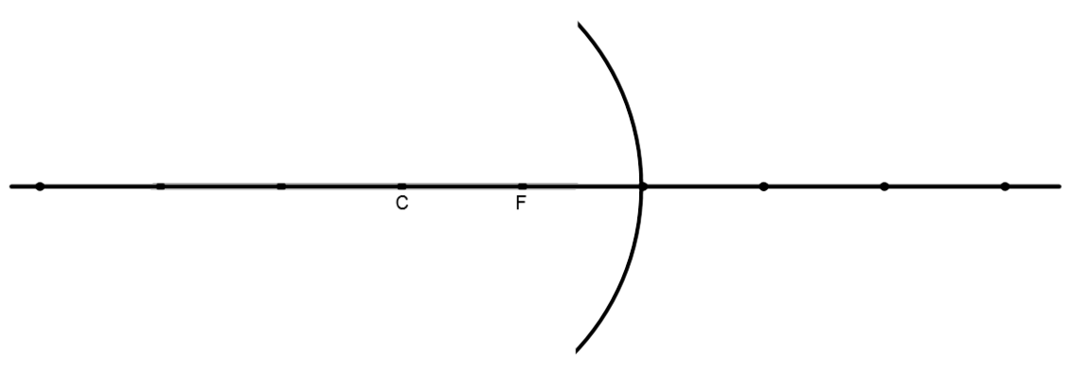

Q2: Calculate the image distance, magnification, and attributes (real/virtual, erect/inverted, enlarged/diminished).

Use the following information to answer Q3-Q4:
A diverging (convex) mirror has a focal distance of 4 cm. A 5cm tall object is placed 12 cm away from the vertex.

Q3: Sketch the ray diagram.

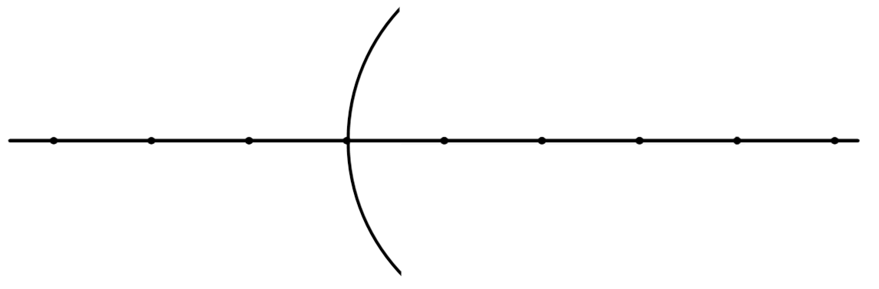

Q4: Calculate the image distance, magnification, and attributes (real/virtual, erect/inverted, enlarged/diminished) using your equations.
Textbook Questions
Pg 664 #2: Determine the image distance, magnification, and attributes for the following:
- A converging mirror with a focal length of 12.0 cm with an object 6.0 cm from the mirror.

- A diverging mirror of focal length 5.00 cm with an object 10.0 cm from the mirror.

- A diverging mirror of focal length 10.0 cm with an object 2.0 cm from the mirror.

Pg 664 #3: A 5.0-cm-high object is placed 2.0 cm in front of a converging mirror and the image is magnified -4x. Where does the image form and what is the focal length of the mirror?

Pg 664 #5: Light from a distance planet is incident on a converging mirror. The image of the planet forms on a screen 15.0 cm from the vertex of the mirror. Find the focal length of the mirror and the image characteristics.

Pg 664 #4: A 4.0-cm-high object is placed 15.0 cm from a concave mirror of focal length 5.0 cm. Determine the image characteristics using a ray diagram and the mirror equation.

Cumulative Review from Previous Units
Use the following information to answer Q1:
Two Object Collision
A 500.0g ball moving at 2.000 m/s collides with a 400.0g ball, per the diagram below.
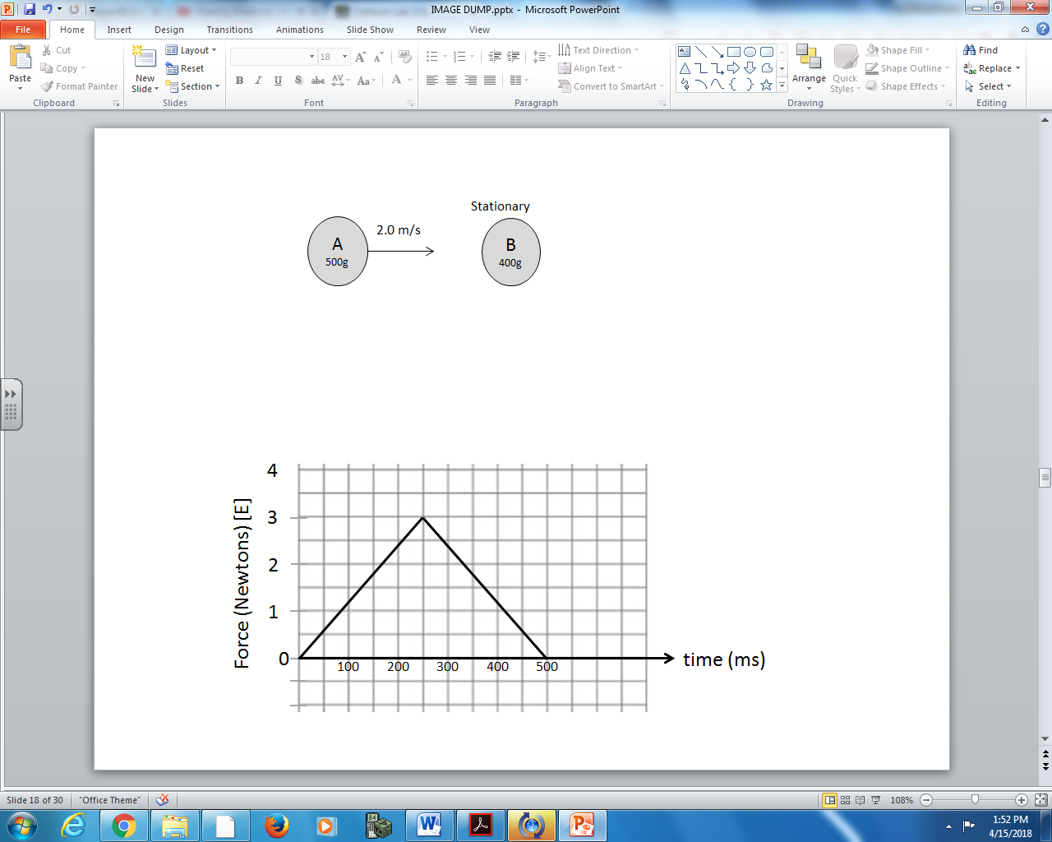
As a result of this collision, the 400.0g ball experiences a force, per the chart below.

Q1: The final velocity of the 500.0g ball is a.bc x 10^{-d} m/s [E], where a, b, c, and d are ___, ___, ___, and ___.
(Record your four-digit answer in the numerical response boxes below.)

