First Name:____________________________ Last Name:______________________________
L05 – Formative Quiz – Assorted Questions
Use the following information to answer Q1-2:
The radioactive isotope Radium-226 decays via Alpha Decay, producing a Radon-222 daughter nucleus and an Alpha particle.
The mass of the parent nucleus, Radium-226, exceeds the sum of the daughter nucleus and the alpha particle. In radioactive decay, this missing “mass defect” is converted into the kinetic energy of the system.
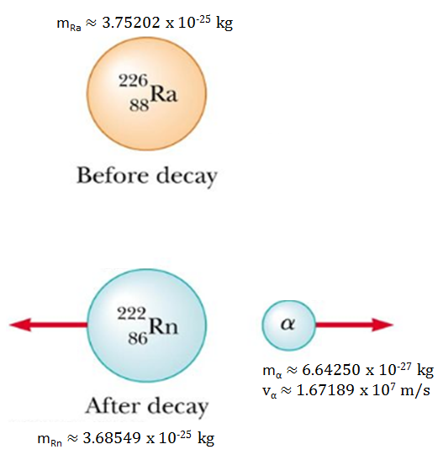

Q2: Text

Q1: If the Radium-226 parent nucleus was originally stationary, and the Alpha particle ejects at a speed of 1.67189 x 10⁷ m/s, then the recoil speed of the Radon-222 daughter nucleus is a.bc x 10^{d} m/s, where a, b, c, and d are ___, ___, ___, and ___.
(Record your four digit answer in the Numerical Response boxes below)

Q2: What is the kinetic energy of the alpha particle, in MeV?
(Record your three digit answer in the Numerical Response boxes below)

Use the following information to answer Q3:
Velocity of a 500g Toy Car.
A variable force is applied to the car between 2.25s and 3.50s, causing it to accelerate.
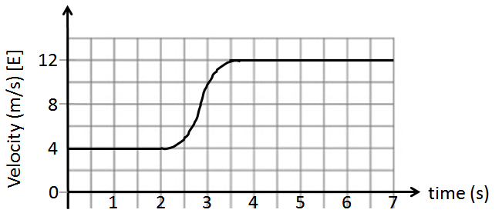

Q3: What is the magnitude of the impulse that acted on the car between 2.25 and 3.50 seconds?
(Record your three digit answer in the Numerical Response boxes below)

Use the following information to answer Q4:
Two positively charged spheres are held 1.00m apart. Once released, both charges electrostatically repel from each other, per the diagram below.
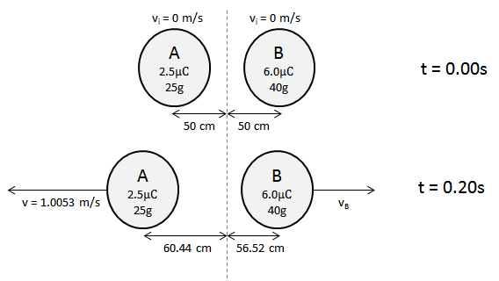

Q4: The final speed of Object B is a.bc x 10^{-d} m/s, where a, b, c, and d are ___, ___, ___, and ___.
(Record your four digit answer in the Numerical Response boxes below)

MARKING:
Beginning 0-1
Progressing 2
Competent 3
Exemplary 4

