First Name:_____________________________ Last Name:______________________________

L05 – FQ – Conservation of Mechanical Energy

Use the following information to answer Q1:
A cart with an unknown initial velocity coasts up a ramp. The cart has a velocity of 5m/s at the top of the ramp. The ramp is assumed to be frictionless.
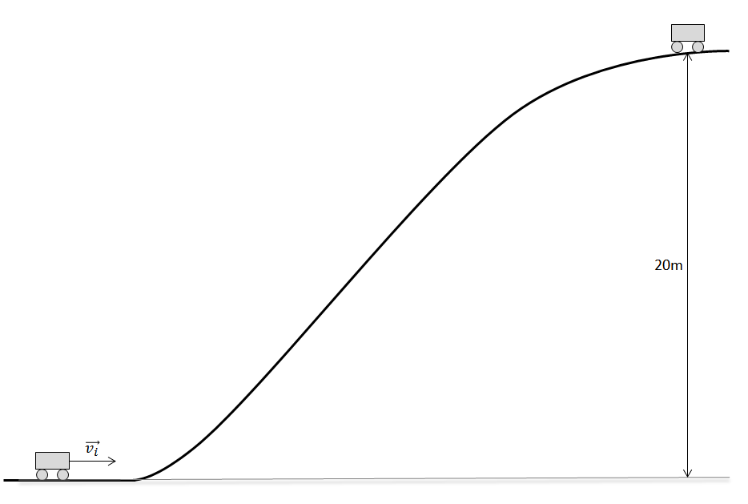

Q1: How fast was the cart moving originally, in m/s?
(Record your three-digit answer in the Numerical Response boxes below)

Use the following information to answer Q2:
A hockey puck of mass of 0.127kg and is resting on the ice. A hockey player takes a slap shot, giving the puck an upward initial velocity.
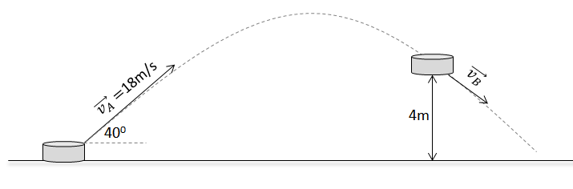

Q2: How fast is the puck moving at Position B, in m/s?
(Record your three-digit answer in the Numerical Response boxes below)

MARKING:
Beginning 0.0 – 0.5
Progressing 1.0
Competent 1.5
Exemplary 2.0

