First Name:____________________________ Last Name:______________________________

L05 – FQ – Coulomb’s Law Examined Graphically

Use the following information to answer Q1-Q2:
Charge by Induction
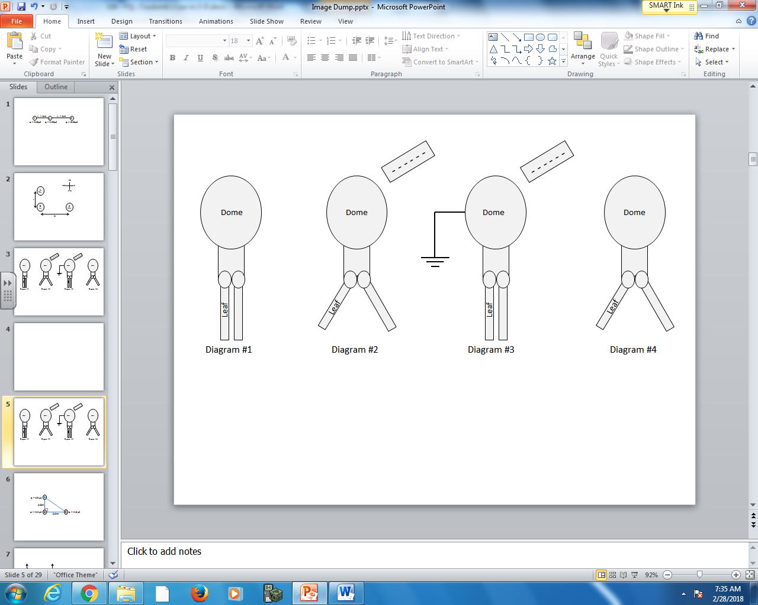

Q1: In Diagram #2, the dome becomes __i__ charged due to the movement of __ii__ charges.
 | i. | ii.
A. | positively | positive
B. | positively | negative
C. | negatively | positive
D. | negatively | negative

Q2: In Diagram #3, due to the presence of the grounding wire, the number of electrons __i__ and the number of protons __ii__ in the electroscope.
 | i. | ii.
A. | increase | stays the same
B. | decrease | stays the same
C. | stays the same | increase
D. | stays the same | decrease
Use the following information to answer Q3:
The electrostatic attraction between a +3.00μC charge and an unknown charge is graphed below.
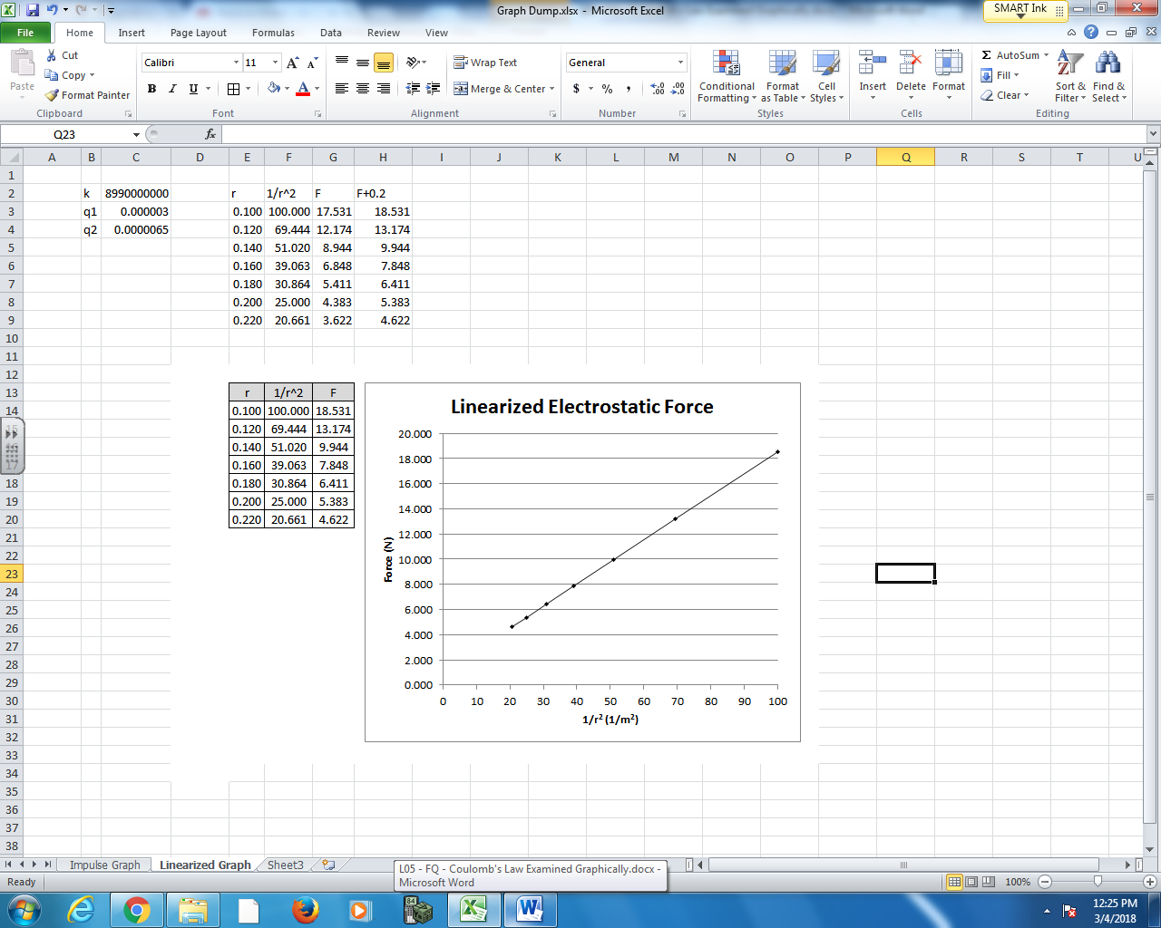

Q3: The unknown charge is
- +6.50μC
- -6.50μC
- +6.87μC
- -6.87μC

MARKING:
Beginning 0.0 – 1.0
Progressing 1.5
Competent 2.0 – 2.5
Exemplary 3.0

