First Name:_________________________________ Last Name:______________________________

L05 – FQ – Interpreting Graphs
Use the following information to answer Q1– Q3:
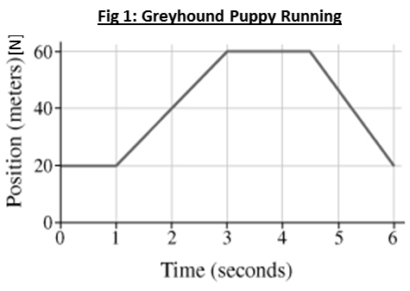

Text

Q1: What is the magnitude of the velocity of the puppy at t = 2.0 seconds?
(Record your three digit answer in the Numerical Response boxes below)

Q2: What is the displacement of the puppy between 1 and 3 seconds?
- 4m [N]
- 20 m [N]
- 40 m [N]
- 80 m [N]
Q3: What is the magnitude of the acceleration of the puppy between 4.5 and 6 seconds?
(Record your three digit answer in the Numerical Response boxes below)

Use the following information to answer Q4– Q6:
Figure 2: An unidentified flying object (UFO) is travelling erratically in the air.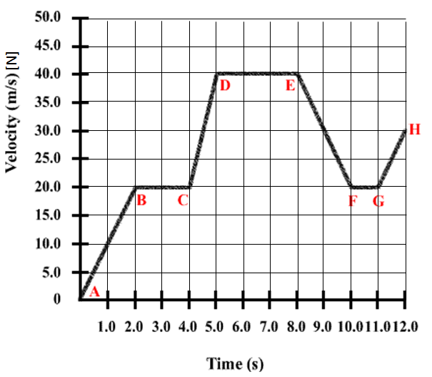

Q4: What is the acceleration of the UFO between 4 and 5 seconds?

Q5: (Short Answer) During what time periods does the UFO have uniform motion?

Q6: (Short Answer) What is the displacement of the UFO between 0 and 2 seconds?

MARKING:
Beginning 0.0 – 2.5
Progressing 3.0 – 4.0
Competent 4.5 – 5.5
Exemplary 6.0

