First Name:____________________________ Last Name:______________________________

L05 – FQ – Wave-Particle Duality
Use the following information to answer Q1 – Q5:
Double Slit Diffraction with an Electron Beam
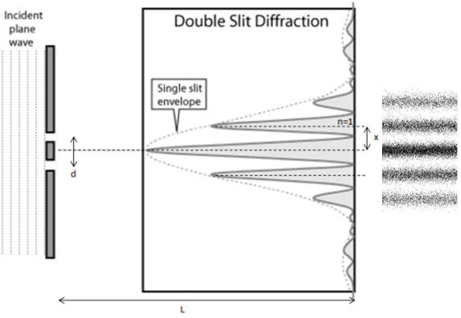

Q1: An electron beam can create an interference pattern in a double-slit diffraction experiment because of which Physics Principle?
(Record your one-digit answer in the Numerical Response boxes below)

Q2: If a proton is moving at a speed of 3.58 x 10⁶ m/s, then its deBroglie wavelength is a.b x 10^{-cd} m, where a, b, c, and d are ___, ___, ___, and ___.
(Record your four-digit answer in the Numerical Response boxes below)

Q3: Which formula best relates the angle of diffraction to the velocity of the incoming electron beam?
- $θ=Sin\left(\frac{nh}{mvd}\right)$ b. $θ={Sin}^{-1}\left(\frac{nh}{mvd}\right)$

- $θ=Sin\left(\frac{mvd}{nh}\right)$ d. $θ={Sin}^{-1}\left(\frac{mvd}{nh}\right)$

Q4: If the diffraction angle, θ, between the central bright spot and the first antinode is 4.17 x 10⁻² deg, and the slit separation distance is 5.0 μm, then the deBroglie wavelength of the incoming electron beam is a.bc x 10^{-d} m, where a, b, c, and d are ___, ___, ___, and ___.
(Record your four-digit answer in the Numerical Response boxes below)

Q5: Given your answer from Q4, the speed of the incoming electrons is a.bc x 10^{d} m/s, where a, b, c, and d are ___, ___, ___, and ___.
(Record your four-digit answer in the Numerical Response boxes below)

MARKING:
Beginning 0.0 – 2.0
Progressing 2.5 – 3.5
Competent 4.0 – 4.5
Exemplary 5.0

