First Name:______________________________ Last Name:______________________________
L05 – Worksheet – Refraction
Textbook Questions
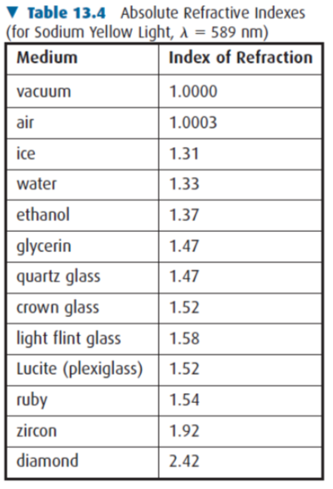
Pg 668 #1: Light passes from a diamond into air. The angle of refraction as the light emerges from the diamond is 25⁰. What was the angle of incidence?

Pg 668 #2: Light travelling from air into a transparent material is incident at an angle of 20⁰ and refracted at an angle of 17⁰. Determine the index of refraction of the transparent material.

Pg 668 #3: A ray of light passes from air into ruby at an incident angle of 15⁰. Calculate the angle of refraction.

Pg 668 #4: A ray of light, travelling in air, is incident on an unknown sample at an angle of 20⁰. If the angle of refraction is 15⁰, determine the index of refraction for the unknown sample.

Pg 670 #2: Light with a wavelength of 737 nm enters quartz glass at an angle of 25.0⁰. Determine the angel of refraction and the wavelength of the light in the quartz glass.

Pg 670 #3: Light enters an unknown crystal from air with a wavelength of 500 nm. If the wavelength of the light in the crystal is found to be 450 nm, what is the refractive index of the crystal?

Pg 673 #1: Determine the critical angle of the following interfaces:
- Water and air
- Diamond and air
- Diamond and water

Diploma Questions – Refraction (Basic Concepts)
Q514: A ray of visible light passes from air into glass and undergoes a change in its
- Frequency and speed
- Wavelength and speed
- Wavelength and frequency
- Frequency, wavelength, and speed

Q516: White light can be dispersed into its component colors because
- The speed of light is independent of wavelength
- Long wavelengths refract less than short wavelengths
- Long wavelengths diffract more than short wavelengths
- Long wavelengths do not travel as fast as short wavelengths

Q520: Wavelength is not a good criterion for categorizing light because wavelength
- Is inversely proportional to frequency
- Is directly proportional to frequency
- Changes during diffraction
- Changes during refraction

Diploma Questions – Refraction (Simple Calculations)
Q528: The speed of light in a medium with an index of refraction of 1.5 is
- 4.5 x 10⁸ m/s
- 3.0 x 10⁸ m/s
- 2.0 x 10⁸ m/s
- 1.5 x 10⁸ m/s

Q529: The refractive indices of water and glass are 1.33 and 1.52 respectively. If the angle of incidence is 40.0⁰ for light travelling from water into glass, the angle of refraction is
- 47.3⁰
- 34.2⁰
- 28.9⁰
- 25.0⁰
Q537: In glass (n = 1.50), a certain infra-red source has a wavelength of 8.00 x 10⁻⁷ m. Its frequency is
- 8.44 x 10¹⁴ Hz
- 5.63 x 10¹⁴ Hz
- 3.75 x 10¹⁴ Hz
- 2.50 x 10¹⁴ Hz

Diploma Questions – Refraction (Total Internal Reflection)
Q548: A ray of light passes through a medium that has a refractive index of 1.2. An angle of refraction of 90⁰ in air will occur when the angle of incidence in the medium is
- 75⁰
- 56⁰
- 34⁰
- 15⁰
Use the following information to answer Q550:
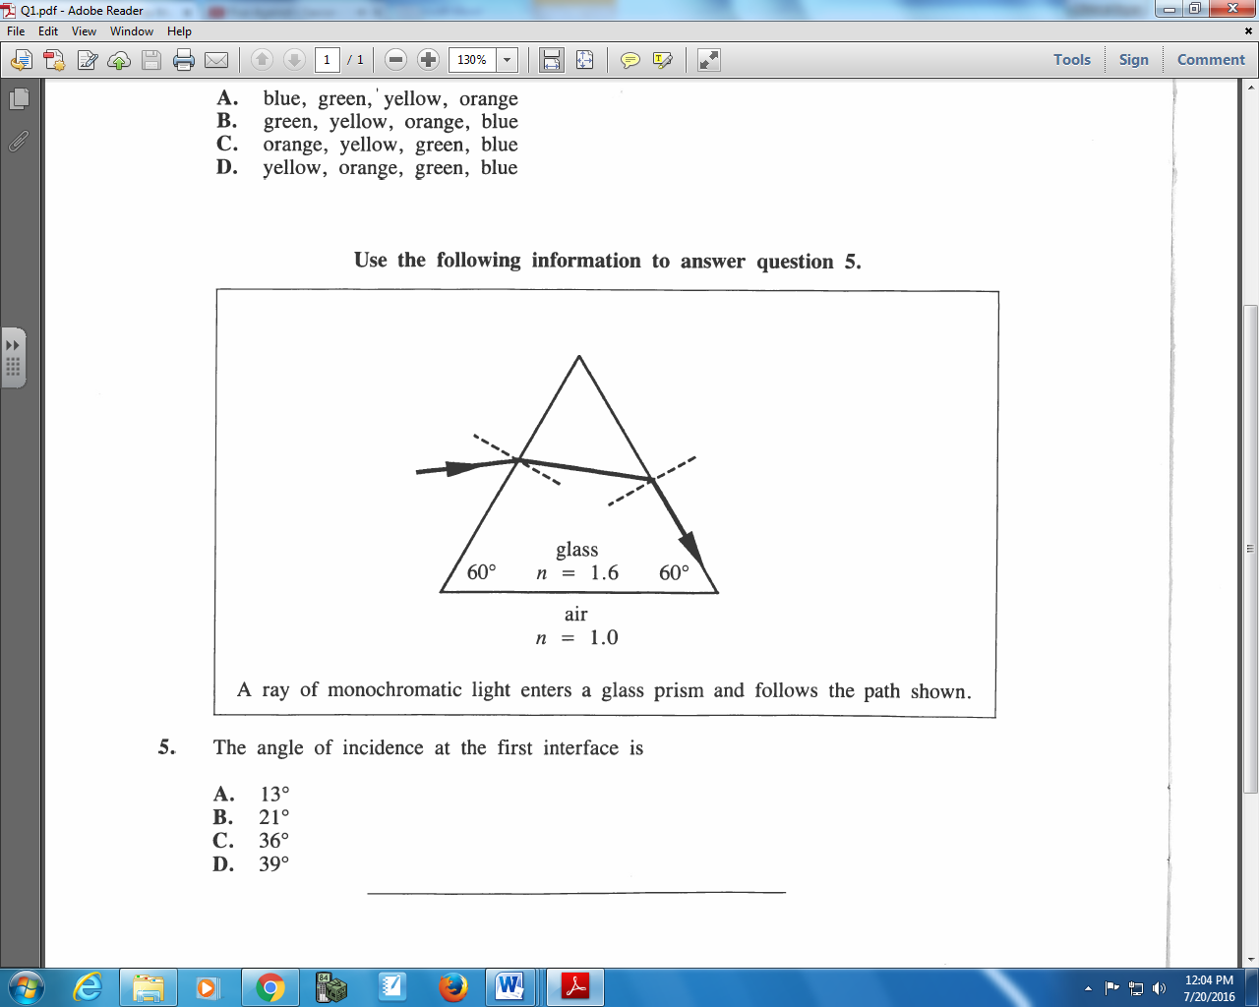

Q550: The angle of incidence at the first interface is
- 13⁰
- 21⁰
- 36⁰
- 39⁰
Use the following information to answer Q551:
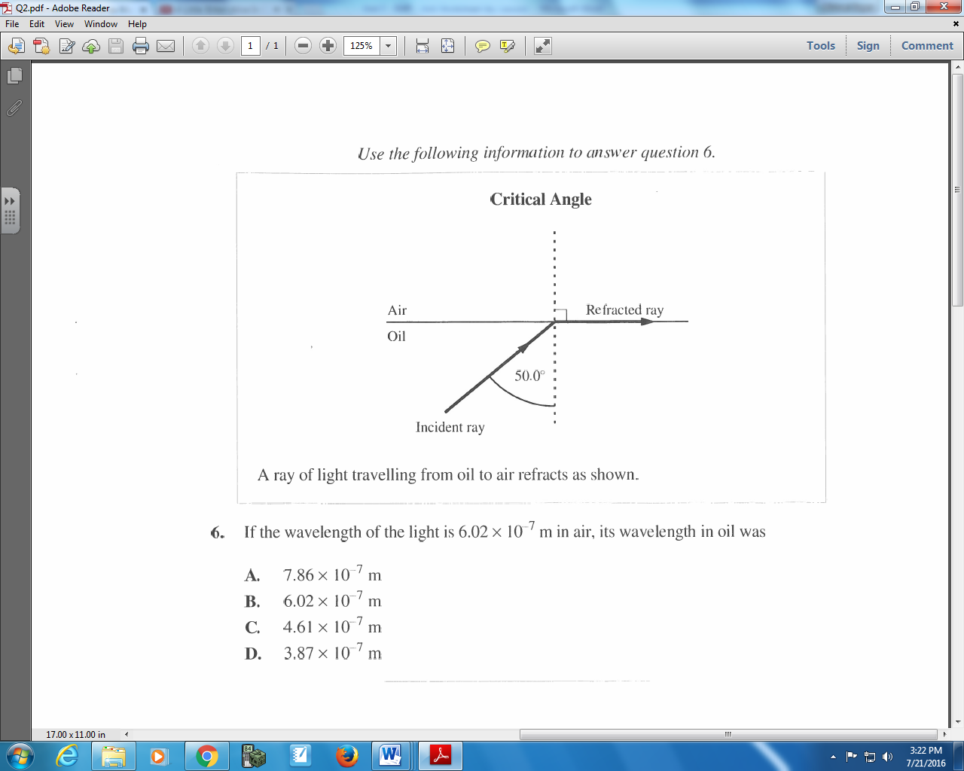

Q551: If the wavelength of the light is 6.02 x 10⁻⁷ m in air, its wavelength in oil was
- 7.86 x 10⁻⁷ m
- 6.02 x 10⁻⁷ m
- 4.61 x 10⁻⁷ m
- 3.87 x 10⁻⁷ m
Diploma Questions – Refraction (Refraction Diagrams)
Use the following information to answer Q552:
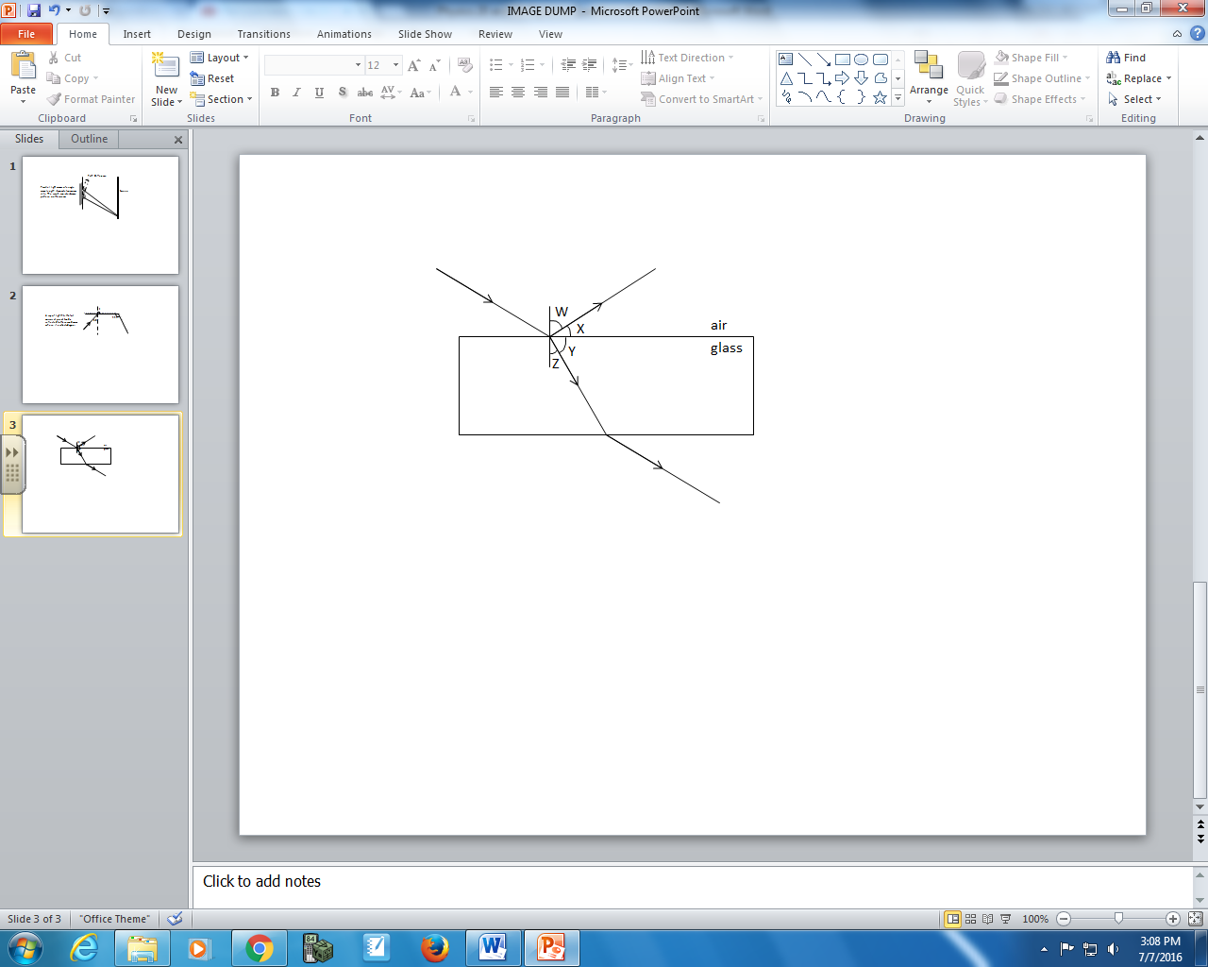

Q552: The angle of refraction is
- W
- X
- Y
- Z
Use the following information to answer Q559:
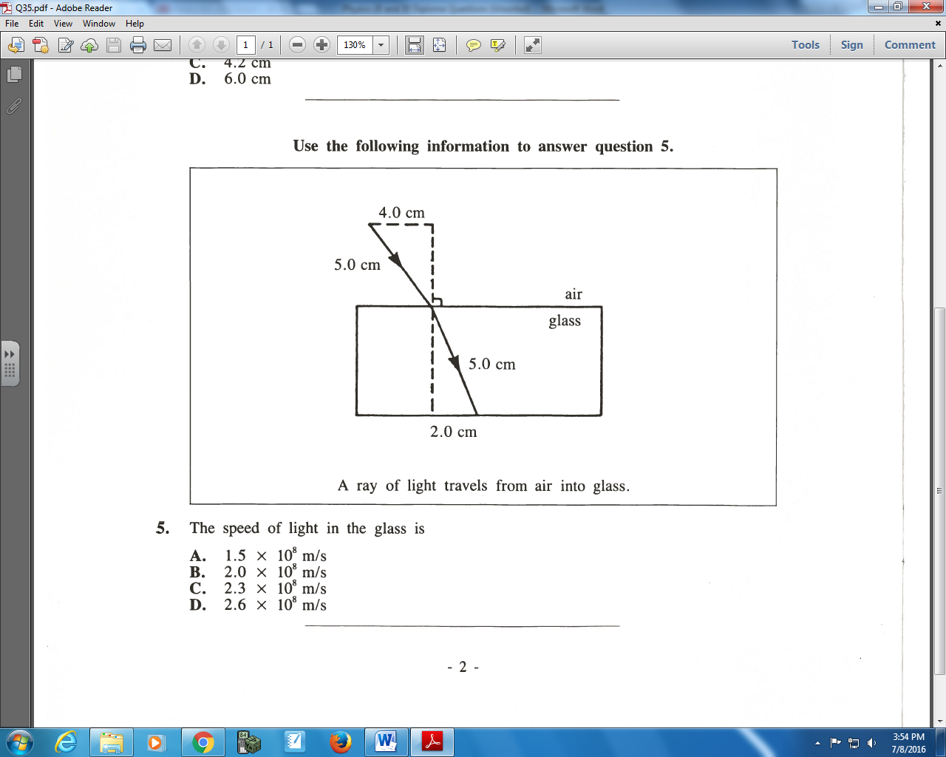

Q559: The speed of light in the glass is
- 1.5 x 10⁸ m/s
- 2.0 x 10⁸ m/s
- 2.3 x 10⁸ m/s
- 2.6 x 10⁸ m/s

Use the following information to answer Q560:
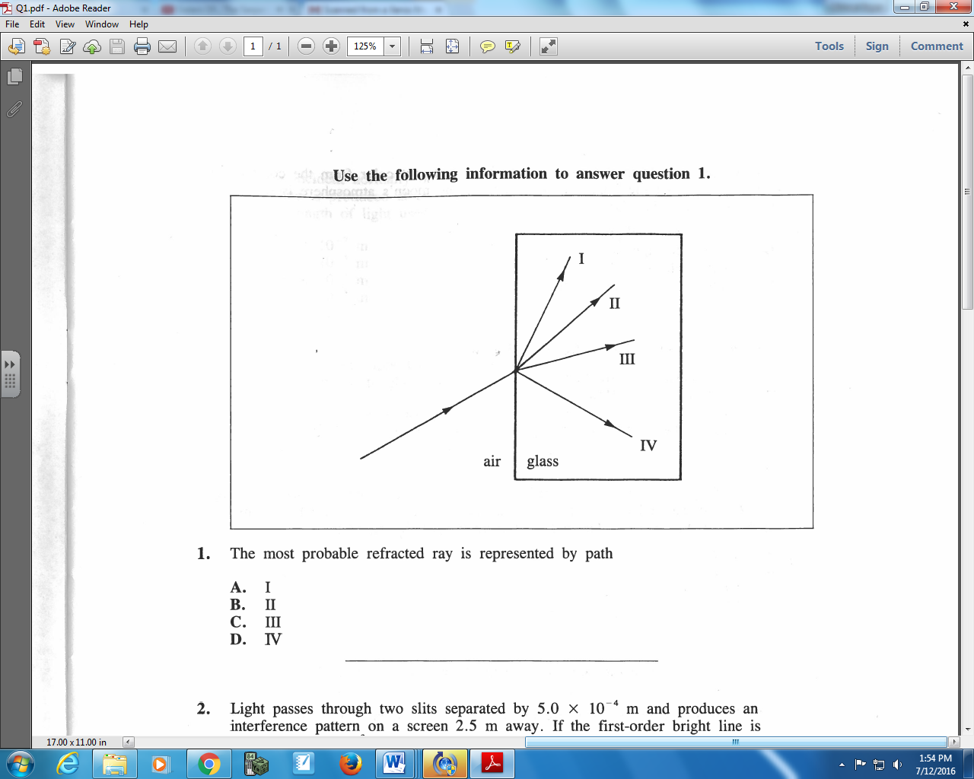

Q560: The most probable refracted ray is represented by path
- I
- II
- III
- IV
Use the following information to answer Q561:
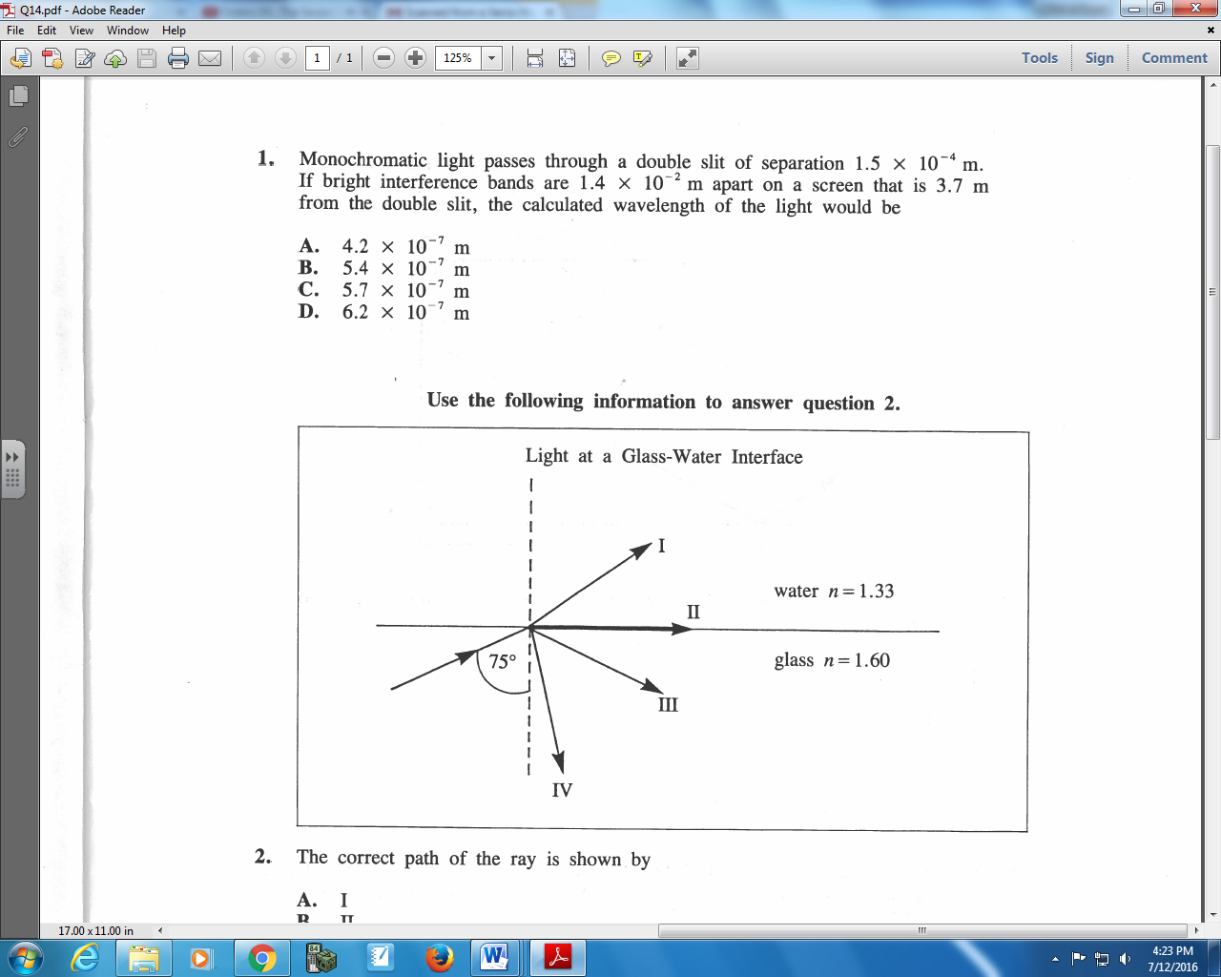

Q561: The correct path of the ray is shown by
- I
- II
- III
- IV
Diploma Questions – Refraction (Multiple Frequencies)
Use the following information to answer Q570:
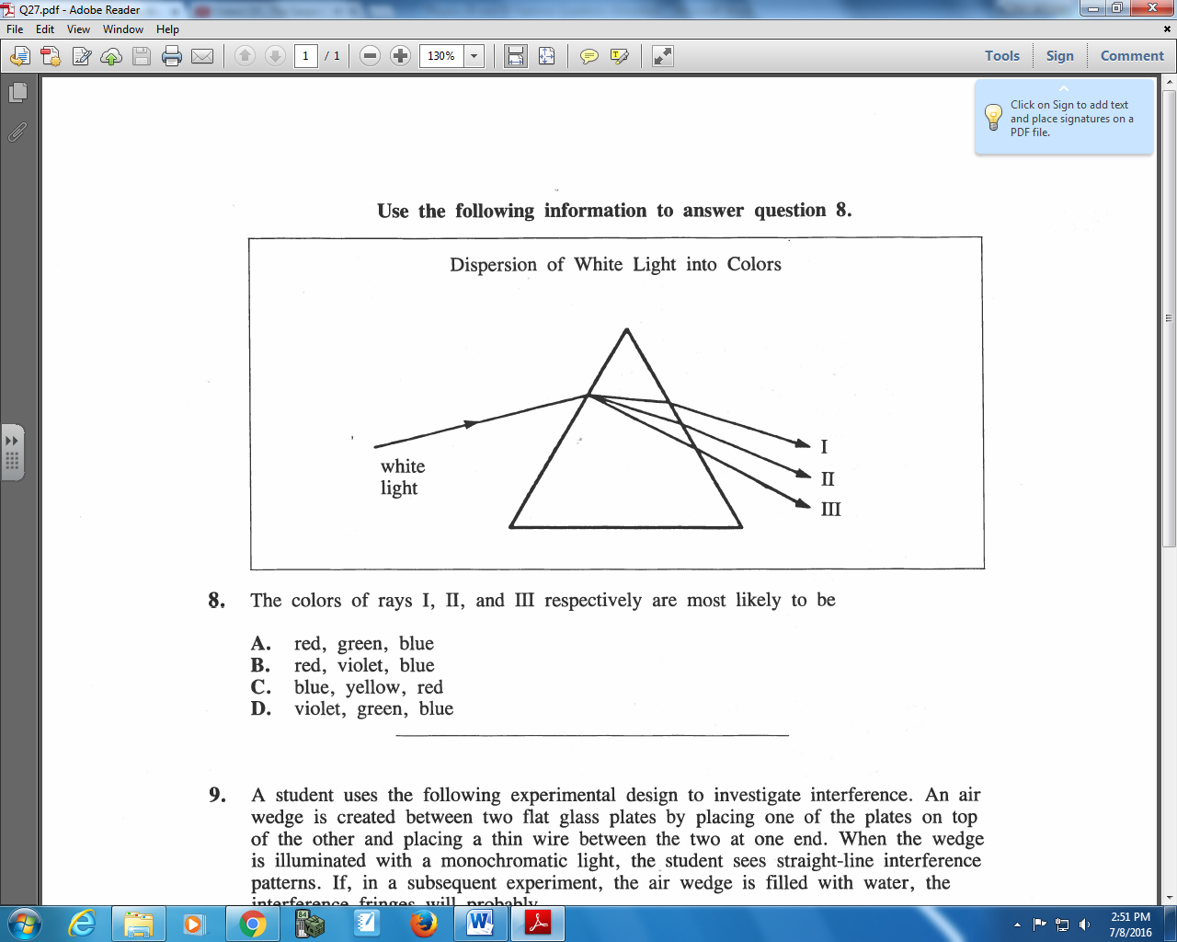

Q570: The colors of rays I, II, and III respectively are most likely to be
- Red, green, blue
- Red, violet, blue
- Blue, yellow, red
- Violet, green, blue
Use the following information to answer Q571:
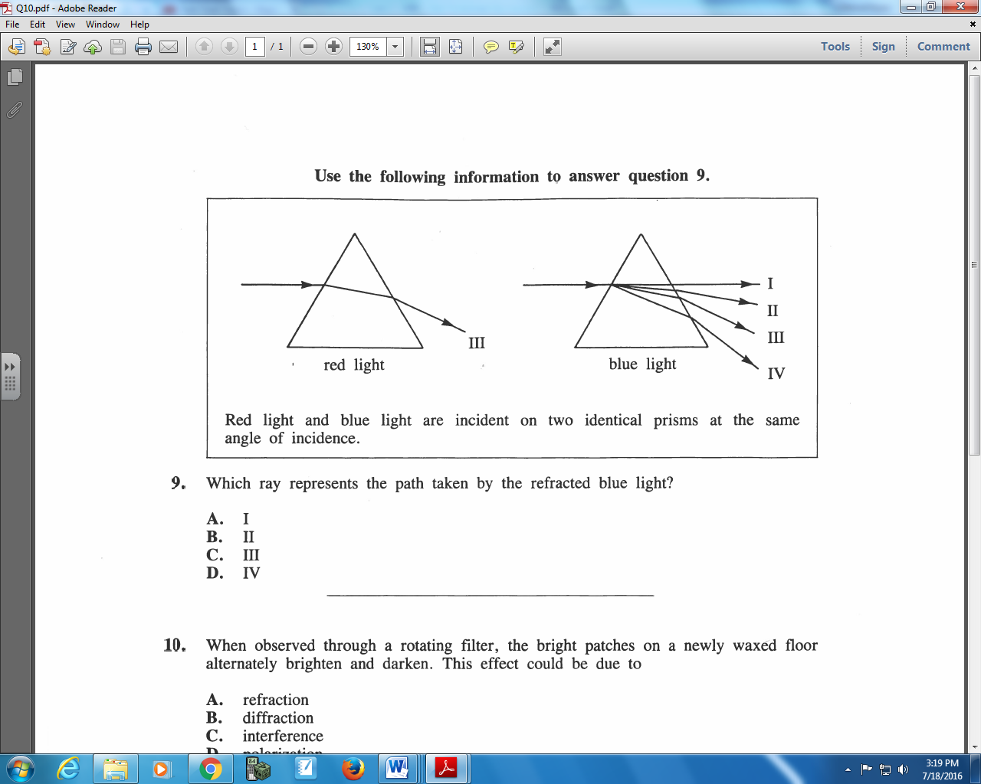

Q571: Which ray represents the path taken by the refracted blue light?
- I
- II
- III
- IV
Challenge Questions
Use the following information to answer Q1:
Light passes from air to a crystal with an unknown index of refraction.
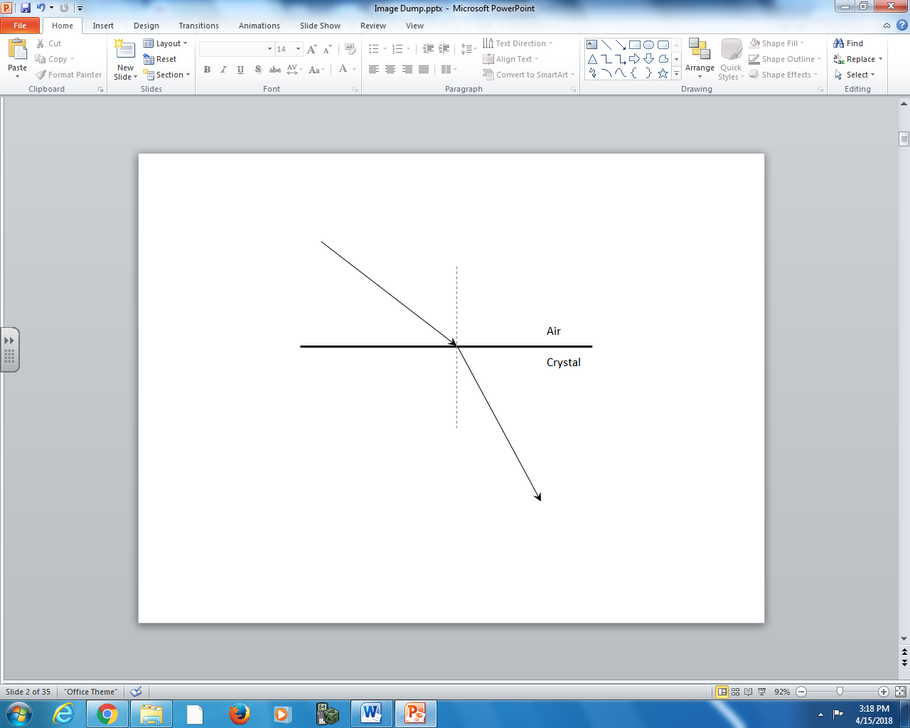
Note: The diagram is drawn to scale.

Q1: The index of refraction of the crystal is _____.
(Record your three-digit answer in the numerical response boxes below.)

