First Name:____________________________ Last Name:______________________________

L05 – Worksheet – Review of the Atomic Model

PART 1 – Progression of the Atomic Model
Use the following information to answer Q1:
Important Advancements in the Atomic Model
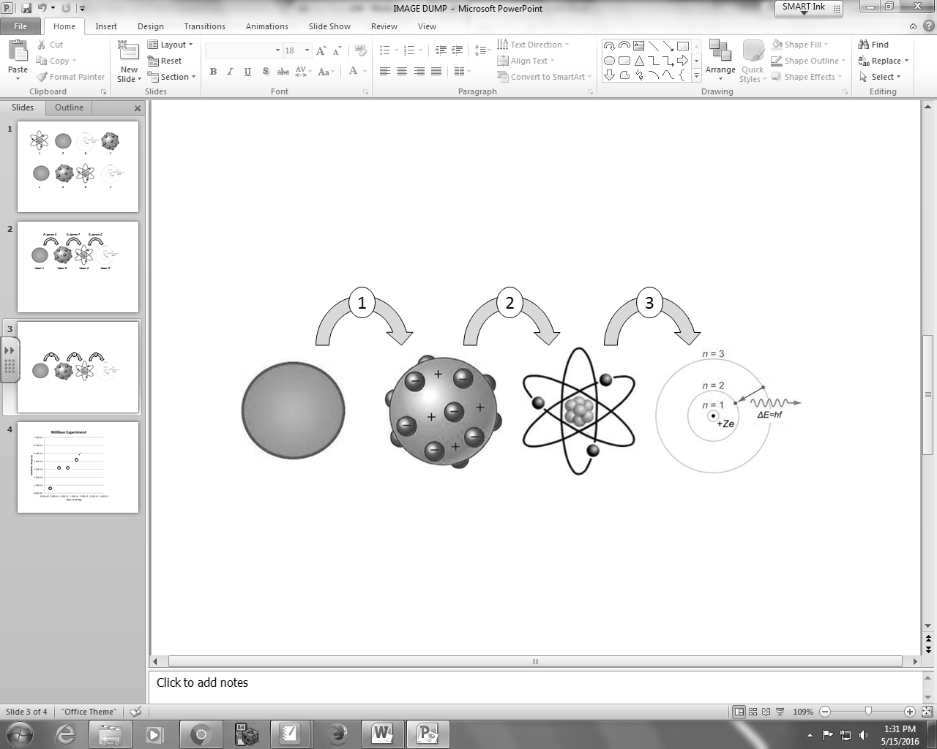

Q1: Four important experiments helped to advance the atomic model. For each experiment, assign it to the correct step, numbered 1 through 3 per the diagram above, where this experiment helped to progress the atomic model.

________ ________ ________ ________
Charge to Mass Emission Spectrums Millikan Rutherford
Ratio of Electrons of Heated Gasses Experiment Scattering
(Record your four digit answer in the Numerical Response boxes below)

Use the following information to answer Q2:
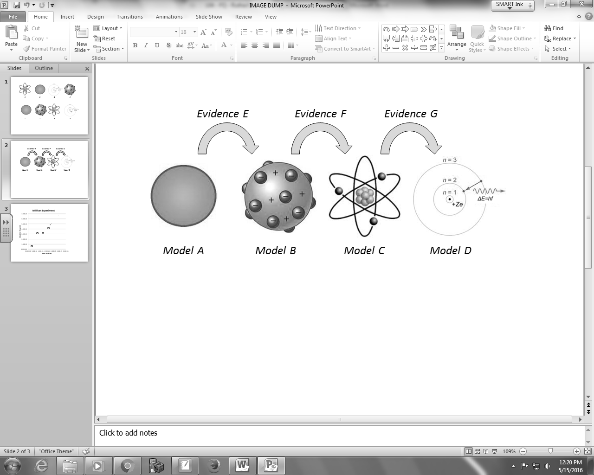
Common Names Credited to Evidence
1 – Billiard Ball 5 – Bohr 8 – Alpha particle scattering
2 – Bohr 6 – Rutherford 9 – Cathode ray experiments
3 – Planetary 7 – Thomson 0 – Emission Spectrums
4 – Plum Pudding

Q2: Using the numbers above, who are Model B through Model D credited to?
________ ________ ________
Model B Model C Model D
(Record your three digit answer in the Numerical Response boxes below)

Q3: Which model is credited with first acknowledging that the atom is mostly empty space?
- Bohr
- Dalton
- J.J. Thomson
- Rutherford
Q4: Which model was the first to incorporate the concept of electrons existing in energy levels?
- Bohr
- Dalton
- J.J. Thomson
- Rutherford

PART 2 – Mass Spectrometers
Use the following information to answer Q5 –Q7:
Mass Spectrometer
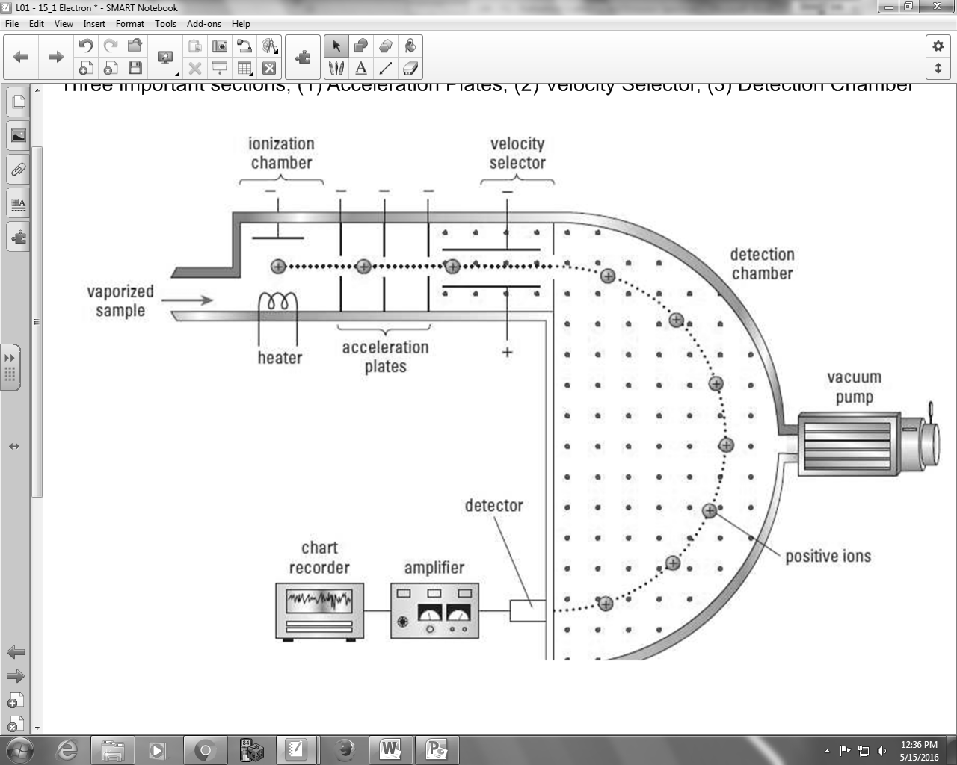

Q5: A subatomic particle makes it through the velocity selector undeflected. If the magnitude of the electric field is 2.00 x 10⁵ N/C, and the magnetic field is 0.36 T, then the speed of the unknown particle must be a.bc x 10^{d} m/s, where a, b, c, and d are ___, ___, ___, and ___.
(Record your four digit answer in the Numerical Response boxes below)

Q6: In the detection chamber, the particle is again subject to a 0.36 T magnetic field. If the radius of curvature of the particle is 1.61 cm, then the charge to mass ratio must be a.bc x 10^{d} C/kg, where a, b, c, and d are ___, ___, ___, and ___.
(Record your four digit answer in the Numerical Response boxes below)

Q7: The unknown particle is most likely
- An electron
- A proton
- An alpha particle (helium nucleus; 2p⁺, 2n⁰)
- A positron (same mass as an electron, but positive charge)

PART 3 – Millikan Experiment
Q8: The Millikan Experiment is credited with proving that
- cathode rays had mass
- cathode rays were negatively charged
- charge was quantized
- all electrons have the same charge-to-mass ratio

Q9: A Millikan-type experiment is conducted, where an oil drop of mass 1.13 x 10⁻¹⁴ kg is suspended in an electric field of 2.30 x 10⁴ N/C. How many excess electrons does the oil drop have?
- 4.82 x 10⁻¹⁸ electrons
- 4.82 x 10⁻¹⁵ electrons
- 3.00 x 10¹ electrons
- 3.01 x 10⁴ electrons

Q10: An oil drop with a mass of 7.20 x 10⁻¹⁶ kg moves upward at a constant speed of 2.50 m/s between two horizontal, parallel plates. If the electric field strength between these plates is 2.20 x 10⁴ V/m, the magnitude of the charge on the oil drop is a.b x 10^{-cd} C, where a, b, c, and d are ___, ___, ___, and ___.
(Record your four digit answer in the Numerical Response boxes below)

Use the following information to answer Q11:
Original Millikan Experiment Apparatus
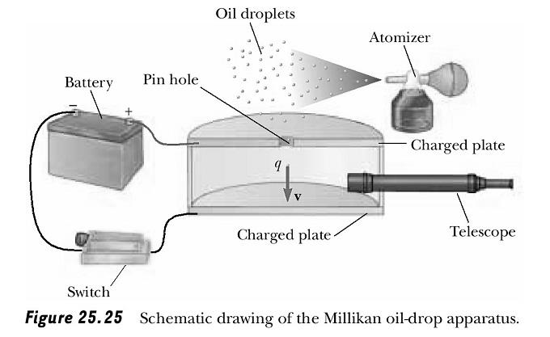

Q11: Using the Millikan Experiment Apparatus above, we can state that the x-rays ionized the __i__, causing electrons to attach to the __ii__, giving the oil drops a net __iii_ charge.
 | i | ii | iii
A. | Air | Oil | Positive
B. | Air | Oil | Negative
C. | Oil | Air | Positive
D. | Oil | Air | Negative

Which row best completes the above sentence?
- Row A.
- Row B.
- Row C.
- Row D.

PART 4 – Emission and Absorption Spectrum
Use the following information to answer Q12-14:
An In-Depth Understanding of Energy Level Diagrams
Energy level diagrams are a means of analyzing the energies electrons can accept and release as they transition from one accepted orbital to another. These energies differences correspond to the wavelengths of light in the discreet spectral lines emitted by an atom as it goes through de-excitation or by the wavelengths absorbed in an absorption spectrum.

Using the Bohr Model, the energy levels (in electron volts, eV) are calculated with the formula:

E_{n} = -13.6 (Z²/n²) eV

where Z is the atomic number and n is the energy level. The ground state is represented by n = 1, first excited state by n = 2, second excited state by n = 3, etc.

Using Bohr's formula, a hypothetical, doubly-ionized atom¹ with Z = 3 could have the following energy level diagram.

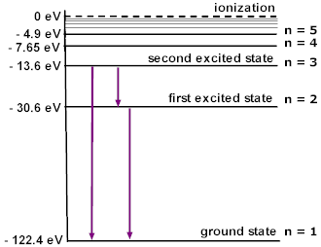
Notice how each energy level closer and closer to the nucleus is more and more negative. This signifies that the electron is trapped in an “energy well.” To ionize a ground-state electron (to take it from -122.4 eV to 0 eV in our example), you would have to irradiate the gas with photons having energies of 122.4 eV or greater. This is the ONLY instance where the incident energy does not have to EXACTLY match the different in two energy levels. Any excess energy would remain in the form of the ionized electron’s kinetic energy.
¹Doubly-ionized simply means that it has lost two electrons. So this atom (Z=3; Lithium) has 3p⁺ and 1e⁻.

Q12: As an electron transitions from the second excited state (n=3) to the ground state (n=1), the wavelength of the photon emitted is a.bc x 10^{-d} m, where a, b, c, and d are ___, ___, ___, and ___.
(Record your four digit answer in the Numerical Response boxes below)

Q13: Is the emitted photon from Q12 visible to the human eye? Explain.__________________________
_______________________________________________________________________________________________________________________________________________________________________________________________________________________________________________________________

Q14: If a single electron existed in the ground state, which frequency of photon would not transition the electron to an excited state?
- 2.22 x 10¹⁶ Hz
- 2.51 x 10¹⁶ Hz
- 2.77 x 10¹⁶ Hz
- 2.84 x 10¹⁶ Hz

Use the following information to answer Q15 and Q16:
Hydrogen Atom Energy Level Diagram
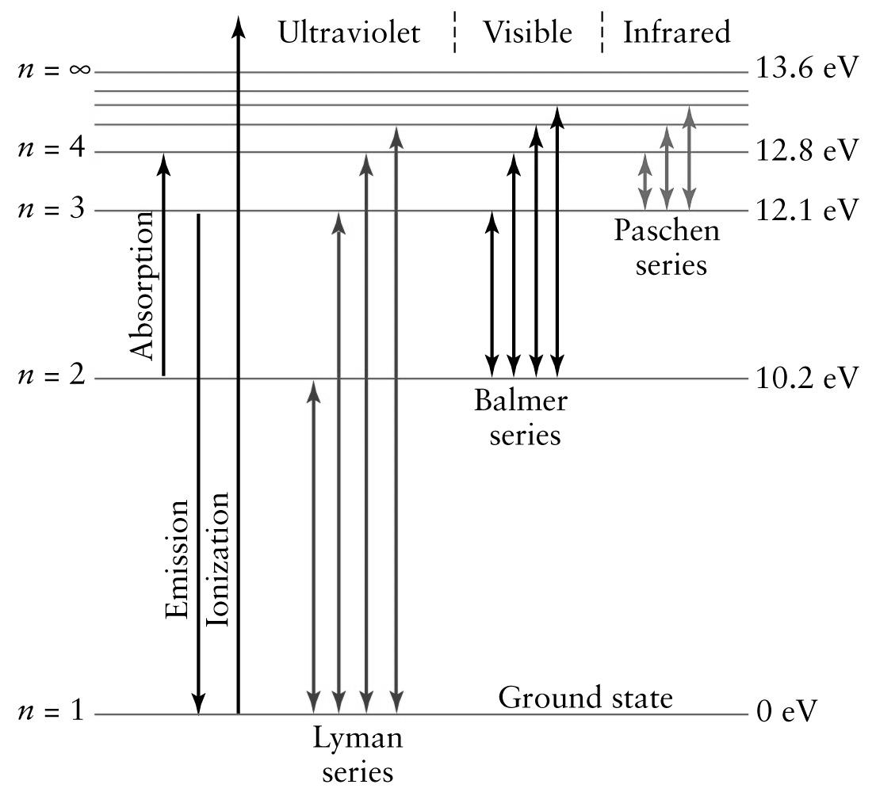

Q15: To ionize a hydrogen atom, an electron in the ground state must absorb a photon of
- E = 13.6 eV
- E ≤ 13.6 eV
- E ≥ 13.6 eV
- E ≠ 13.6 eV

Q16: To bring an electron from the ground state to the first excited state, the electron must absorb a photon of
- E = 10.2 eV
- E ≤ 10.2 eV
- E ≥ 10.2 eV
- E ≠ 10.2 eV

