First Name:______________________________ Last Name:______________________________

L05&06 – Worksheet – Electric Fields

Textbook Questions
Pg 548 #1: An ion with a charge of 1.60 x 10⁻¹⁹ C is placed in an electric field produced by another larger charge. If the magnitude of the field at this position is 1.00 x 10³ N/C, calculate the magnitude of the electrostatic force on the ion.

Pg 548 #2: The magnitude of the electrostatic force on a small charged sphere is 3.42 x 10⁻¹⁸ N when the sphere is at a position where the magnitude of the electric field due to another larger charge is 5.34 N/C. What is the magnitude of the charge on the small charged sphere?

Pg 549 #1: The electric field at a position 2.00 cm from a charge is 40.0 N/C directed away from the charge. Determine the charge producing the electric field.

Pg 549 #2: An electron has a charge of -1.60 x 10⁻¹⁹C. At what distance from the electron would the magnitude of the electric field be 5.14 x 10¹¹ N/C?

Pg 550 #1: Calculate the net electric field at a point 2.10 x 10⁻² m to the left of the 1.50 x 10⁻⁶ C charge in the figure below.
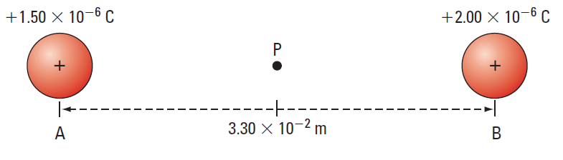

Pg 550 #2: An electron an a proton are 5.29 x 10⁻¹¹ m apart in a hydrogen atom. Determine the net electric field at a point midway between the two charges.

Pg 553 #7ab: Given a small sphere with a positive charge of 4.50 x 10⁻⁶ C, determine
- The magnitude and direction of the electric field at a point 0.300 m to the right of the charge.
- The magnitude and direction of the electric force acting on a positive charge of 2.00 x 10⁻⁸ C placed at the point in (a).

Pg 553 #8: A small test sphere with a negative charge of 2.50 μC experiences an electrostatic attractive force of magnitude 5.10 x 10⁻² N when it is placed at a point 0.0400 m from another larger charged sphere. Calculate
- The magnitude and direction of the electric field at this point.
- The magnitude and the sign of charge on the larger charged sphere.

Pg 553 #9a: A negative charge of 3.00 mC is 1.20 m to the right of another negative charge of 2.00 mC. Calculate
- The net electric field at a point along the same line and midway between the two charges.

Pg 553 #10: Four similarly charged spheres of -5.00 μC are placed at the corners of a square with sides of 1.20 m. Determine the electric field at the point of intersection of the two diagonals of the square.

Diploma Worksheet Questions – Electric Fields (Basic Definitions)
Q143: If a positively charged test body is placed in an electric field that is directed downward, the direction of the force on the test body is
- Up
- Down
- Left
- Right
Q145: The direction assigned to an electric field vector is the same direction of the force exerted by the field on a
- Positive test charge
- Negative test charge
- Flow of positive charge
- Flow of negative charge
Q147: The direction of the electric field near a positively-charged particle is
- Counter-clockwise around the charge
- Clockwise around the charge
- Inward toward the particle
- Outward from the particle
Q148: A unit for electric field strength is
- V
- N/C
- J/C
- N/(C*m)
Diploma Worksheet Questions – Electric Fields (Diagrams)
Q153: Which diagram would represent the electric field surrounding a positive charge?
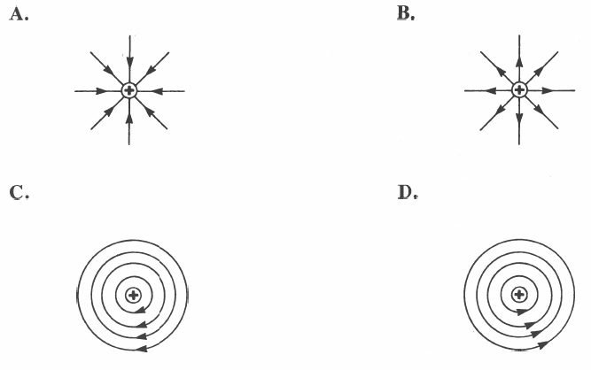
Q153: The diagram that best represents the electric field around two oppositely charged spheres is
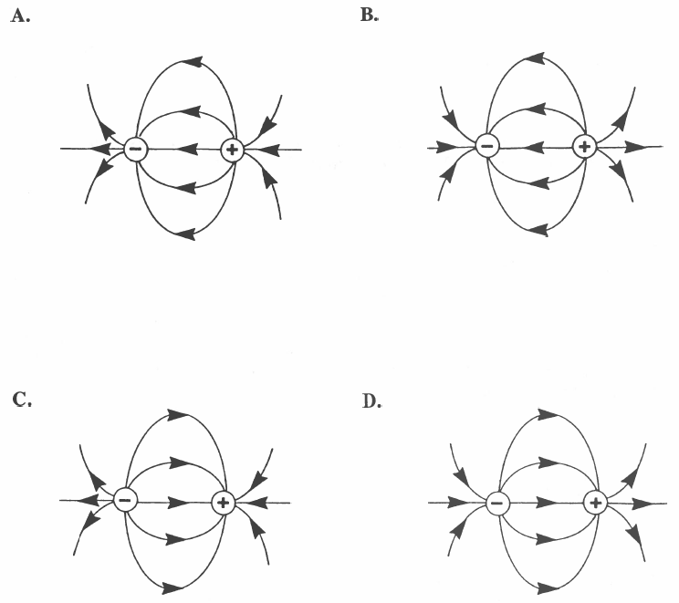

Use the following information to answer Q157:
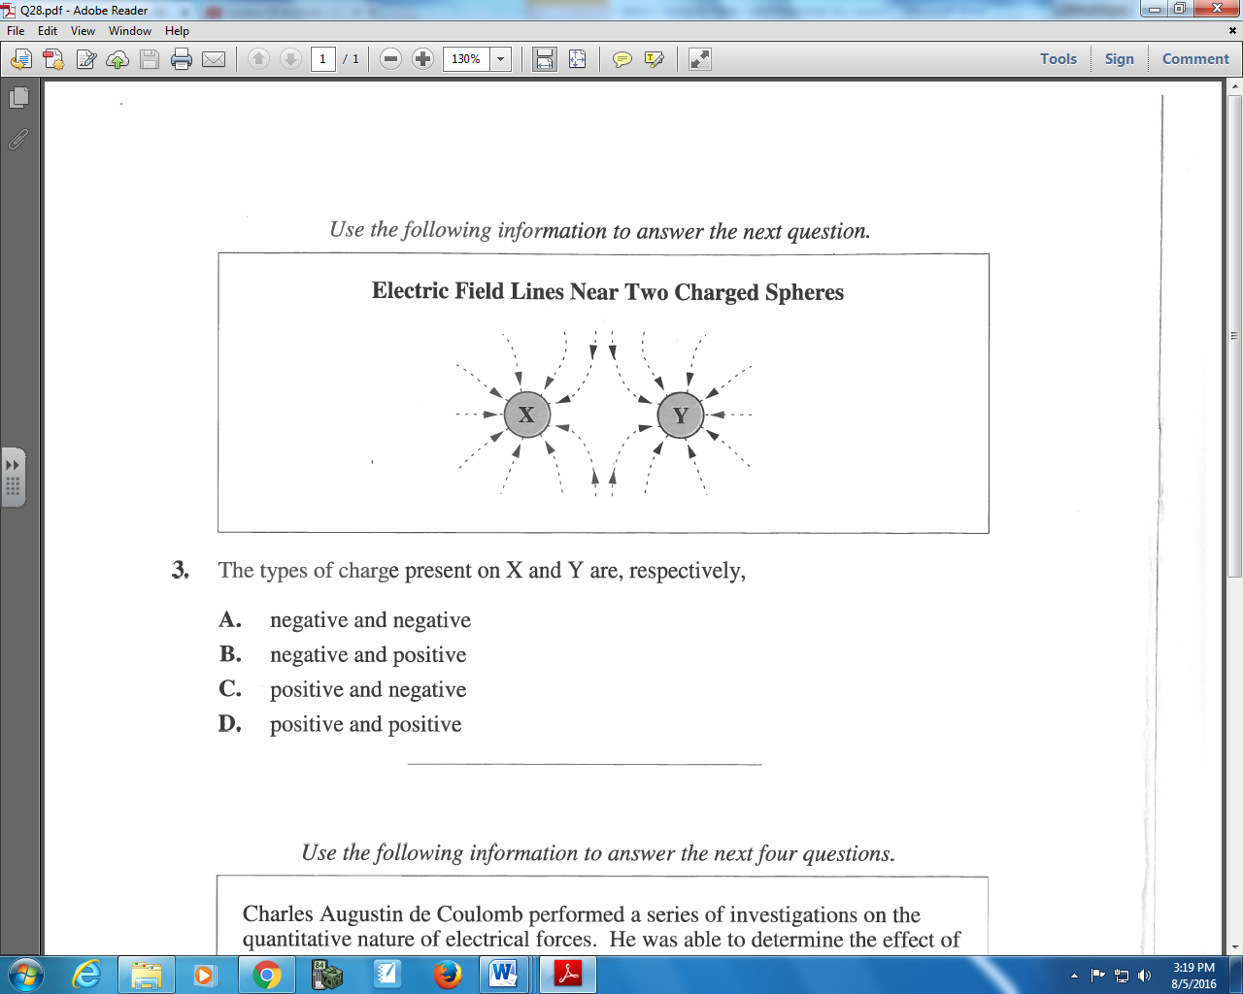

Q157: The types of charge present on X and Y are, respectively,
- Negative and negative
- Negative and positive
- Positive and negative
- Positive and positive

Diploma Worksheet Questions – Electric Fields (in 1-Dimension)
Q159: A 4.0 x 10⁻⁶ C charge with a mass of 3.0 g experiences a force of 8.0 N while under the influence of an electric field. What is the intensity of the electric field (assuming there are negligible gravitational forces)?
- 2.0 x 10⁶ N/C
- 4.8 x 10⁶ N/C
- 6.0 x 10⁶ N/C
- 1.6 x 10⁷ N/C

Q160: Two charged objects, each with a mass of 2.0 x 10⁻⁹ kg, accelerate in an electric field with a strength of 4.0 x 10⁶ N/C. If the acceleration of one object is -3.2 x 10⁻³ m/s² and the acceleration of the other object is -1.92 x 10⁻³ m/s², the charges differ by
- 8e
- 6e
- 4e
- 2e

Q166: A point charge of magnitude 6.9 x 10⁻⁵ C produces an electric field of 1.0 x 10³ N/C at point P. The distance from P to the charge is
- 4.3 x 10⁻² m
- 2.1 x 10⁻¹ m
- 2.5 x 10¹ m
- 6.2 x 10² m

Q168: The magnitude of an electric field at a distance x from a point charge Q is 8.3 x 10⁻⁴ N/C. If the distance is increased to 3x and the charge is reduced to Q/4, then the magnitude of the electric field will be
- 1.9 x 10⁻³ N/C
- 3.7 x 10⁻⁴ N/C
- 6.9 x 10⁻⁵ N/C
- 2.3 x 10⁻⁵ N/C

Diploma Worksheet Questions – Electric Fields (in 2-DImensions)
Use the following information to answer Q169:
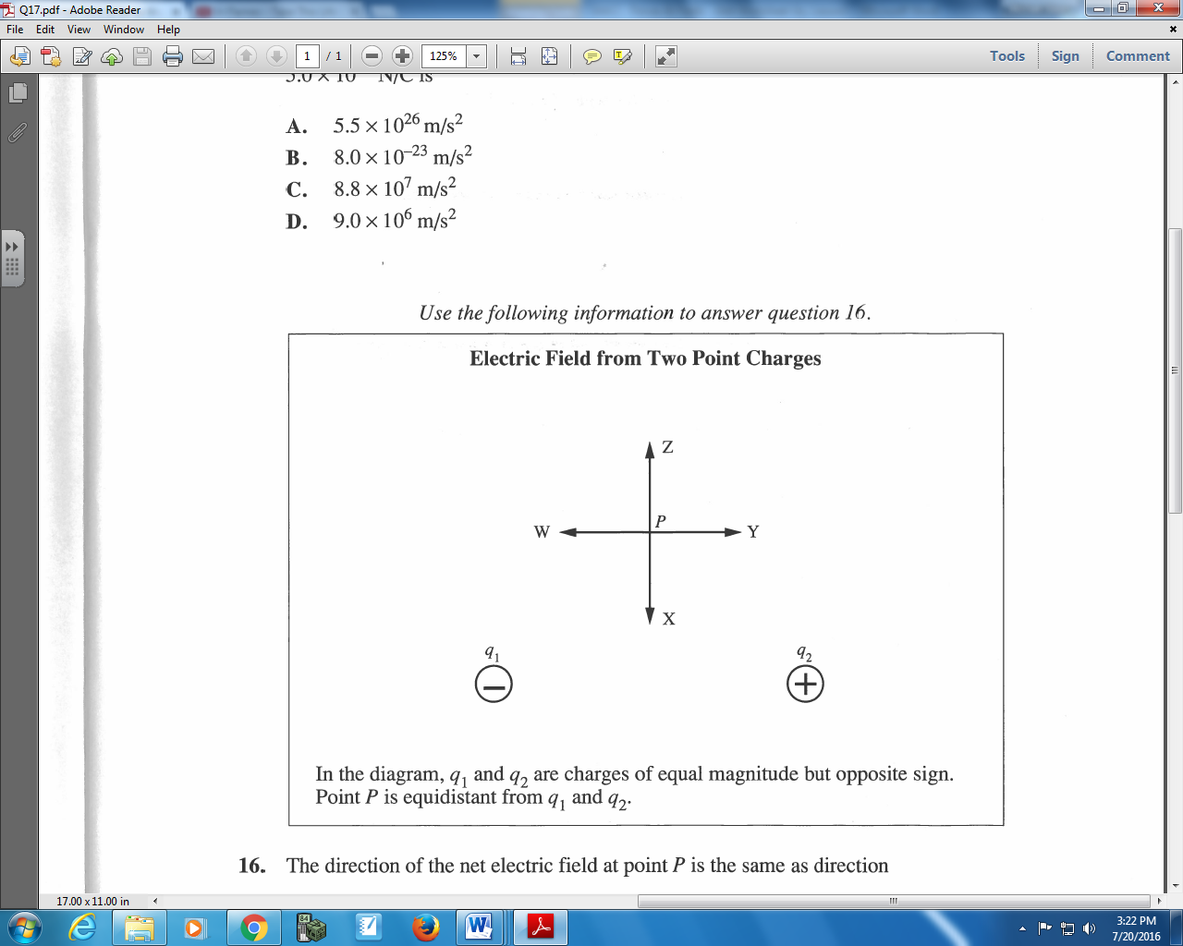

Q170: The direction of the net electric field at point P is the same as direction
- W
- X
- Y
- Z

Use the following information to answer Q173 – Q174:
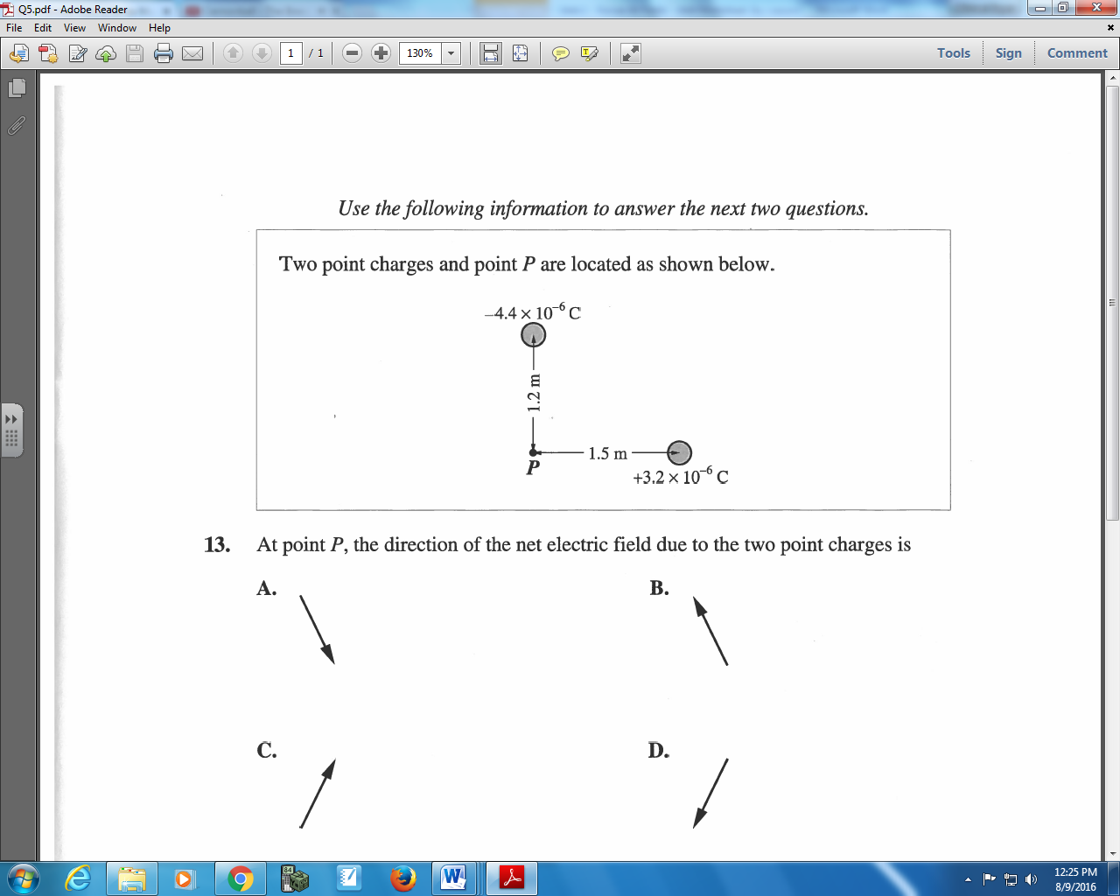

Q173: At point P, the direction of the net electric field due to the two point charges is

Q174: At point P, the magnitude of the net electric field due to the two point charges is
- 1.5 x 10⁴ N/C
- 3.0 x 10⁴ N/C
- 4.0 x 10⁴ N/C
- 5.2 x 10⁴ N/C

Diploma Worksheet Questions – Electric Fields (Graphing)
Q175: Which graph represents the electric field strength $\left|\vec{E}\right|$ as a function of the distance r from a point charge?
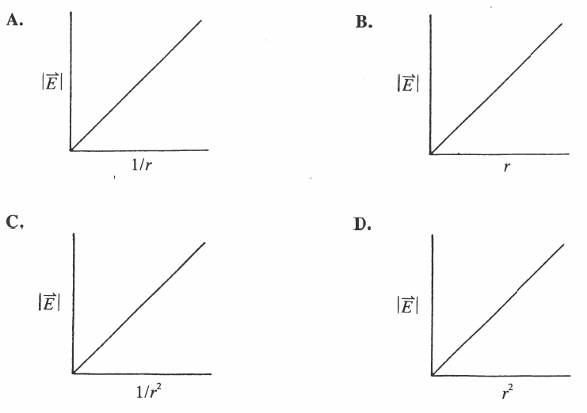
Use the following information to answer Q177:
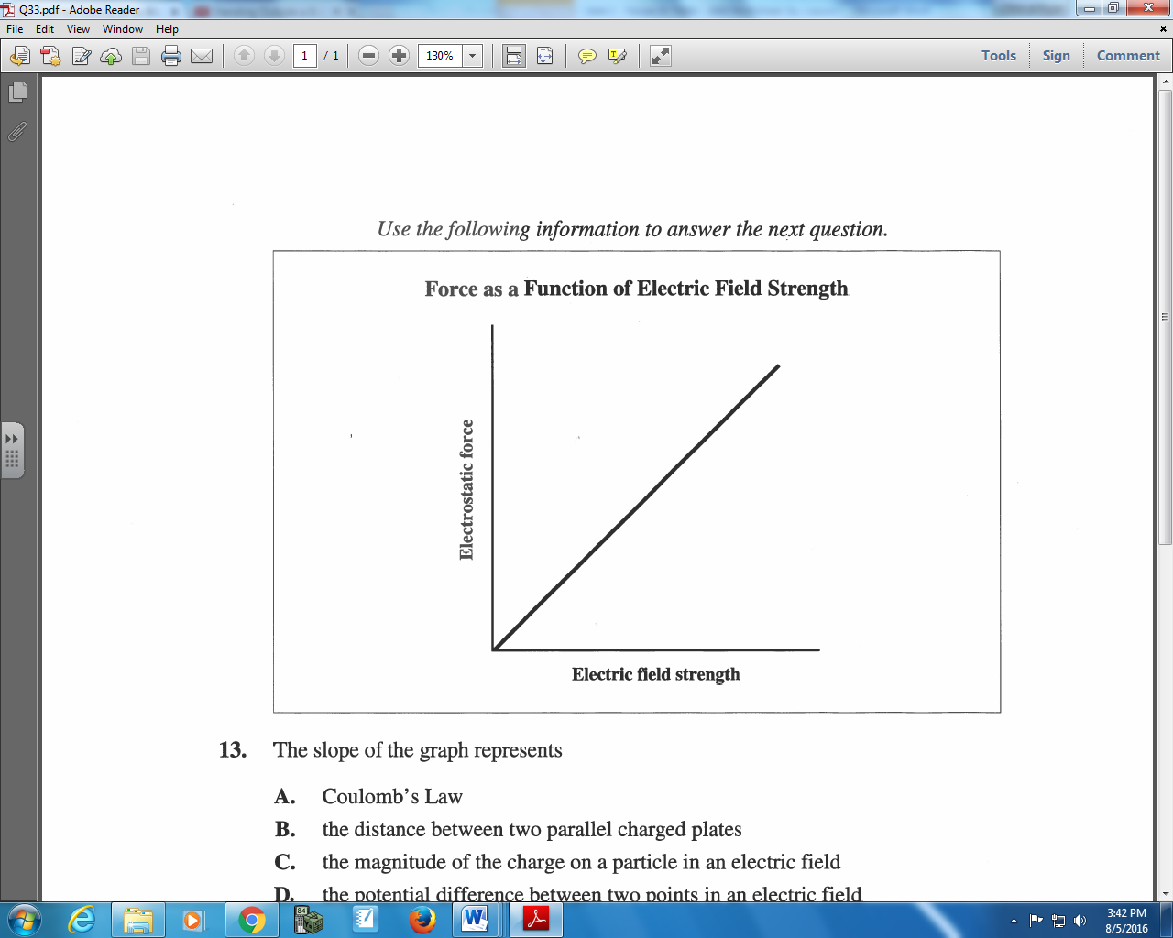

Q177: The slope of the graph represents
- Coulomb’s Law
- The distance between two parallel charged plates
- The magnitude of the charge on a particle in an electric field
- The potential difference between two points in an electric field
Challenge Questions
Pg 551 #1: Calculate the net electric field at point P, which is 0.100 m from two similar spheres with positive charges of 2.00 C and separated by a distance of 0.0600 m, as shown in the figure below.
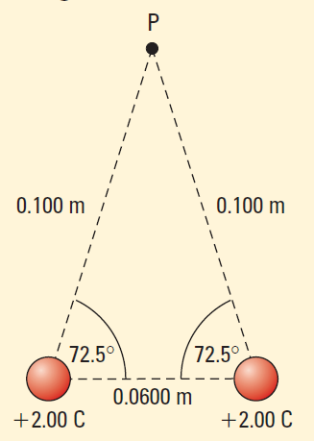

Use the following information to answer Q1:
The strength of an electric field is measured at various distances from a negatively charged sphere, and graphed below.
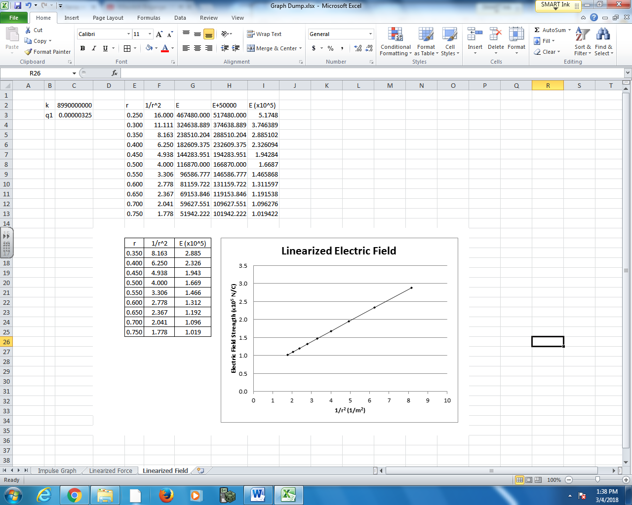

Q1: The negatively charged sphere has a charge of a.bc x 10^{-d} C, where a, b, c, and d are ___, ___, ___, and ___.
(Record your four digit answer in the Numerical Response boxes below)

Use the following information to answer Q2-Q5:
Two positively charged spheres are held 1.00m apart. Once released, both charges electrostatically repel from each other, per the diagram below.
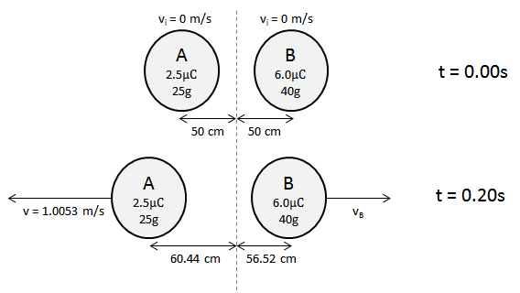

Q2: The instantaneous acceleration of Object A, the moment it is released, is
- 5.39 x 10⁻³ m/s²
- 2.16 x 10⁻² m/s²
- 5.39 m/s²
- 2.16 x 10¹ m/s²

Q3: What is the impulse experienced by Object A within the first 0.20 seconds?
- 2.35 x 10⁻² Ns
- 2.51 x 10⁻² Ns
- 2.70 x 10⁻² Ns
- 2.87 x 10⁻² Ns

Q4: What is the speed of Object B at exactly 0.20 seconds is a.bc x 10^{-d} m/s, where a, b, c, and d are ___, ___, ___, and ___.
(Record your four digit answer in the Numerical Response boxes below)

Q5: The electrostatic force between Object A and Object B, measured at exactly 0.20s, is a.bc x 10^{-d} N, where a, b, c, and d are ___, ___, ___, and ___.
(Record your four digit answer in the Numerical Response boxes below)

