First Name:____________________________ Last Name:______________________________
L06 – Formative Quiz – Assorted Questions
Use the following information to answer Q1-6:
Ionization-Chamber-Based Smoke Detectors
For more than 25 years, Canadians have used ionization-chamber-based smoke detectors to warn them of possible fires in their homes. Most of these detectors use a small quantity (approximately 0.25 µg) of americium-241 (²⁴¹Am) in the form of americium dioxide (AmO₂). This small quantity of ²⁴¹Am corresponds to 30 kilobecquerels (kBq) of radioactive material, which has a half-life of 432.27 years. The alpha radiation emitted by the ²⁴¹Am ionizes oxygen and nitrogen in the air in the sensing chamber. The electric potential from a battery causes a small current to flow. Smoke particles (or aerosols, or mists from the bathroom shower) that enter the chamber absorb alpha particles. This reduces the ionization of the air, and hence reduces the electric current in the chamber. The reduction in the current is detected by an electronic circuit and the alarm is triggered.
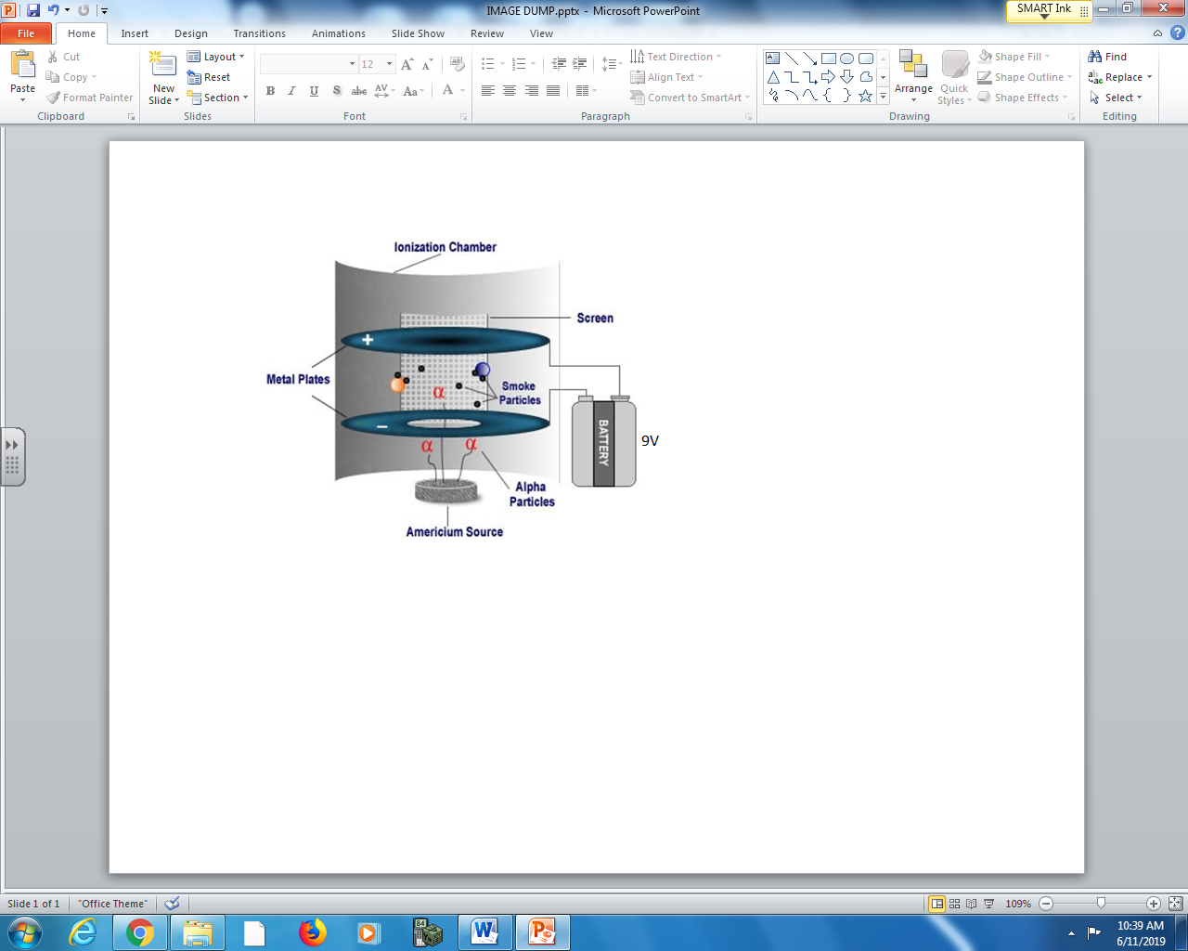

Q1: If a smoke detector is 10 years old, then it experiences a.bc x 10^{d} nuclear decays per second, where the values of a, b, c, and d are ___, ___, ___, and ___.
(Record your four digit answer in the Numerical Response boxes below)

Q2: When an oxygen atom in the air is ionized, the free electron will be attracted to the positive metal plate. The maximum speed an electron may strike this plate is a.bc x 10^{d} m/s, where a, b, c, and d are ___, ___, ___, and ___.
(Record your four digit answer in the Numerical Response boxes below)

Use the following additional information to answer Q3-4:
Americium-241 decays mainly via alpha decay, with a weak gamma ray byproduct. The alpha decay is shown as follows:
$${}_{95}^{241}{Am}→{}_{93}^{237}{Np}+{}_{2}^{4}{α+γ59.5409keV}$$
The atomic mass of Am-241 is 241.056829120u, the atomic mass of Np-237 is 237.048173420u, and the atomic mass of the alpha particle is 4.001506179u.

Q3: When a single stationary Americium-241 nucleus decays, a photon of 59.5409 keV is emitted, and the remaining objects gain how much kinetic energy?
- 6.62 MeV
- 6.68 MeV
- 6.74 MeV
- 6.80 MeV

Q4: If the daughter nucleus recoils backward at a speed of 2.989x10⁵ m/s, then the emitted alpha particle has a speed of a.bc x 10^{d} m/s, where a, b, c, and d are ___, ___, ___, and ___.
(Record your four digit answer in the Numerical Response boxes below)

Use the following additional information to answer Q5-6:
A very small percentage of the time (~7.4x10⁻¹² %), Americium-241 undergoes Cluster Decay, also named heavy particle radioactivity or heavy ion radioactivity, which is a type of nuclear decay in which an atomic nucleus emits a small "cluster" of neutrons and protons, more than in an alpha particle, but less than a typical binary fission fragment.
Americium-241 undergoes the following cluster decay:
$${}_{95}^{241}{Am→{}_{81}^{207}{Tl}}+{}_{cd}^{ab}X$$

Q5: In the above reaction, the values of a,b, c, and d are ___, ___, ___, and ___.
(Record your four digit answer in the Numerical Response boxes below)

Q6: In order to determine the daughter nucleus, we use Physics Principle ___ to determine the values of ab, and Physics Principle ___ to determine the values of cd.
(Record your two digit answer in the Numerical Response boxes below)

Use the following information to answer Q7-Q10:
Photoelectric Smoke Detectors
A photoelectric smoke detector is characterized by its use of light to detect fire. Inside the alarm, there’s a light-sensing chamber. In this chamber, a 200mW LED light shoots a beam of near-infrared light (900nm) in a straight line across the chamber. The alarm detects smoke; when smoke enters the chamber, it deflects the LED light from the straight path into an Indium Gallium Arsenide (GaInAs) photosensor in a different compartment in the same chamber. Indium Gallium Arsenide is used specifically because of its low Work Function of 0.75eV. As soon as light beams hit this sensor, a current is generated and the alarm begins to sound.
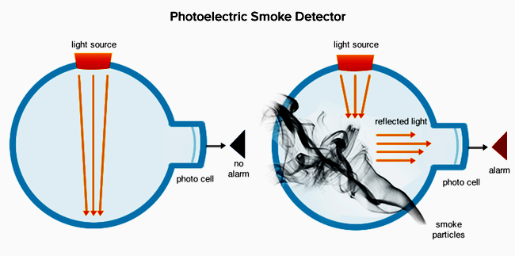

Text

Q7: The energy of a single near-infrared photon is ____eV.
(Record your three digit answer in the Numerical Response boxes below)

Q8: The threshold frequency of the Indium Gallium Arsenide photosensor is a.b x 10^{cd} Hz, where a, b, c, and d are ___, ___, ___, and ___.
(Record your four digit answer in the Numerical Response boxes below)

Q9: The speed of the photoelectrons generated at the photosensor is a.bc x 10^{d} m/s, where a, b, c, and d are ___, ___, ___, and ___.
(Record your four digit answer in the Numerical Response boxes below)

Q10: Assuming that 20% of the photons emitted by the LED are deflected by the smoke, the current generated at the photosensor is ____mA.
(Record your three digit answer in the Numerical Response boxes below)

Marking:
Beginning 0-4
Progressing 5-7
Competent 8-9
Exemplary 10

