First Name:_____________________________ Last Name:______________________________

L06 - FQ – Elastic Potential Energy

Q1: In preparing to shoot an arrow, an archer pulls a bowstring back 0.51 m by exerting a force that increases uniformly from 0 to 215 N. What is the equivalent spring constant of the bow?
- 110 N/m
- 211 N/m
- 422 N/m
- 1653 N/m

Use the following information to answer Q2-Q3:
An archer pulls their bowstring, which has a spring constant of 350 N/m, back a distance of 0.46 m.

Q2: How much potential energy is stored in that bowstring?
- 3.70 x 10¹ J
- 7.41 x 10¹ J
- 8.05 x 10¹ J
- 1.61 x 10² J

Q3: If the arrow has a mass of 25.0 grams, and all the elastic potential energy of the system was successfully transferred into the arrow, then the arrow is released with an initial speed of a.bc x 10^{d} m/s, where a, b, c, and d are ___, ___, ___, and ___.
(Record your four-digit answer in the Numerical Response boxes below)

Use the following information to answer Q4-Q5:
Force to Stretch a Spring
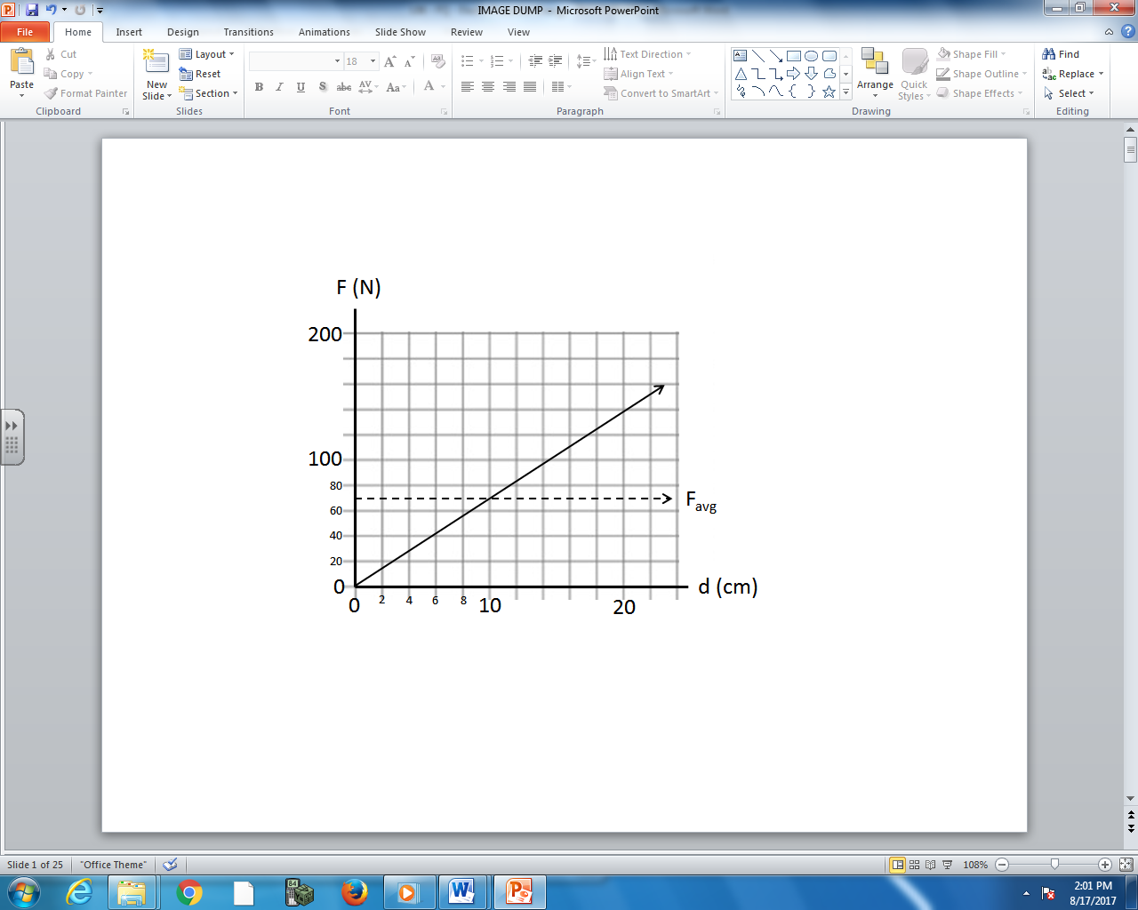

Q4: When the spring is stretched 20cm from equilibrium there is a.bc x 10^{d} Joules of energy stored in the spring, where a, b, c, and d are ___, ___, ___, and ___.
(Record your four-digit answer in the Numerical Response boxes below)

Q5: How much force is required to stretch the spring to a distance of 45 cm? (2 marks)

MARKING:
Beginning 0 - 2.5
Progressing 3 - 4
Competent 4.5 - 5
Exemplary 5.5 - 6

