First Name:____________________________ Last Name:______________________________

L06 – FQ – Electric Fields

Use the following information to answer Q1-Q5:
Two Point Charges
Two point charges are arranged at a right angle according to the diagram below.
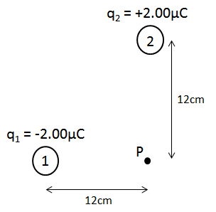
Directions
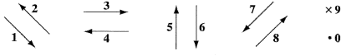

Q1: Use the vector directions above to fill in the blanks below.

Direction: __________ __________ __________
Description: Direction of Direction of Direction of
E-Field at Point P E-Field at Point P net E-Field at
due to Charge 1 due to Charge 2 Point P

(Record your three-digit answer in the Numerical Response boxes below)

Q2: The magnitude of the electric field at Point P due to Charge 1 is a.bc x 10^{d} C, where a, b, c, and d are ___, ___, ___, and ___.
(Record your four-digit answer in the Numerical Response boxes below)

Q3: The magnitude of the net electric field at Point P a.bc x 10^{d} C, where a, b, c, and d are ___, ___, ___, and ___.
(Record your four-digit answer in the Numerical Response boxes below)

Use the following additional information to answer Q4-Q5:
Charge C has a charge of -2.5μC, and is placed at Point P.

Q4: Charge C will accelerate at an angle of ____ degrees, measured in Polar Coordinates.
(Record your three-digit answer in the Numerical Response boxes below)

Q5: The magnitude of the electrostatic force acting on Charge C is ______ N.
(Record your three-digit answer in the Numerical Response boxes below)

MARKING:
Beginning 0.0 – 2.0
Progressing 2.5 – 3.5
Competent 4.0 – 4.5
Exemplary 5.0

