First Name:___________________________ Last Name:______________________________

L06 - FQ – Refraction

Use the following information to answer Q1 and Q2.
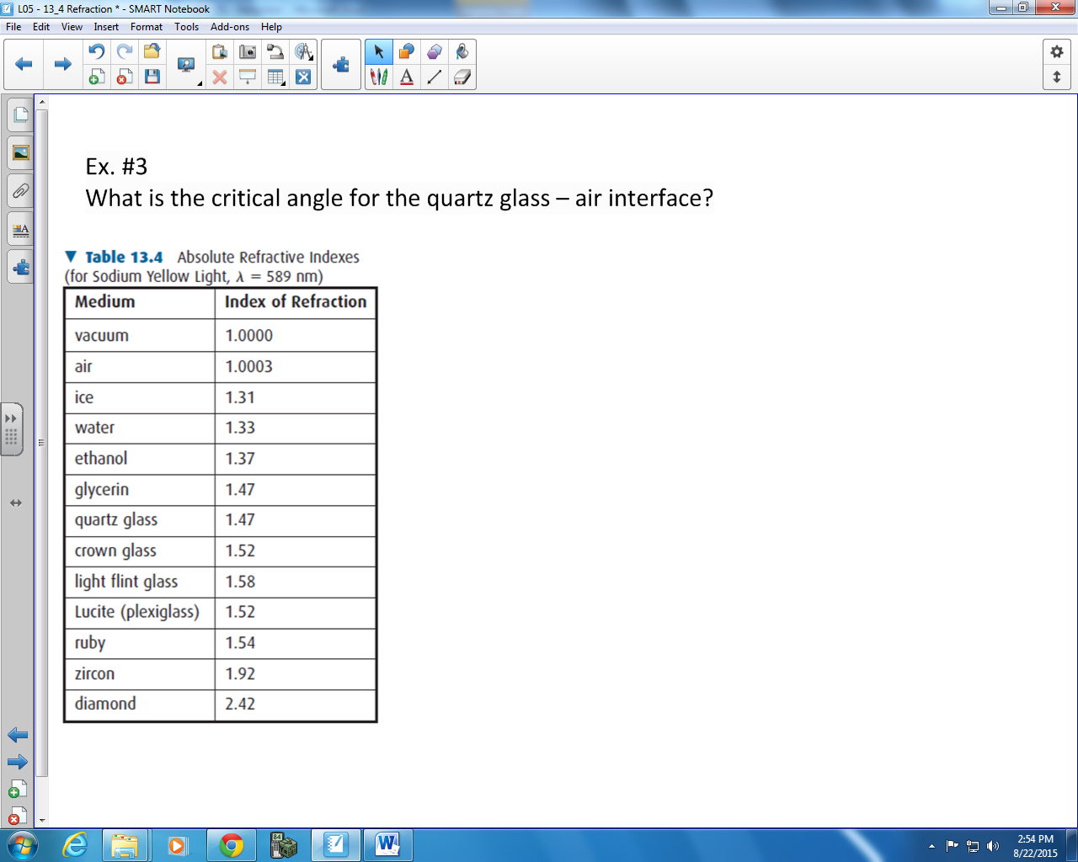

Q1: Light travels fastest in which of the following mediums?
- Ruby
- Ice
- Light Flint Glass
- Glycerin
Q2: Light of wavelength 588nm in air is incident on ethanol at an angle of 38º. Upon entering the ethanol, what is the new wavelength, to the nearest nanometer?
(Record your three-digit answer in the numerical response boxes below.)

Use the following information to answer Q3.

Q3: What is the critical angle necessary for total internal reflection at a crown glass and diamond interface?
(Record your three-digit answer in the numerical response boxes below.)

MARKING:
Beginning 0
Progressing 1
Competent 2
Exemplary 3

