Lab Partner #1:__________________________ Lab Partner #2:__________________________
L06 – Lab – Static Friction Lab /24 marks
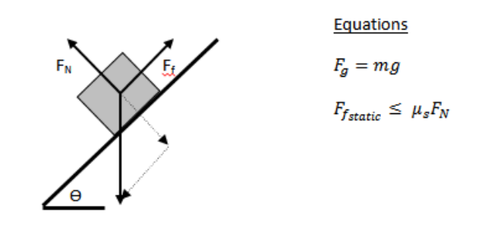
Today’s lab is an investigation into Static Friction. We will be using one (1) object supplied by the students and an incline ramp to calculate the coefficient of static friction (µs) between the two surfaces, and looking in depth at the relationship between angle of inclination (Ѳ) and the magnitude of the static friction.
Initiating and Planning
The first part of this lab requires you to calculate the coefficient of static friction. Detail below your procedure and material list for accomplishing this task.
Material list:
Procedure for calculating coefficient of static friction:

 | Marks | Weighting Multiplier | 3 | 2 | 1 | 0
Evaluate and select appropriate procedures and instruments for collecting evidence and information, including appropriate sampling procedures. |  | x1 | Student has included a detailed procedure and complete materials list. | Student has neglected minor steps or equipment, or has included an incorrect step in their procedure. | Student did not include important procedural steps or critical pieces of equipment necessary for the completion of the lab. | Not included in write-up.

Performing and Recording
Use the space below to record all of your values and identify your controlled, manipulated, and responding variables:
Mass of object (kg):
Object:
Angle of inclination of time of slip:

Responding Variables:
Manipulated Variables:
Controlled Variables:

 | Marks | Weighting Multiplier | 3 | 2 | 1 | 0
Carry out procedures, controlling the major variables, and adapt or extend procedures if needed. |  | x1 | Student was able to correctly identify (1) controlled variables, (2) manipulated variables, and (3) responding variables. | Student was able to correctly categorize 2 of the 3 types of variables. | Student was able to correctly categorize 1 of the 3 types of variables. | Not included in write-up.
Organize and integrate data, using a format that is appropriate to the task or experiment. |  | x1 | Student has chosen a clear method of recording and presenting their data.  Object, mass of object, and angle of inclination at time of slip are clearly labelled and easily found by the teacher. | Student has provided evidence of complete data collection.  Object, mass of object, and angle of inclination at time of slip are present, but not clearly labelled or easily found. | Student's data is vague or misses the main purpose of the experiment. | Not included in write-up.
Analyze and Interpret
Use the space below to calculate the coefficient of static friction for your objects:
Calculations for Coefficient of Static Friction

 | Marks | Weighting Multiplier | 3 | 2 | 1 | 0
Interpret patterns and trends in data, and infer and calculate linear and nonlinear relationships among the variables. |  | x2 | Student is able to use prerequisite knowledge to make correct and complete inferences in regards to their data. | Student is able to make correct, but incomplete, inferences in regards to their data | Student's inferences are vague or incorrect. | Not included in write-up.
Identify and explain your sources of error, and describe their impact on your final calculation.
Impact on Accuracy:
Major Sources of Error:

Impact on Accuracy:
Minor Sources of Error:

 | Marks | Weighting Multiplier | 3 | 2 | 1 | 0
Identify and explain sources of error; and evaluate the relevance, reliability and adequacy of data and data collection methods. |  | x1 | Student is able to identify and categorize sources of error as either major or minor sources, and state their impact on accuracy. | Student is able to identify major sources of error only, and state their impact on accuracy. | Student is not aware of any significant sources of error that are indeed present, or is unable to state the impact on accuracy. | Not included in write-up.

You will next look at the relationship between angle of incline and static friction. Remember that as you increase your angle, your static friction will increase up to the maximum, which is what you calculated just before it started to slip.
Complete the table below:
Angle (θ) | Force of Gravity, Fg (N) | Parallel Component of Gravity, Fg// (N) | Force of Friction (N)
0 |  | 0 | 0
Graph the relationship between the angle of inclination and the magnitude of the frictional force on your object. Don’t forget to include a scale on the y-axis.
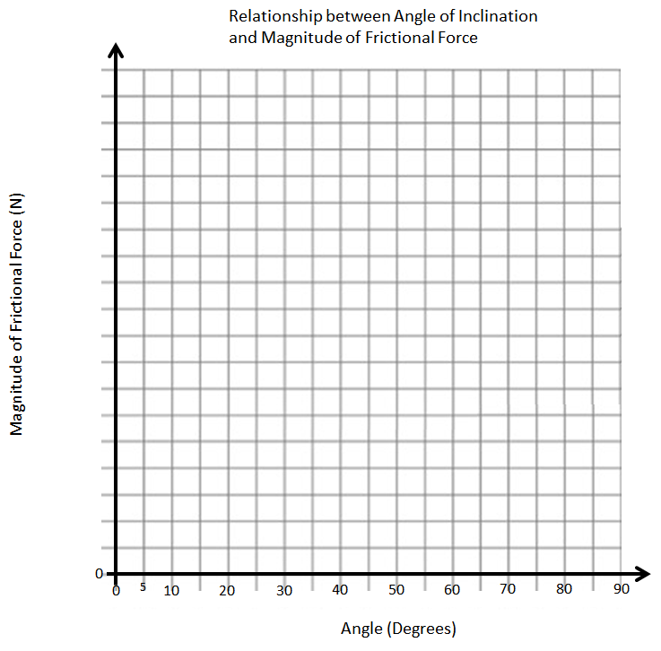
 | Marks | Weighting Multiplier | 3 | 2 | 1 | 0
Interpret patterns and trends in data, and infer and calculate linear and nonlinear relationships among the variables. |  | x2 | Student has correctly graphed the relationship, and can correctly explain the relationship. | Student is able to correctly graph Static Friction versus Angle of Inclination, but did not graph the appropriate domain. | Student incorrectly graphed Static Friction versus Angle of Inclination. | Not included in write-up.

