First Name:______________________________ Last Name:______________________________

L06 – Worksheet – Collisions in 1-Dimension, Elastic & Inelastic Collisions

Textbook Questions
Pg 476 #1: A 110-kg astronaut and a 4000-kg spacecraft are attached by a tethering cable. Both masses are motionless relative to an observer a slight distance away from the spacecraft. The astronaut wants to return to the spacecraft, so he pulls on the cable until his velocity changes to 0.80 m/s [toward the spacecraft] relative to the observer. What will be the change in velocity of the spacecraft?

Pg 476 #2: A student is standing on a stationary 2.3-kg skateboard. If the student jumps at a velocity of 0.37 m/s [forward], the velocity of the skateboard becomes 8.9 m/s [backward]. What is the mass of the student?

Pg 477 #1: A student on a skateboard, with a combined mass of 78.2 kg, is moving east at 1.60 m/s. As he goes by, the student skillfully scoops his 6.4-kg backpack from the bench where he had left it. What will be the velocity of the student immediately after the pickup?

Pg 477 #2: A 1050-kg car at an intersection has a velocity of 2.65 m/s [N]. The car hits the rear of a stationary truck, and their bumpers lock together. The velocity of the car-truck system immediately after collision is 0.78 m/s [N]. What is the mass of the truck?

Pg 478 #1: A 0.25-kg volleyball is flying west at 2.0 m/s when it strikes a stationary 0.58-kg basketball dead center. The volleyball rebounds east at 0.79 m/s. What will be the velocity of the basketball immediately after impact?

Pg 478 #2: A 9500-kg rail flatcar moving forward at 0.70 m/s strikes a stationary 18,000-kg boxcar, causing it to move forward at 0.42 m/s. What will be the velocity of the flatcar immediately after collision if they fail to connect?

Pg 479 #1: A 72-kg snowboarder gliding at 1.6 m/s [E] bounces west at 0.84 m/s immediately after colliding with an 87-kg skier travelling at 1.4 m/s [W]. What will be the velocity of the skier just after impact?

Pg 479 #2: A 125-kg bighorn ram butts heads with a younger 122-kg ram during mating season. The older ram is rushing north at 8.50 m/s immediately before the collision, and bounces back at 0.11 m/s [S]. If the younger ram moves at 0.22 m/s [N] immediately after collision, what was its velocity just before impact?

Pg 486 #10: A 75.6-kg volleyball player leaps toward the net to block the ball. At the top of his leap, he has a horizontal velocity of 1.18 m/s [right], and blocks a 0.275-kg volleyball moving at 12.5 m/s [left]. The volleyball rebounds at 6.85 m/s [right].
- What will be the horizontal velocity of the player immediately after the block?

- Determine if the collision is elastic.

Diploma Worksheet Questions
Q29: Two railway cars, each of mass m₁, are approaching each other on a straight line with the same constant speed v. Their total kinetic energy E_{k} and total momentum $\vec{p}$ are
- $E_{k}=mv^{2}, \vec{p}=2m\vec{v}$
- $E_{k}=\frac{1}{2}mv^{2}, \vec{p}=m\vec{v}$
- $E_{k}=mv^{2}, \vec{p}=0$
- $E_{k}=0, \vec{p}=2m\vec{v}$

Use the following information to answer Q37:
A lump of clay with a mass of 50.0 g is moving south at a speed of 20.0 cm/s. It collides head on with a second lump of clay with a mass of 70.0 g that is moving north at a speed of 40.0 cm/s.

Q37: The two lumps stick together, and no external horizontal forces act on the system. The velocity of the combined lump after the collision is
- 60.0 cm/s, south
- 31.7 cm/s, south
- 20.0 cm/s, north
- 15.0 cm/s, north

Challenge Question
Use the following information to answer Q1-Q2:
Train Car Collision
An empty train car, labelled Car 1, with a mass of 2000 kg is travelling with an initial velocity of 2.5 m/s [R]. Two other train cars are present, and are currently stationary.
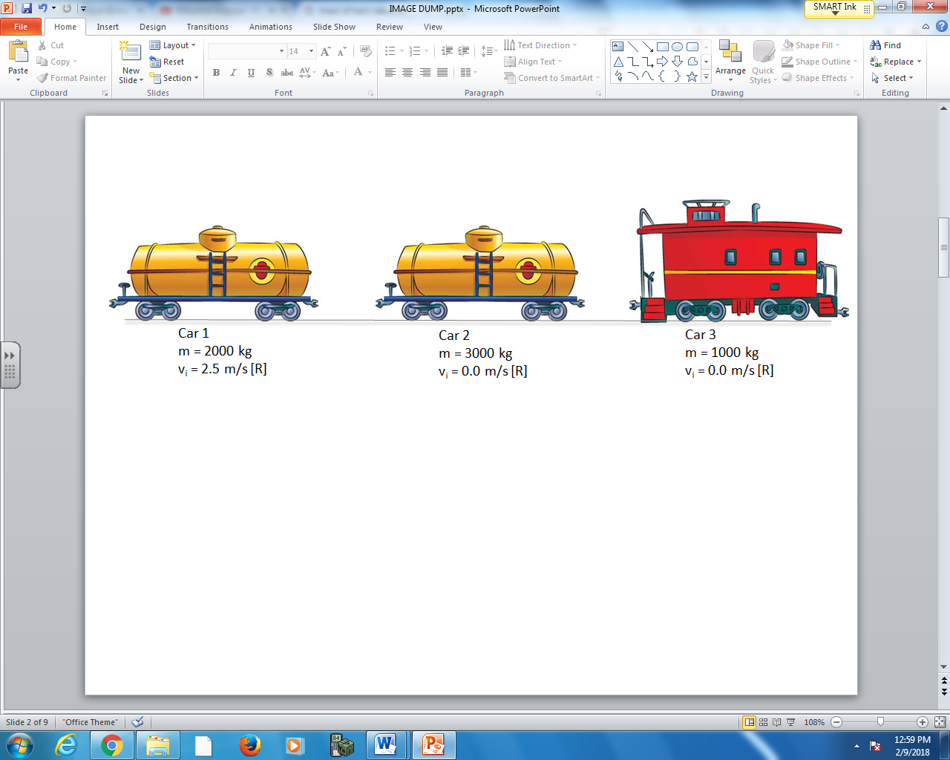
Collision #1: Car 1 collides with Car 2, and rebounds at 0.50 m/s [L], while Car 2 travels forward to the right.
Collision #2: Car 2 collides with Car 3. The two cars lock together and travel as a single unit after the collision.

Q1: Immediately after Collision #1, the speed of Car 2 is ____ m/s [R].
(Record your three digit answer in the Numerical Response boxes below)

Q2: Immediately after Collision #2, the speed of Cars 2&3 is ____ m/s [R].
(Record your three digit answer in the Numerical Response boxes below)

Use the following information to answer Q3:
A 12g airsoft pellet strikes a 0.2 kg mass on the end of a 1.0m string. The pendulum arm swings 30⁰ after the impact.
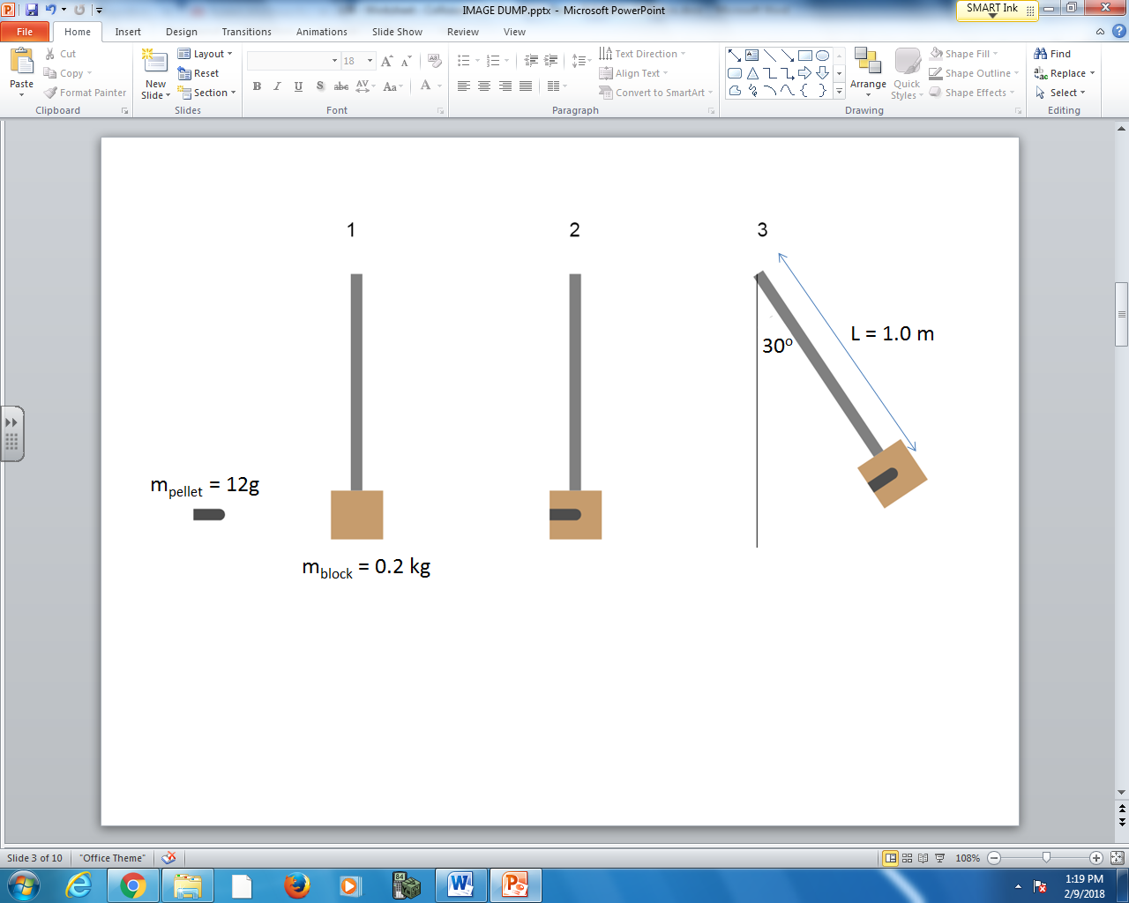

Q3: The initial speed of the airsoft pellet, prior to impact, is a.bc x 10^{d} m/s, where a, b, c, and d are ___, ___, ___, and ___.
(Record your four digit answer in the Numerical Response boxes below)

