First Name:__________________________________ Last Name:______________________________

L06 – Worksheet – Net Forces, Acceleration, and Friction

PART 1: Net Force and Acceleration
Use the following information to answer Q1:
While searching for potential Physics 20 questions online, Mr. Bayer found this very suspect Free-Body Diagram.

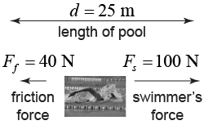

Doubting the validity of these values, Mr. Bayer decided to investigate by calculating the swimmer’s final velocity, assuming they were initially stationary on one side of the pool, and swam the entire 25.0m. Assume the swimmer has a mass of 80kg.

Q1: (Long Answer) What is the calculated final velocity of the swimmer?

PART 2: Friction in 1-Dimension
Use the following information to answer Q2– Q3:
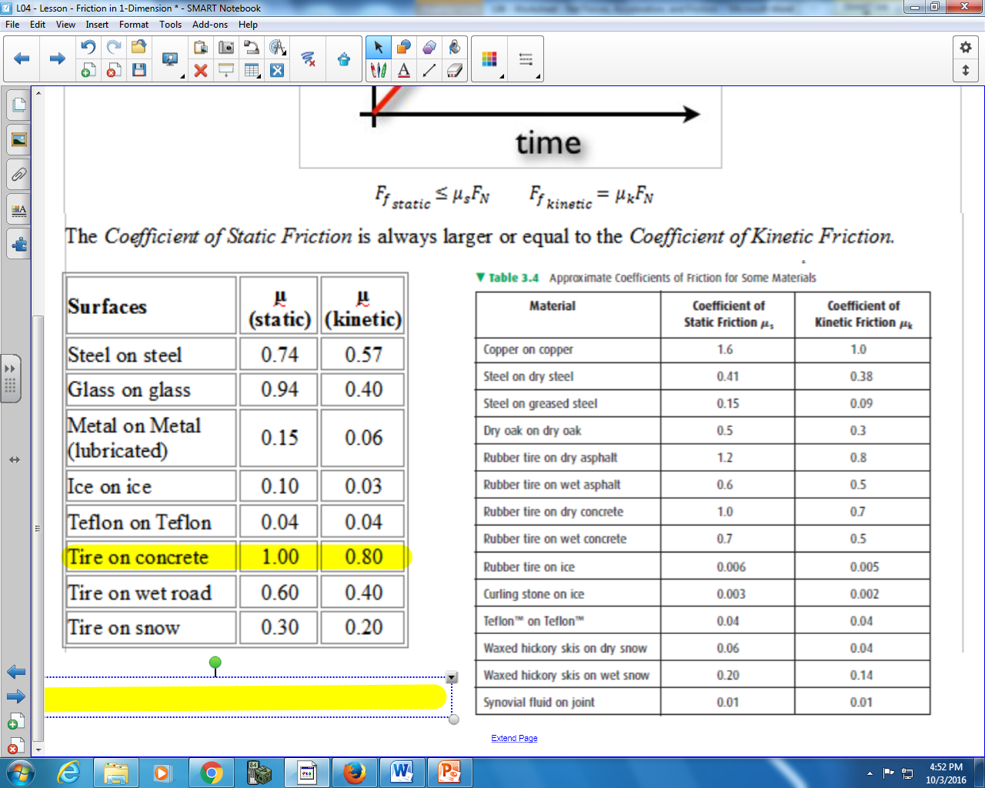

Q2: A 25.0 kg oak block is initially stationary on an oak floor. A small child applies a force of 80N. What is the force of friction acting on the block?
- 3.2 N
- 73.6 N
- 80.0 N
- 122.6 N
Q3: A 19.0 kg curling stone is resting on ice. How much force is required to overcome static friction?
- 5.7 x 10⁻² N
- 3.7 x 10⁻¹ N
- 5.6 x 10⁻¹ N
- 1.9 x 10² N

PART 3: Static Friction in 2-Dimensions
Use the following to answer Q4:
Static Friction on a Block on a Ramp
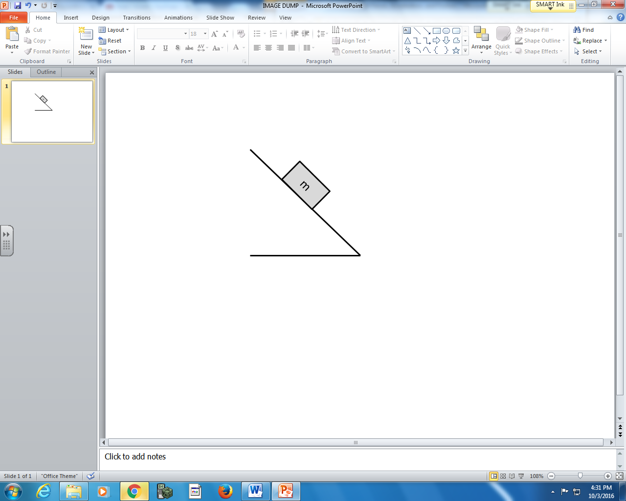
Directions
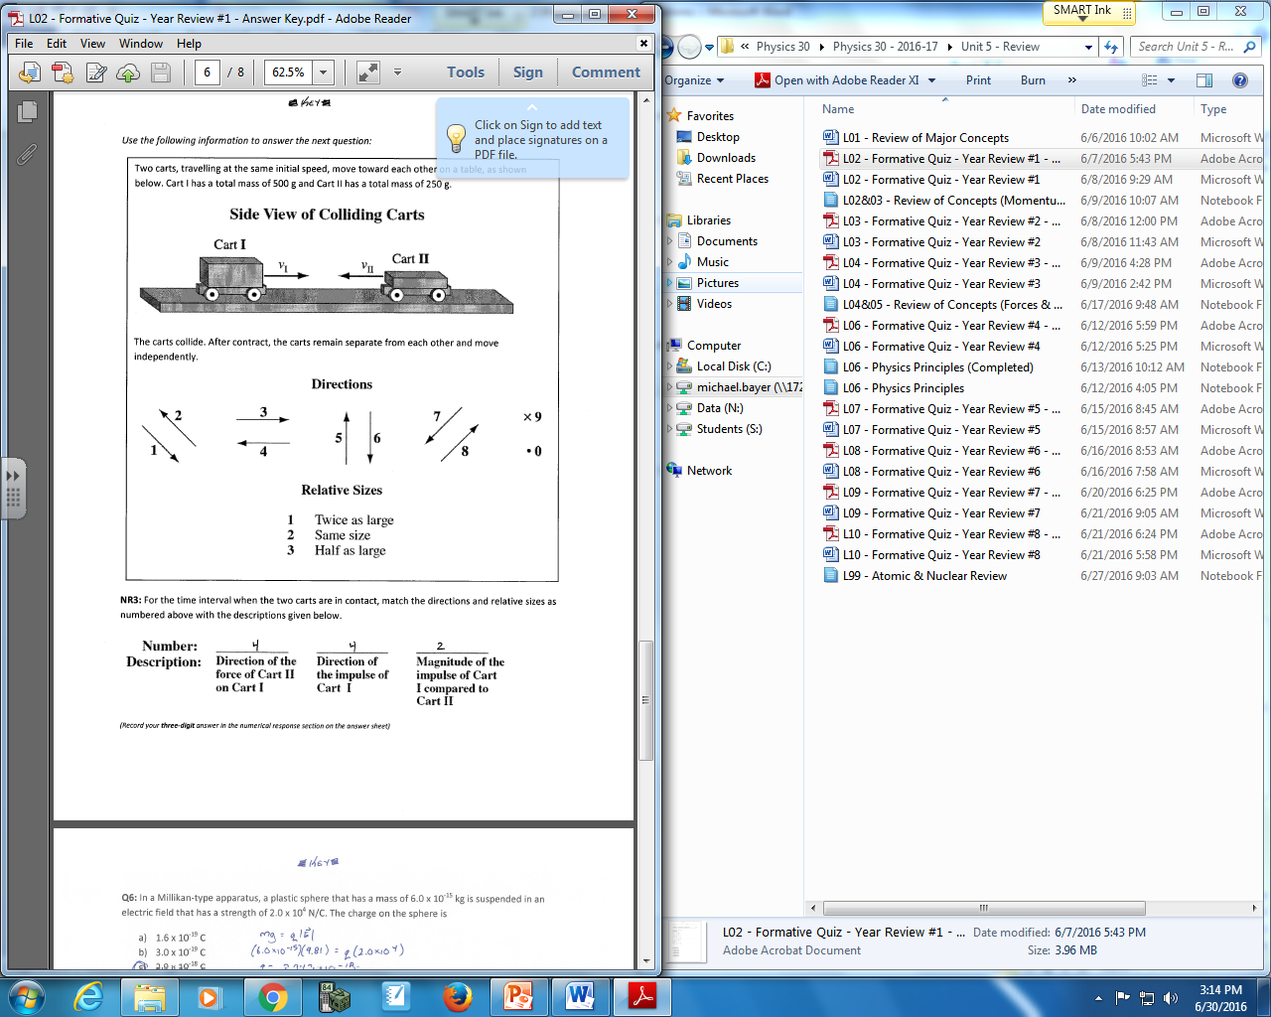

Q4: Use the vector directions above to fill in the blanks below.

Direction: __________ __________ __________
Description: Direction of Direction of Direction of
Force of Gravity Normal Force Force of Friction

(Record your three-digit answer in the Numerical Response boxes below)

Q5: A 5.0kg block rests on a 30⁰ incline. What is the magnitude of the Normal Force that the block experiences?
- 24.53 N
- 28.32 N
- 42.48 N
- 49.05 N
Use the following information to answer Q6:
A 8.5 kg block rests on a surface. The surface is inclined until the block just starts to slip, which happens at an angle of inclination of 42.3⁰.
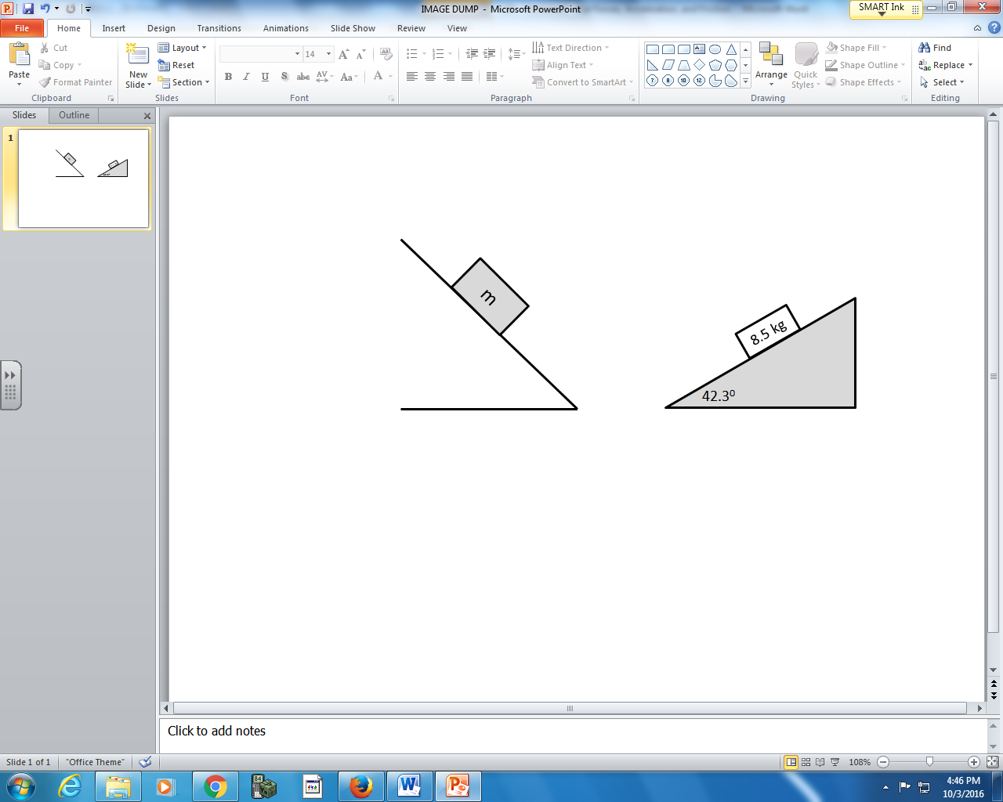

Q6: The coefficient of static friction is a.bc x 10^{-d}, where a, b, c, and d are ___, ___, ___, and ___.
(Record your four-digit answer in the Numerical Response boxes below)

PART 4: Kinetic Friction in 2-Dimensions
Use the following information to answer Q7:
A young child with a mass of 30.0 kg is going to toboggan down a hill, as depicted below. He initially starts stationary, and the coefficient of kinetic friction between his sled and the hill is 0.05.
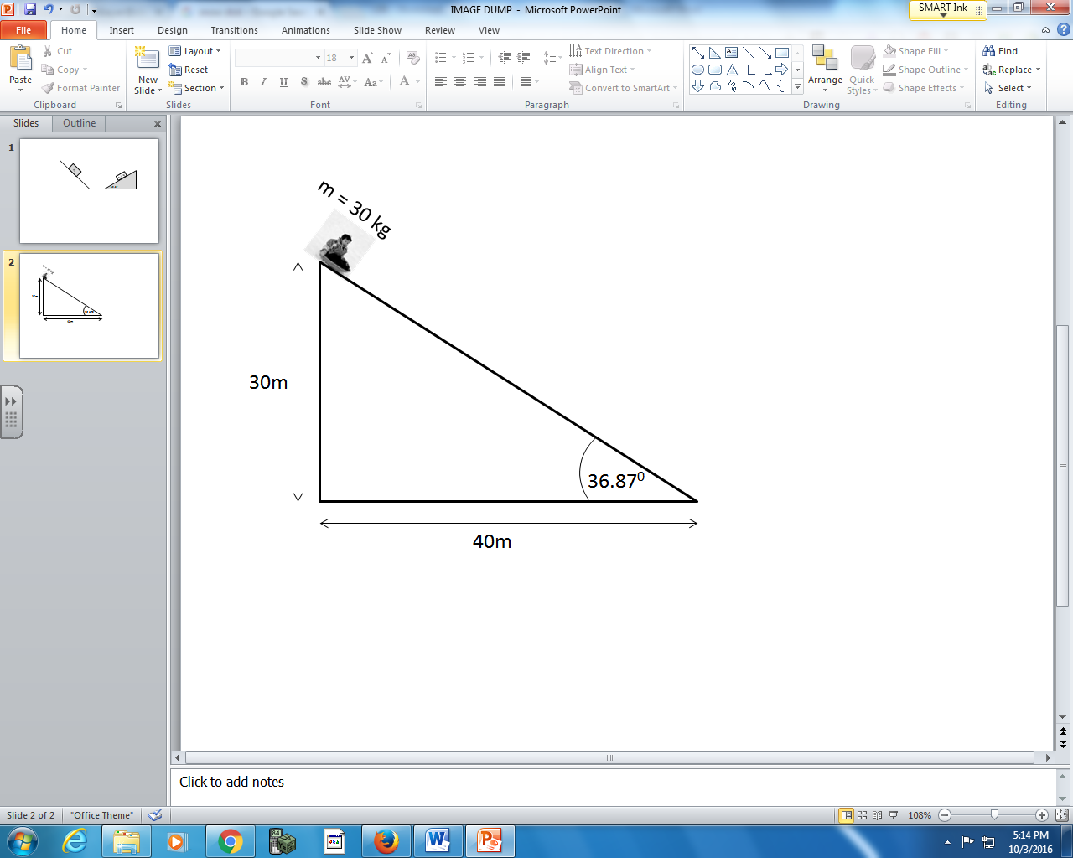

Q7: (Long Answer) What is the acceleration of the child?

