First Name:______________________________ Last Name:______________________________
L06 – Worksheet – Refraction Lenses
Basic Concepts
Q1: An 8.0cm tall object is placed 25.0cm from the vertex of a concave mirror with focal length 10.0cm. Using both (a) a Ray Diagram, and (b) Equations, determine the image position and attributes (real/virtual, erect/inverted, enlarged/diminished).
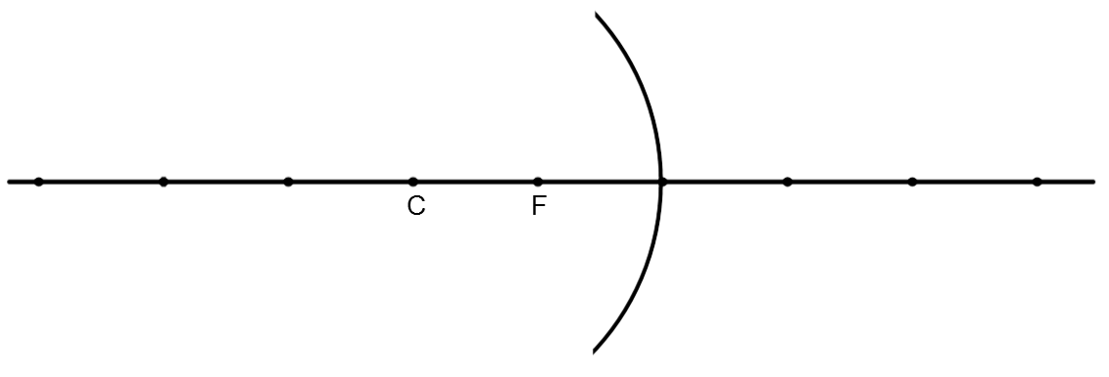

Q2: An 8.0cm tall object is placed 15.0cm from the vertex of a convex mirror with focal length 10.0cm. Using both (a) a Ray Diagram, and (b) Equations, determine the image position and attributes (real/virtual, erect/inverted, enlarged/diminished).
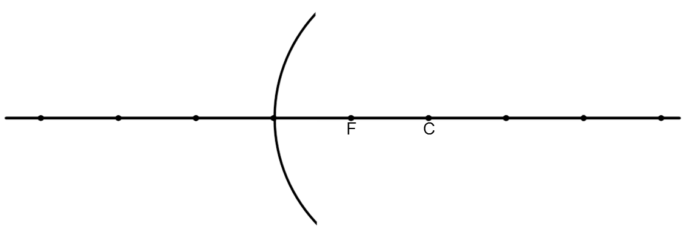

Q3: An 8.0cm tall object is placed 15.0cm from the vertex of a converging lens with focal length 10.0cm. Using both (a) a Ray Diagram, and (b) Equations, determine the image position and attributes (real/virtual, erect/inverted, enlarged/diminished).
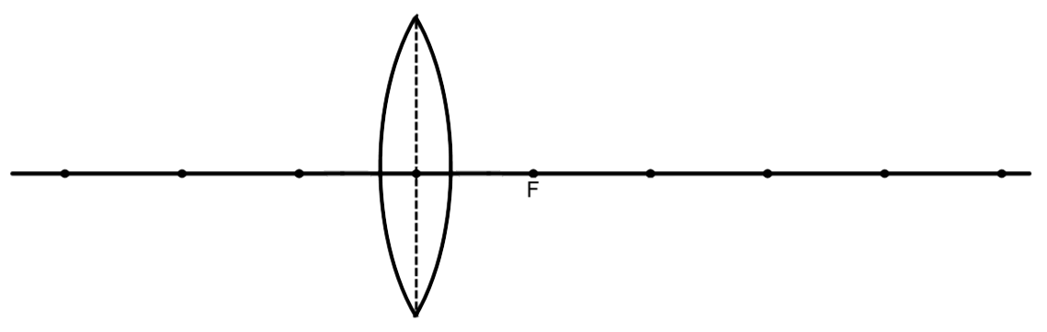

Q4: An 8.0cm tall object is placed 20.0cm from the vertex of a converging lens with focal length 10.0cm. Using both (a) a Ray Diagram, and (b) Equations, determine the image position and attributes (real/virtual, erect/inverted, enlarged/diminished).
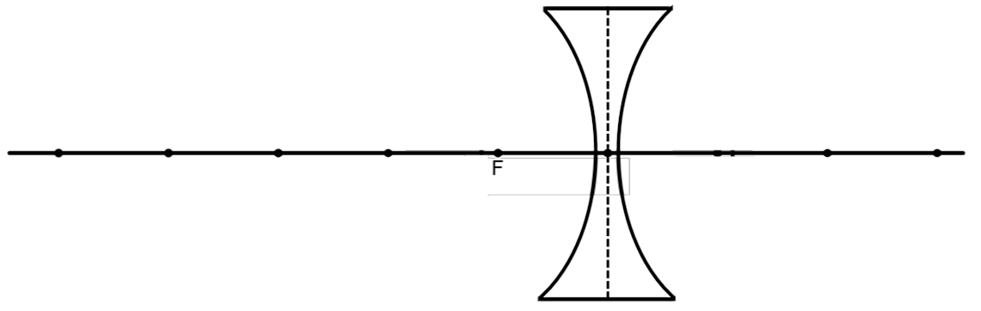
Textbook Questions
Pg 683 #1: Is light bent toward or away from the normal line when it passes from a low-index medium to a high-index medium?

Pg 683 #2: How is the index of refraction measured for a particular medium?

Pg 683 #9: What is the speed of light in water (n = 1.33) ?

Pg 683 #10: A light ray is incident on a block of quartz glass (n = 1.47) at an angle of 35.0⁰. Determine the angle of refraction.

Pg 683 #15: Using a ray diagram, determine the image attributes of an object located at 2F’ relative to a converging lens.

Pg 683 #16: A camera with a converging lens (f = 4.50 cm) is used to take a picture of a 25.0-m-high tree that is 50.0 m from the camera. How tall is the image? Is it erect or inverted?

Diploma Questions – Refraction (Basic Concepts)
None
Challenge Questions
None
Cumulative Review from Previous Units
Use the following information to answer Q1:
A proton is placed on the positive plate of a set of parallel plates. When released, it accelerates downward and collides with the lower plate.
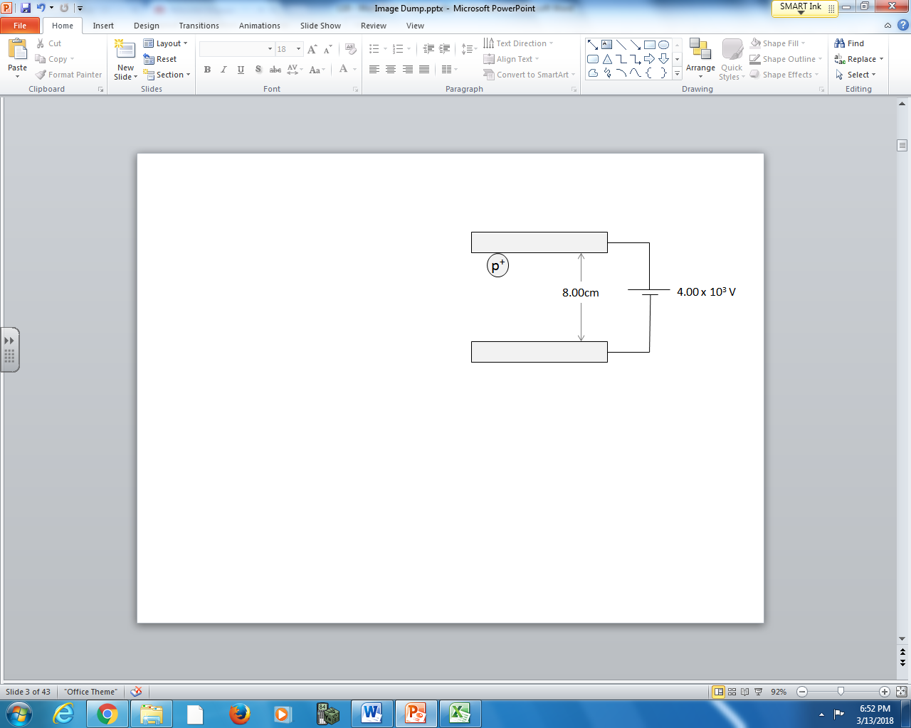

Q1: The proton has a speed of a.bc x 10^{d} m/s when it collides with the lower plate, where a, b, c, and d are ___, ___, ___, and ___.
(Record your four digit answer in the Numerical Response boxes below)

Use the following information to answer Q2:

Magnetic Fields around Current in a Wire
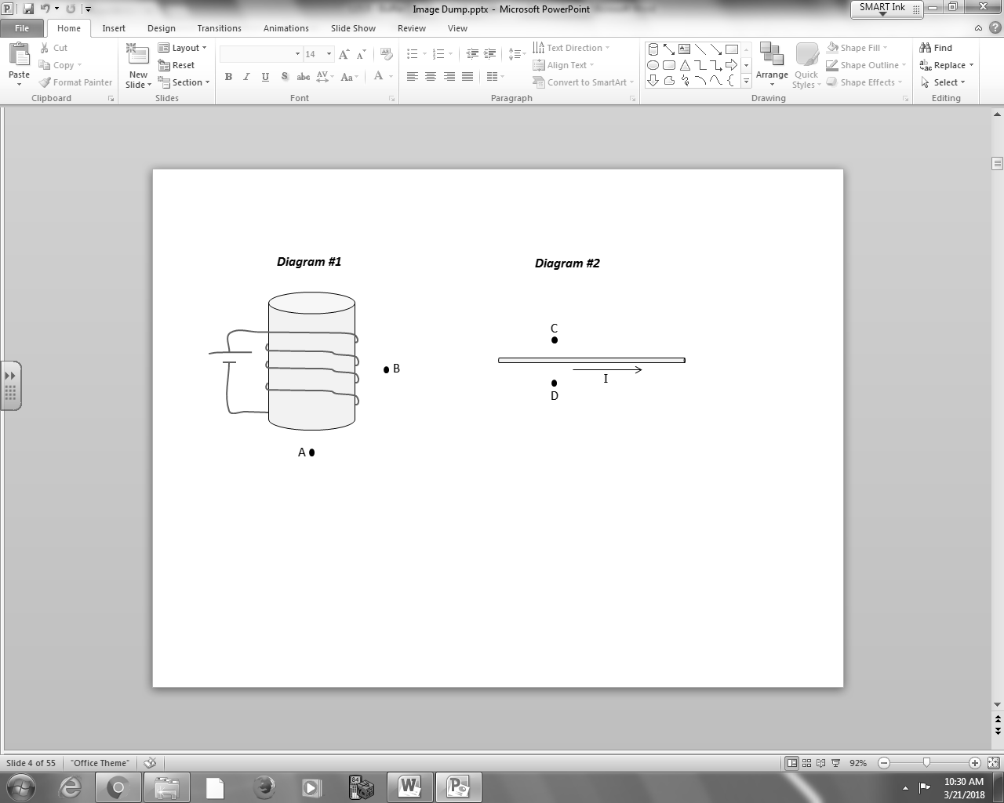
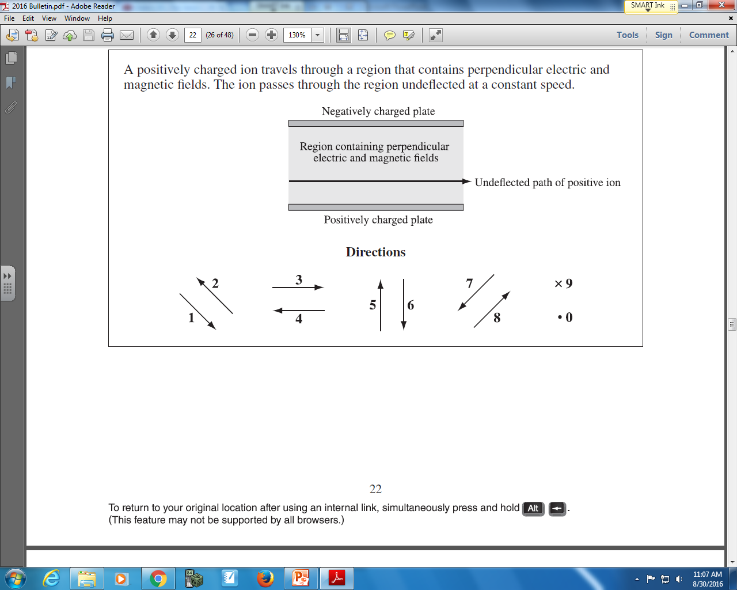

Q2: The directions of magnetic fields at various locations can be described using the numbers given above.
Direction: __________ __________ __________ __________
Field: Direction of Direction of Direction of Direction of
magnetic field magnetic field magnetic field magnetic field
at Position A at Position B at Position C at Position D
(Record your four digit answer in the Numerical Response boxes below)

