First Name:____________________________ Last Name:______________________________

L07 – Formative Quiz – Collisions in 1-Dimension

Q1: An 13.5kg dog runs at 2m/s [E] and tackles a stationary 10.0kg baby. Their masses stick together as they fly through the air. Their velocity at the moment after impact is ____ m/s [E].
(Record your three digit answer in the Numerical Response boxes below)

Use the following information to answer Q2:
A 40g ball is travelling 2.0 m/s [R] when it collides with a stationary 80g ball. The 40g ball then rebounds at 0.$\overline{3}$ m/s [L].
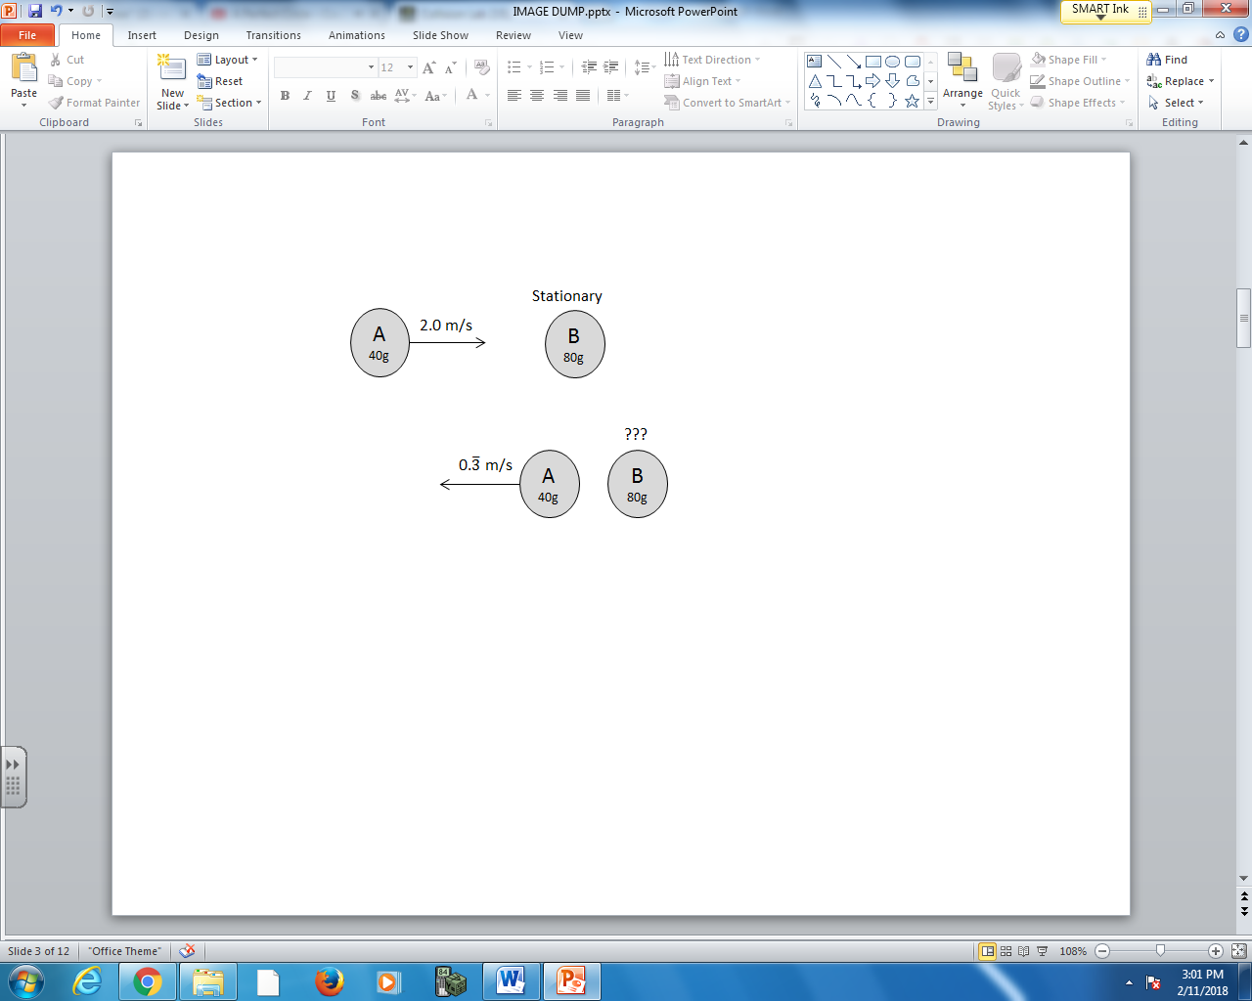

Q2: What is the final velocity of the 80g ball?
- 0.83 m/s [R]
- 1.17 m/s [R]
- 1.35 m/s [R]
- 1.47 m/s [R]

Use the following information to answer Q3:
The radioactive isotope Radium-226 decays via Alpha Decay, producing a Radon-222 daughter nucleus and an Alpha particle.
The mass of the parent nucleus, Radium-226, exceeds the sum of the daughter nucleus and the alpha particle. In radioactive decay, this missing “mass defect” is converted into the kinetic energy of the system.
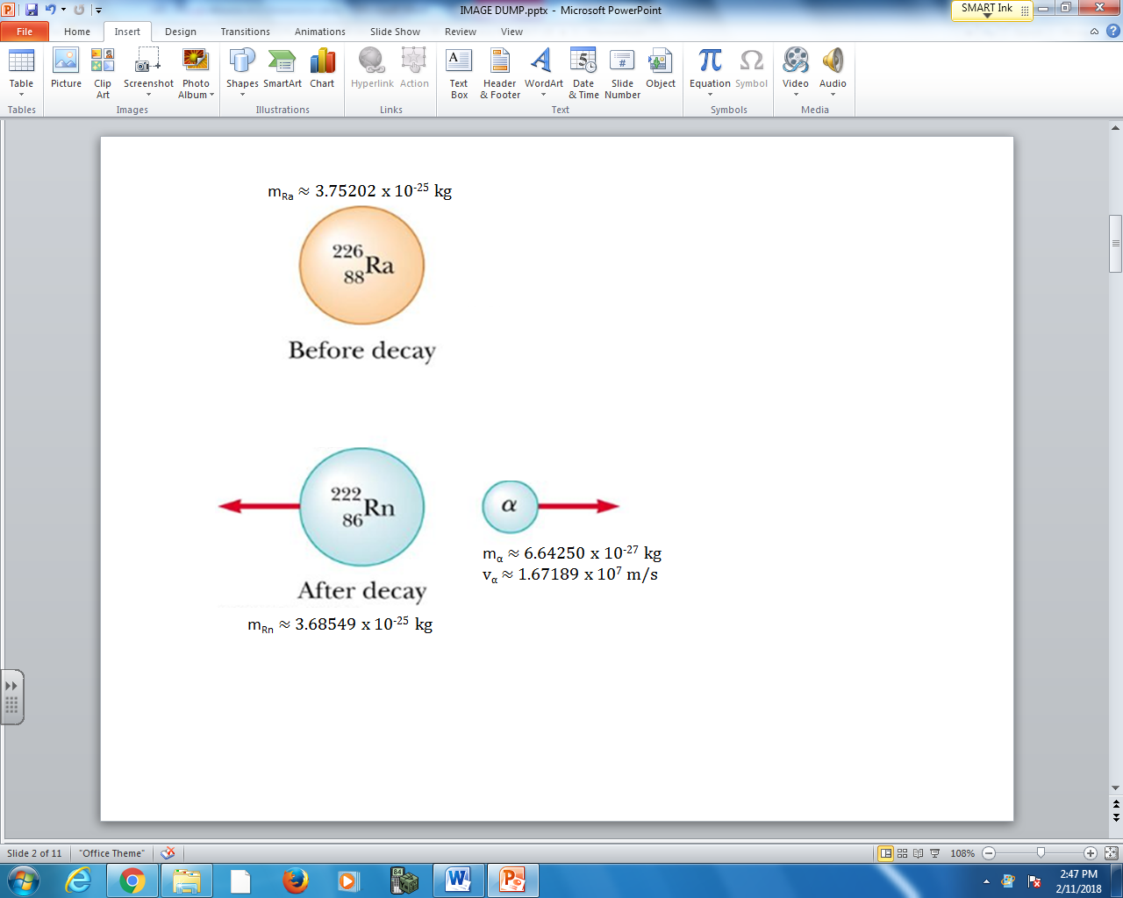

Q2: Text

Q3: If the Radium-226 parent nucleus was originally stationary, and the Alpha particle ejects at a speed of 1.67189 x 10⁷ m/s, then the recoil speed of the Radon-222 daughter nucleus is a.bc x 10^{d} m/s, where a, b, c, and d are ___, ___, ___, and ___.
(Record your four digit answer in the Numerical Response boxes below)

MARKING:
Beginning 0
Progressing 1
Competent 2
Exemplary 3

