First Name:_____________________________ Last Name:_____________________________

L07 – FQ – Double-Slit Diffraction

Use the following information to answer Q1:
Every point on a wave is a source of wavelets.
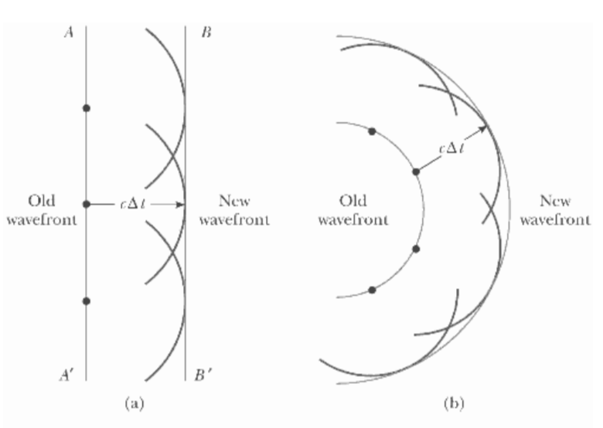

Q1: The concept diagrammed above is known as:
- The Hyugen-Fresnel principle
- The Hadoken-Fresnel principle
- The Shoryuken-Fresnel principle
- The Wave Dispersion principle

Q2: Destructive interference occurs when two waves meet
- Crest to crest
- Crest to trough
- Trough to trough
- At an anti-node

Use the following information to answer Q3:
Two Source Interference
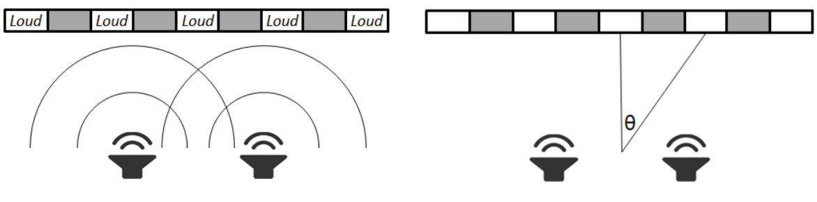

Q3: Two Smart Board speakers, located 2.2 meters apart, are playing a 350 Hz pure tone. If the speed of sound is 343m/s, what is the angle of diffraction to the second antinode? (2 marks)
(Record your three digit answer in the Numerical Response boxes below)

MARKING:
Beginning 0 – 1.5
Progressing 2 – 2.5
Competent 3 – 3.5
Exemplary 4

