First Name:____________________________ Last Name:______________________________

L07 – FQ – Electric Fields 2

Use the following information to answer Q1:
Electric Fields due to Point Charges
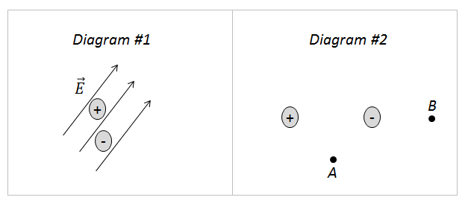
Directions
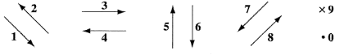

Q1: Use the vector directions above to fill in the blanks below.

Direction: __________ __________ __________ __________
Description: Direction of Direction of Direction of Direction of
force acting on force acting on electric field electric field
positive charge negative charge lines at Point A lines at Point B
in Diagram #1 in Diagram #1 in Diagram #2 in Diagram #2

(Record your three-digit answer in the Numerical Response boxes below)

Q2: A positive charge moves __i__ the electric field lines and a negative charge moves __ii__ the electric field lines.
 | i. | ii.
A. | with | with
B. | with | against
C. | against | with
D. | against | against

Use the following information to answer Q3-Q4:
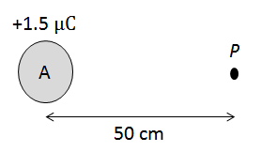

Q3: The electric field strength at Point P is
- 5.394 x 10¹ N/C
- 2.697 x 10² N/C
- 2.697 x 10⁴ N/C
- 5.394 x 10⁴ N/C
Q4: If a charge of -2.5 μC were placed at Point P, then the electrostatic force acting on it would be
- 1.35 x 10⁻⁵ N [Right]
- 1.35 x 10⁻⁵ N [Left]
- 1.35 x 10⁻¹ N [Right]
- 1.35 x 10⁻¹ N [Left]

MARKING:
Beginning 0.0 – 1.5
Progressing 2.0 – 2.5
Competent 3.0 – 3.5
Exemplary 4.0

