First Name:___________________________ Last Name:______________________________

L07 - Formative Quiz – Refraction Lenses

Q1: Draw a ray diagram for the following converging lens. (1 mark)

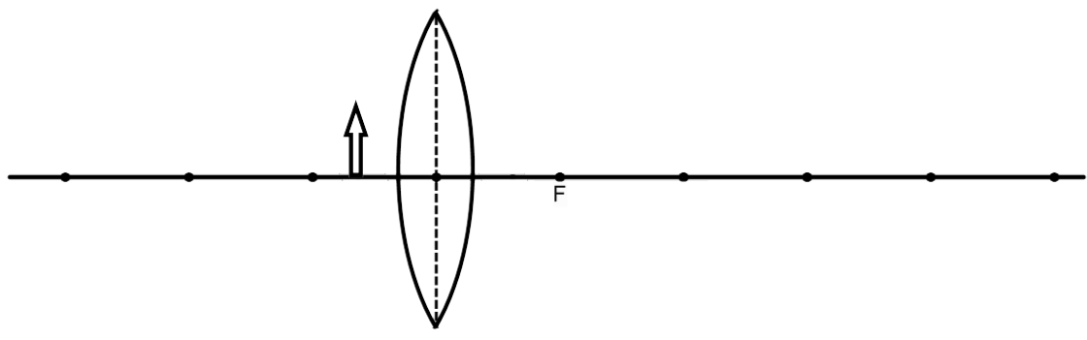

Q2: Draw a ray diagram for the following diverging lens. (1 mark)

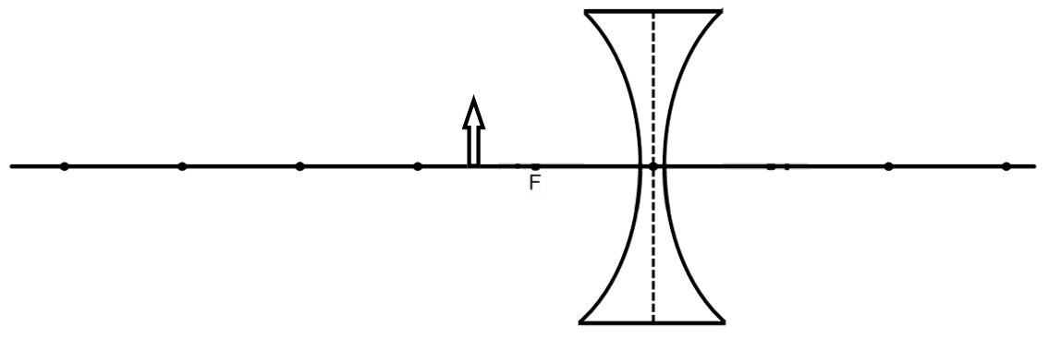
FLIP THE PAGE TO CONTINUE
Use the following information to answer Q3 to Q4.
A 3cm high object is placed 8cm from a converging lens with a focal length of 5cm.
Image Characteristics
1 – Real 3 – Erect 5 – Enlarged
2 – Virtual 4 – Inverted 6 – Diminished

Q3: Using the Image Characteristics above, the image can best be described as:
Type: _____ Attitude: _____ Magnification: _____
(Record your three-digit answer in the numerical response boxes below.)

Q4: What is the position of the image, in centimeters?
(Record your three-digit answer in the numerical response boxes below.)

MARKING:
Beginning 0-1
Progressing 2
Competent 3
Exemplary 4

