First Name:__________________________ Last Name:______________________________

L07 – Worksheet – Double-Slit Diffraction and Doppler Shift

Part 1 – Double-Slit Diffraction
Use the following information to answer Q1 and Q2:
Two Smart Board speakers, located 2.2 meters apart, are playing a 500 Hz pure tone. The speed of sound is 343 m/s.
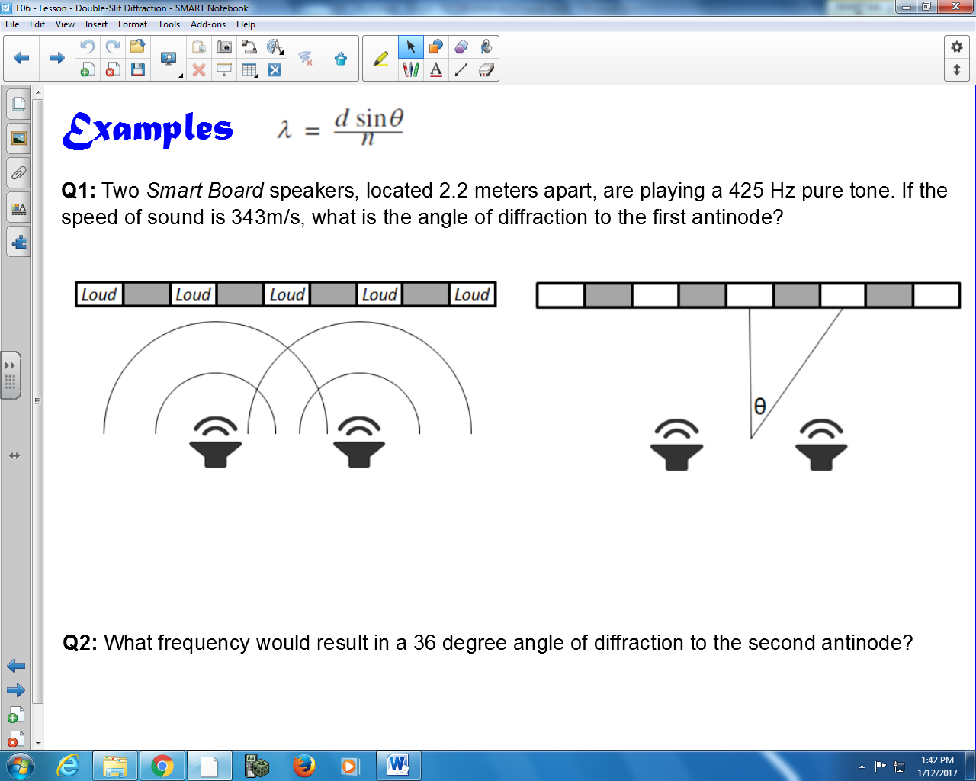

Q1: What is the angle of diffraction to the first antinode?

Q2: If the distance between the speakers and the walking path is 5.0 meters, how far apart are the central antinode and the first order antinode?

Use the following information to answer Q3:
Text
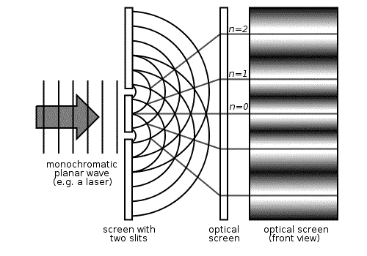

Q3: A monochromatic light source of wavelength 625 nm is incident on a double slit with a slit separation of 75 mm. At what angle is the first order antinode located?

Use the following information to answer Q4 and Q5:
Two speakers are placed 85 cm apart, and are playing a pure tone of 700 Hz. The speed of sound is 343 m/s.

Q4: What is the angle of diffraction to the first antinode?

Q5: If the distance between the speakers and the walking path is 4.0 meters, how far apart are the central antinode and the adjacent antinode?

Part 2 – Doppler Shift
Q6: You are crossing in a crosswalk when an approaching driver blows his horn. If the true frequency of the horn is 264 Hz and the car is approaching you at a speed of 60.0 km/h, what is the apparent (or Doppler) frequency of the horn? Assume that the speed of sound in air is 340 m/s.

Q7: An airplane is approaching at a speed of 360 km/h. If you measure the pitch of its approaching engines to be 512 Hz, what must be the actual frequency of the sound of the engines? The speed of sound in air is 345 m/s.

Q8: An automobile is travelling toward you at a speed of 25.0 m/s. When you measure the frequency of its horn, you obtain a value of 260 Hz. If the actual frequency of the horn is known to be 240 Hz, calculate v_{w}, the speed of sound in air.

Q9: As a train moves away from you, the frequency of its whistle is determined to be 475 Hz. If the actual frequency of the whistle is 500 Hz and the speed of sound in air is 350 m/s, what is the train’s speed?

Q10: A siren of a police car has s a frequency of 660 Hz. If the car is travelling toward you at 40.0 m/s, what do you perceive to be the frequency of the siren? The speed of sound in air is 340 m/s.

Q11: The horn on a car has a frequency of 290 Hz. If the speed of sound in air is 340 m/s and the car is moving toward you at a speed of 72.0 km/h, what is the apparent frequency of the sound?

Q12: How fast is a sound source moving toward you if you hear the frequency fo be 580 Hz when the true frequency is 540 Hz? The speed of sound in air is 350 m/s. Express your answer in km/h.

