First Name:____________________________ Last Name:______________________________

L07 – Worksheet – Motion in 1-Dimension / 30 marks

Part 1: Uniform Motion Equation
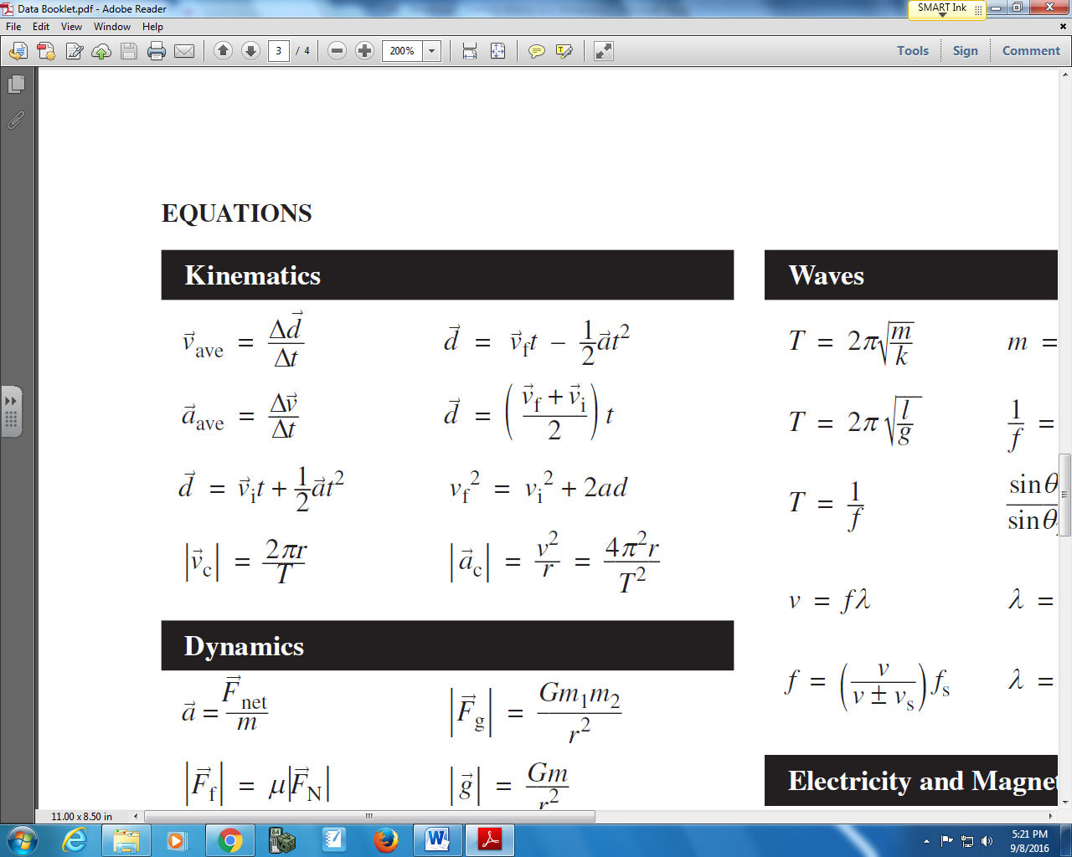

Use the following information to answer Q1 – Q5:
John starts 15m [N] of his house and runs until he is 28 m [S] of his house. This run takes him 50 seconds.

Q1: John ran a total distance of a.bc x 10^{d} m, where a, b, c, and d are ___, ___, ___, and ___.
(Record your four digit answer in the Numerical Response boxes below)

Q2: Which of the following best describes John’s initial position?
- $\vec{d_{i}}$ = 13m [S]
- $\vec{d_{i}}$ = 15m [N]
- $\vec{d_{i}}$ = 28m [S]
- $\vec{d_{i}}$ = 43m [S]

Q3: Which of the following best describes John’s final position?
- $\vec{d_{f}}$ = 13m [S]
- $\vec{d_{f}}$ = 15m [N]
- $\vec{d_{f}}$ = 28m [S]
- $\vec{d_{f}}$ = 43m [S]
Q4: Which equation best models how to calculate John’s displacement?
- $∆\vec{d}=15m \left[N\right]+28m[N]$
- $∆\vec{d}= -28m \left[N\right]+15m[N]$
- $∆\vec{d}= -28m \left[N\right]-15m[N]$
- $∆\vec{d}=28m \left[N\right]-15m [N]$

Q5: John’s velocity is a.bc x 10^{-d} m/s, where a, b, c, and d are ___, ___, ___, and ___.
(Record your four digit answer in the Numerical Response boxes below)

Q6: A rabbit is 15m [E] of a rabbit hole when initially, then runs to 24m [E]. This total run takes place in 4 seconds. What is the rabbit’s velocity? (3 marks)

Part 2: Interpreting Position-Time Graphs
Use the following information to answer Q7 – Q14:
Position-Time Graph
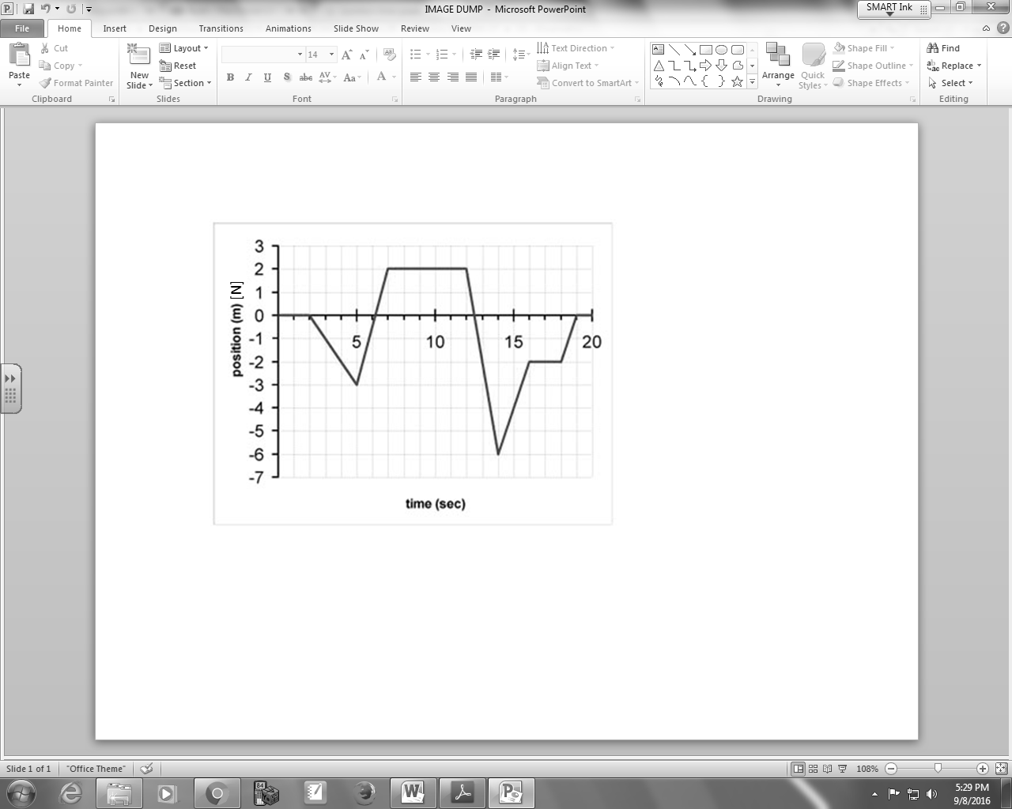

Q7: During what time period(s) is the object north of the origin?
- 5 - 7s, 14 - 16s, 18 - 19s
- 6 - 12.5s
- 0 - 2s, 7 - 12s, 16 - 18s, 19 - 20s
- 2 - 5s, 12 - 14s

Q8: During what time period(s) is the object moving north?
- 5 - 7s, 14 - 16s, 18 - 19s
- 6 - 12.5s
- 0 - 2s, 7 - 12s, 16 - 18s, 19 - 20s
- 2 - 5s, 12 - 14s

Q9: During what time period(s) is the object stationary?
- 5 - 7s, 14 - 16s, 18 - 19s
- 6 - 12.5s
- 0 - 2s, 7 - 12s, 16 - 18s, 19 - 20s
- 2 - 5s, 12 - 14s

Q10: What is the magnitude of the velocity between 5 and 7 seconds?
(Record your three digit answer in the Numerical Response boxes below)

Q11: What is the magnitude of the acceleration of the object between 12 and 14 seconds?
(Record your three digit answer in the Numerical Response boxes below)

Q12: During what time period(s) is the object south of the origin?

Q13: During what time period(s) is the object moving south?

Q14: The displacement of the object between 14 and 16 seconds is
- 4m [N]
- 4m [S]
- 8 m [N]
- 8 m [S]

Part 3: Interpreting Velocity-Time Graphs
Use the following information to answer Q15 – Q22:
Velocity-Time Graph
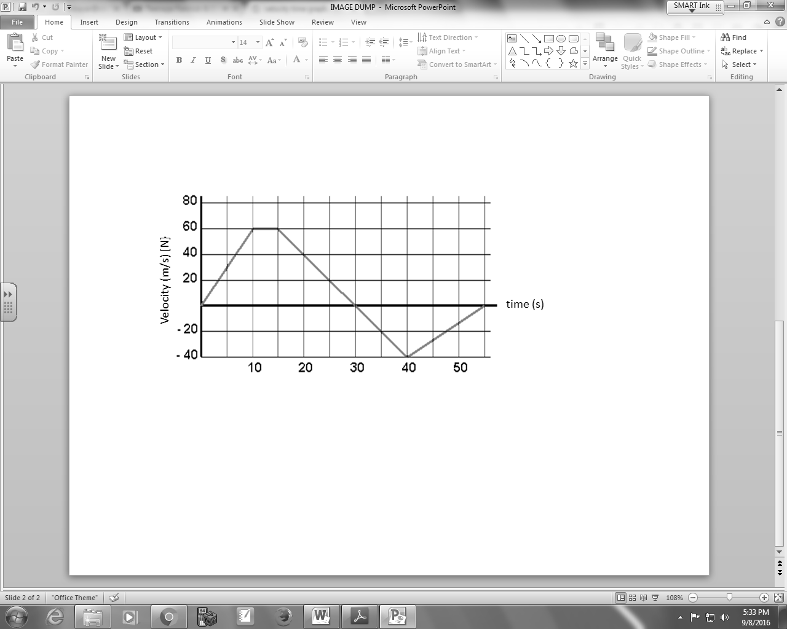

Q15: During what time period(s) is the object stationary?
- 10 – 15s
- 55 – 60s
- All of the above
- None of the above

Q16: During what time period(s) is the object moving north?
- 0 – 10s
- 0 – 30s
- 40 – 55s
- Both A and C

Q17: During what time period(s) is the object accelerating?
- 0 – 10s
- 0 – 30s
- 30 – 40s
- Both A and C

Q18: What is the acceleration of the object between 20 and 30 seconds?

Q19: What is the acceleration of the object between 40 and 55 seconds?

Q20: What is the velocity of the object at 20 seconds?

Q21: What is the displacement of the object between 10 and 30 seconds?

Q22: During what time period(s) is the object decelerating?

Part 4: Horizontally Accelerated Motion
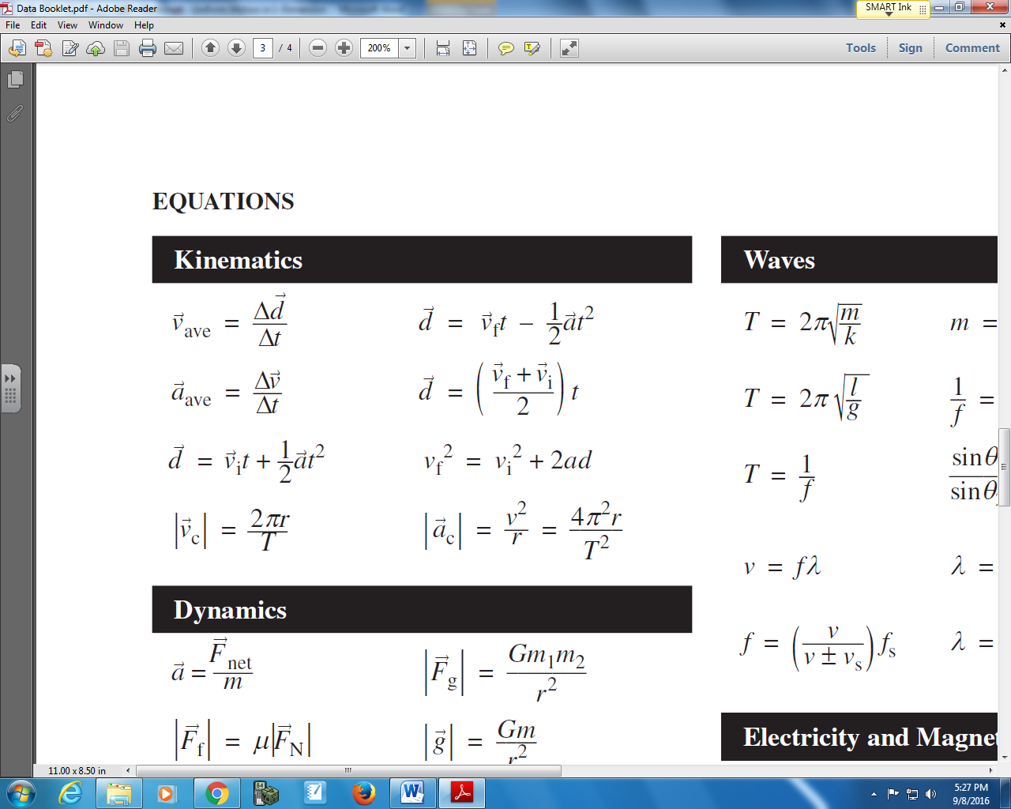

Q23: A Honda civic can accelerate from a rest to 26.8m/s [S] in 9.8 seconds, covering a distance of
a.bc x 10^{d} m, where a, b, c, and d are ___, ___, ___, and ___.
(Record your four digit answer in the Numerical Response boxes below)

Q24: A stationary object is accelerated at 3.2m/s² [S] for 15m [S]. How much time elapsed, in seconds?
(Record your three digit answer in the Numerical Response boxes below)

Part 5: Vertically Accelerated Motion

Use the following information to answer Q25 to Q27:
A ball at ground level is shot vertically upward at 2m/s.

Q25: The ball reaches a maximum height of a.bc x 10^{-d} m, where a, b, c, and d are ___, ___, ___, and ___.
(Record your four digit answer in the Numerical Response boxes below)

Q26: The ball has a total flight time of a.bc x 10^{-d} s, where a, b, c, and d are ___, ___, ___, and ___.
(Record your four digit answer in the Numerical Response boxes below)

Q27: How fast is the ball moving at t=0.36 seconds, in meters per second?
(Record your three digit answer in the Numerical Response boxes below)

Part 6: Harder Questions
Use the following information to answer Q28:
Two men are running towards each other on a jogging trail.
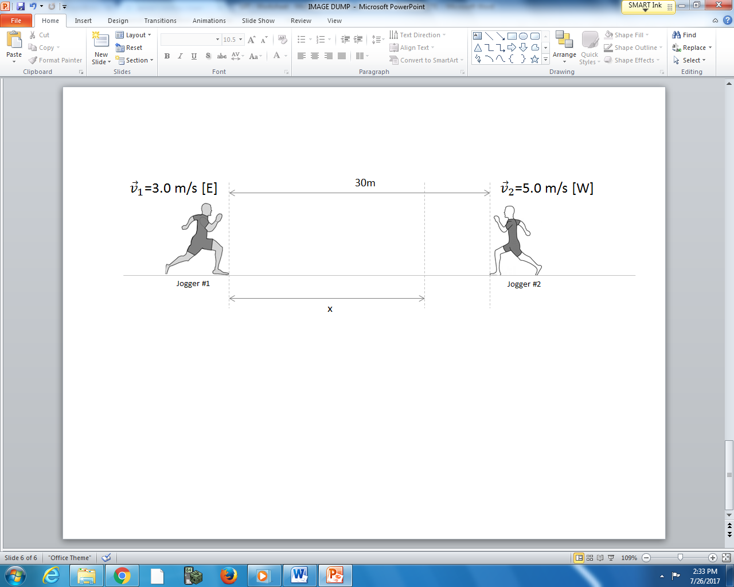

Q28: How far from Jogger #1’s original position to they meet, measured in meters?
(Record your three digit answer in the Numerical Response boxes below)

Use the following information to answer Q29:
A criminal is running at a steady 5.0 m/s when he runs up parallel to a police officer. The officer, originally stationary, immediately begins to accelerate at 1.0 m/s².
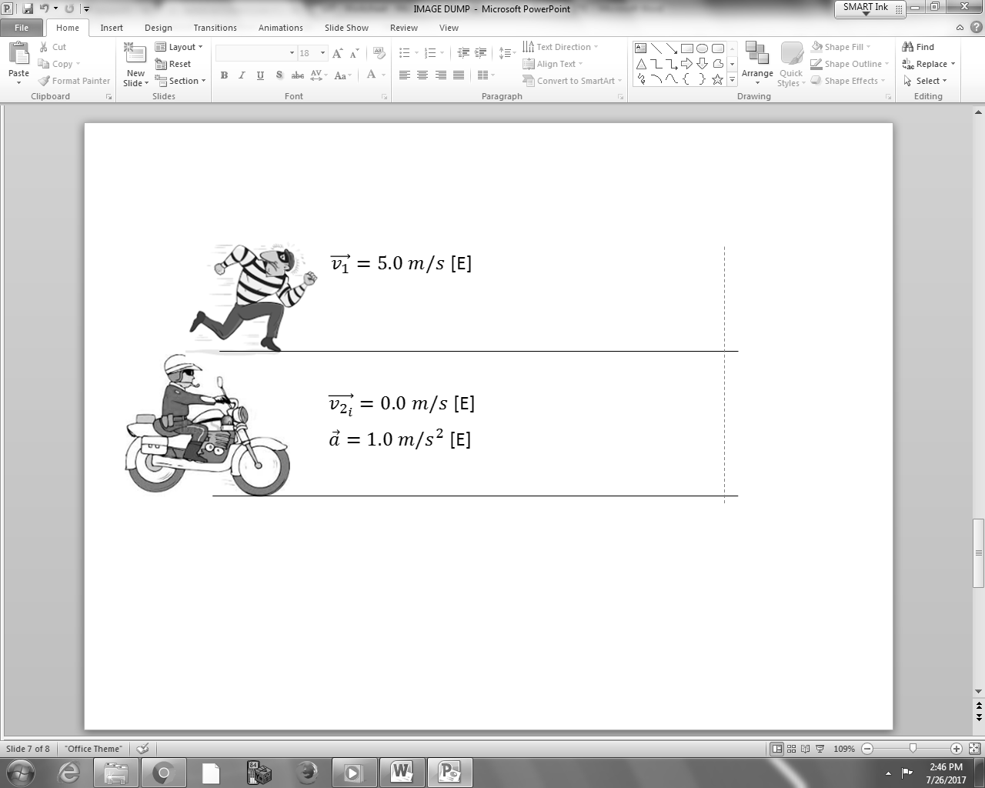

Q29: How many seconds does it take the police officer to catch up to the criminal again?
(Record your three digit answer in the Numerical Response boxes below)

Use the following information to answer Q30:
A football player kicks a ball vertically upward at 15.0 m/s. Another player, 10m away, runs at a steady speed to intercept the ball on its way back down.
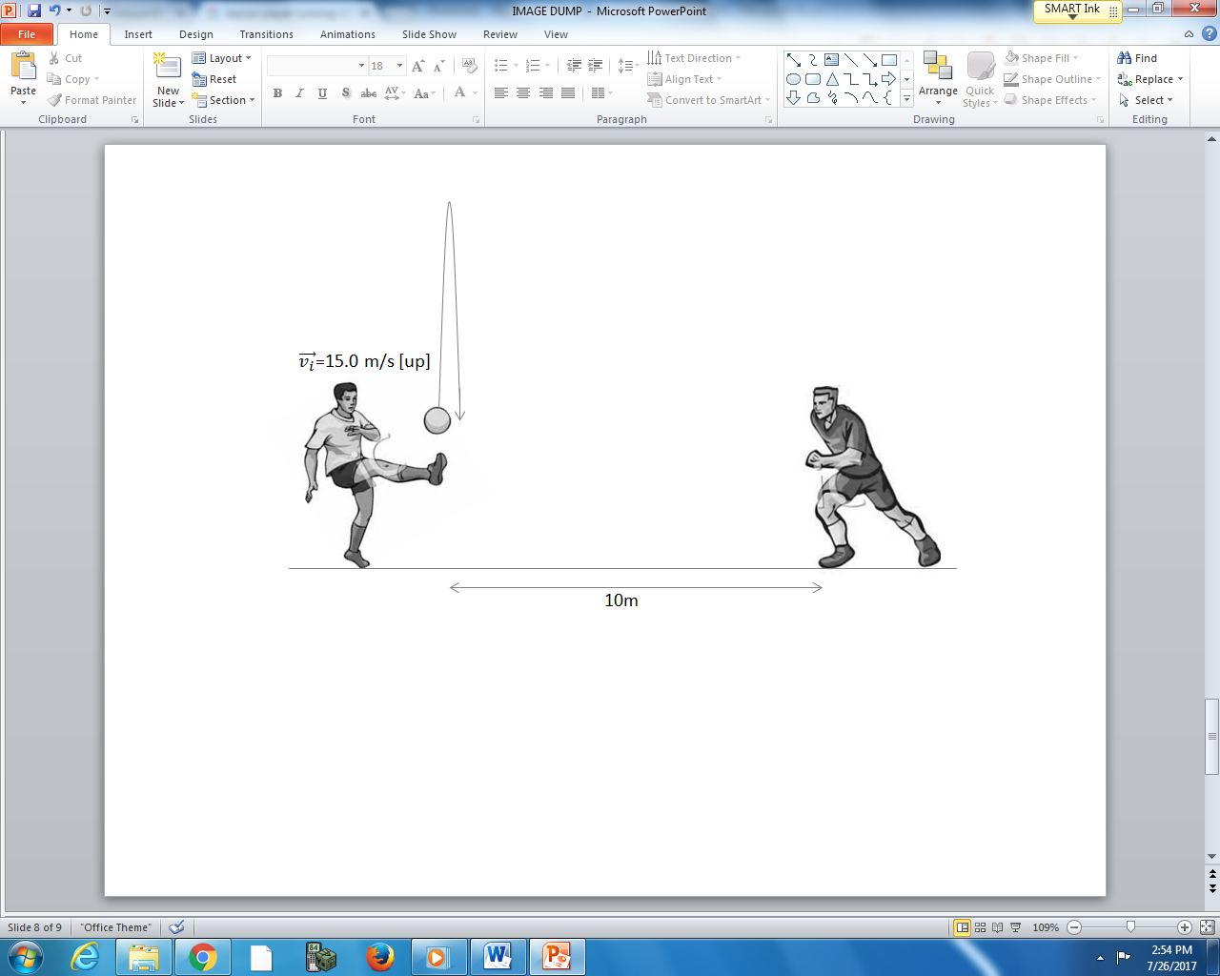

Q30: If the second player intercepts the ball at exactly the height it was originally launched upward at, how fast what the second player running, in meters per second?
(Record your three digit answer in the Numerical Response boxes below)

