First Name:______________________________ Last Name:______________________________

L07 – Worksheet – Parallel Plates

Textbook Questions
Pg 565 #1: In moving a charge of 5.0 C from one terminal to the other, a battery raises he electric potential energy of the charge by 60 J. Determine the potential difference between the battery terminals.

Pg 565 #2: A charge of 2.00 x 10⁻² C moves from one charged plate to an oppositely charged plate. The potential difference between the plates is 500 V. How much electric potential energy will the charge gain?

Pg 566 #1: A sphere with a charge of magnitude 2.00 C is moved between two positions between oppositely charged plates. It gains 160 J of electric potential energy. What is the potential difference between the two positions?

Pg 566 #2: An electron moves between two positions with a potential difference of 4.00 x 10⁴ V. Determine the electric potential energy gained by the electron, in joules (J) and electron volts (eV).

Pg 568 #1: Two charged parallel plates, separated by 5.0 x 10⁻⁴ m, have an electric field of 2.2 x 10⁴ V/m between them. What is the potential difference between the plates?

Pg 568 #2: Spark plugs in a car have electrodes whos faces can be considered to be parallel plates. These plates are separated by a gap of 5.00 x 10⁻³ m. If the electric field between the electrodes is 3.00 x 10⁶ V/m, calculate the potential difference between the electrode faces.

Pg 569 #4: At a point in Earth’s atmosphere, the electric field is 150 N/C downward and the gravitational field is 9.80 N/kg downward.
- Determine the electric force on a proton (p⁺) placed at this point.

- Determine the gravitational force on the proton at this point. The proton has a mass of 1.67 x 10⁻²⁷ kg.

Pg 569 #6: What is the electric field intensity 0.300 m away from a small sphere that has a charge of 1.60 x 10⁻⁸ C?

Diploma Worksheet Questions – Parallel Plates (Basic Definitions)
Q178: A negatively charged particle with an initial velocity of zero (v_{o} = 0) is placed in a uniform electric field. If no other forces are present, the particle subsequently will
- Lose charge
- Lose momentum
- Gain kinetic energy
- Gain potential energy

Q179: A charged plastic sphere is midway between two parallel plates that are connected to a battery. The action that will NOT double the force on the sphere is
- Halving the distance between the plates
- Doubling the voltage of the battery
- Doubling the charge on the sphere
- Halving the area of the plates

Q180: The electric field between charged parallel plates is
- Uniform
- Strongest near each plate
- Dependent on the area of the plates
- Strongest midway between the plates

Q185: The direction of the electric field between two charged, parallel, metal plates is shown by
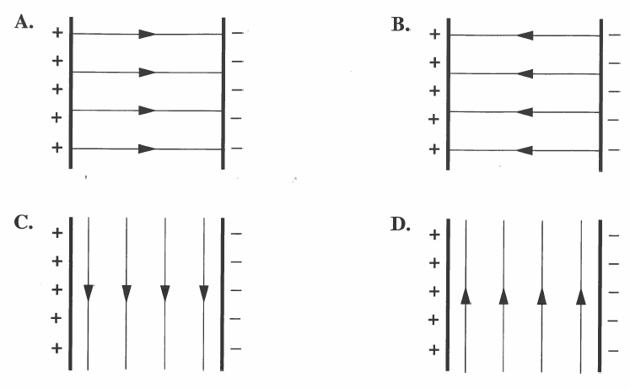
Diploma Worksheet Questions – Parallel Plates (Calculations)
Q186: The electric field between two parallel plates that are 5.0 cm apart is 1.0 x 10² N/C. The potential difference across the plates is
- 2.0 x 10³ V
- 5.0 x 10² V
- 2.0 x 10¹ V
- 5.0 x 10⁰ V

Q187: The electric field between two parallel plates that are 0.20 m apart and have a potential difference of 6.0 x 10² V is
- 3.0 x 10¹ N/C
- 1.2 x 10² N/C
- 3.0 x 10³ N/C
- 1.5 x 10⁴ N/C

Use the following information to answer Q190:
Two parallel metal plates are 1.5 cm apart and are maintained at a potential difference of
2.5 x 10² V

Q190: The magnitude of the electrical force on an alpha particle when the alpha particle is between the plates is
- 5.3 x 10⁻¹⁵ N
- 2.7 x 10⁻¹⁵ N
- 5.3 x 10⁻¹⁷ N
- 2.7 x 10⁻¹⁷ N

Diploma Worksheet Questions – Parallel Plates (Graphing and Algebra)
Use the following information to answer Q192:
A charged sphere, located in the space between two flat parallel plates connected to a battery, experiences an electrical force of 3.32 x 10⁻³ N.

Q192: The plates are kept at the original separation. If the charge on the sphere is reduced to exactly one-half and the potential difference between the plates is exactly tripled, then the force on the charged sphere will be b x 10⁻³ N. The value of b is ____.
(Record your three digit answer in the Numerical Response boxes below)

Use the following information to answer Q193 – Q195:
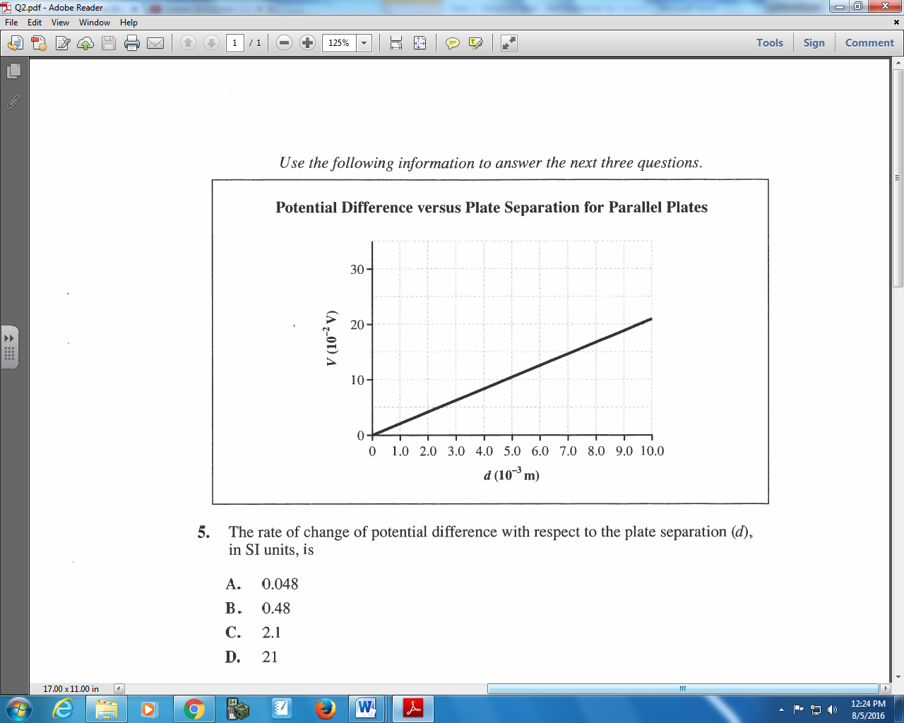

Q193: The rate of change of potential different with respect to the plate separation, (d), in SI units, is
- 0.048
- 0.48
- 2.1
- 21
Q194: The proper SI units for the slope of the line on the graph are
- J/m
- V/m
- V/s
- N/s
Q195: The physical quantity that the slope represents is the electric
- Force
- Power
- Field strength
- Potential energy

Diploma Worksheet Questions – Parallel Plates (Case Studies)
Use the following information to answer Q200 – Q203:
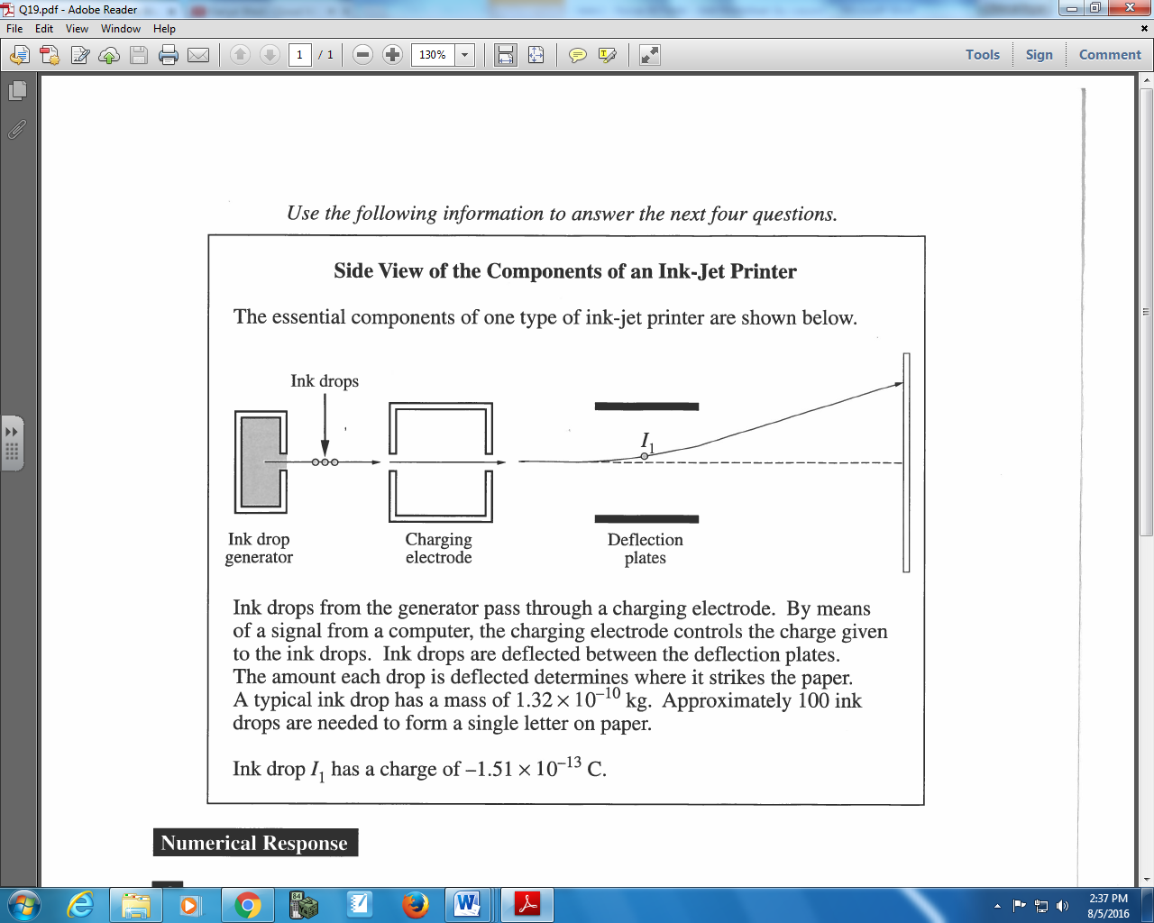

Q200: The number of excess electrons given to ink drop I₁ expressed in scientific notation, is a.bc x 10^{d} electrons. The values of a, b, c, and d are ___, ___, ___, and ___.
(Record your four digit answer in the Numerical Response boxes below)

Q201: The deflection plates are 0.100 mm apart, and there is a potential difference of 120 V across them. The magnitude of the electric field between the plates is
- 1.20 x 10⁶ N/C
- 1.20 x 10³ N/C
- 1.20 x 10¹ N/C
- 1.20 x 10⁻² N/C

Q203: To cause ink drop I₁ to follow the path shown, the direction of the electric field between the charged deflection plates must be toward the
- Bottom of the page
- Top of the page
- Right of the page
- Left of the page
Challenge Questions
None
Cumulative Review from Previous Units
Use the following information to answer Q1:
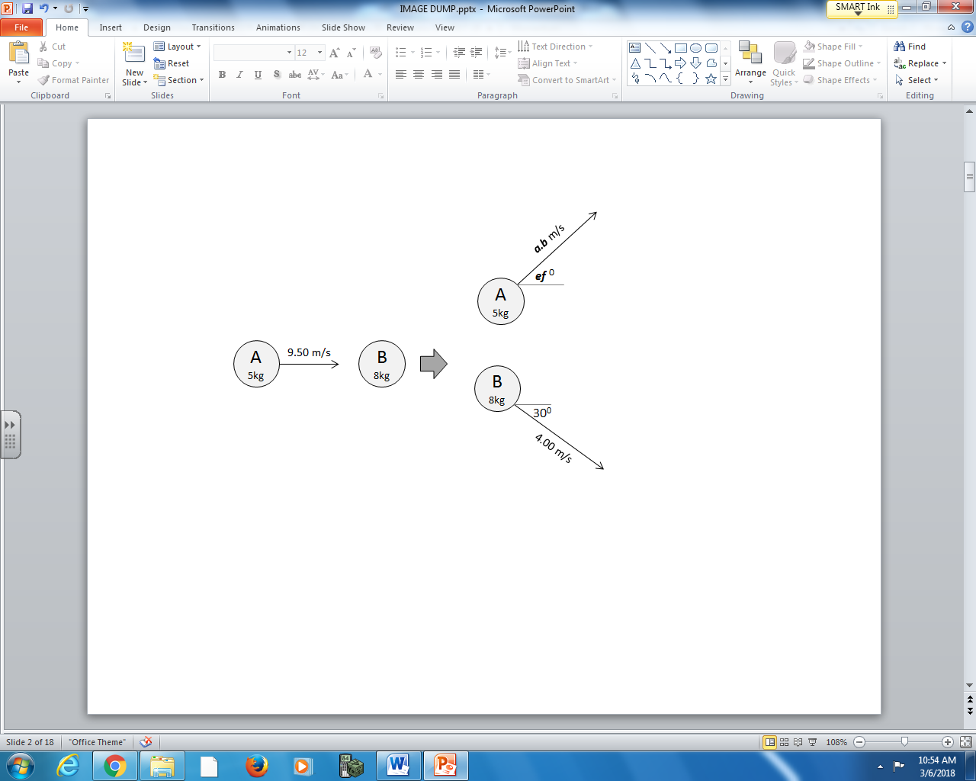

Q1: Object A rebounds with a velocity of a.b m/s [ef ⁰], where a, b, e, and f are ___, ___, ___, and ___.
(Record your four digit answer in the Numerical Response boxes below)

