First Name:______________________________ Last Name:______________________________
L07 – Worksheet – Radioactive Decay
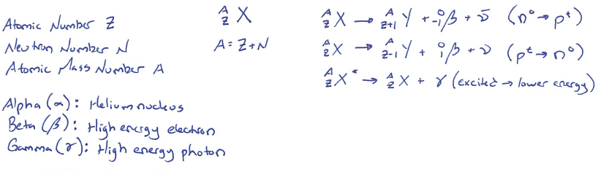
Textbook Questions
Pg 791 #1: How many neutrons are in a nucleus of ${}_{12}^{24}{Mg}$?

Pg 791 #2: Find the atomic mass number for a uranium atom that contains 92 protons and 146 neutrons.

Pg 799 #1-3: Determine whether these decay processes are possible.
Pg 799 #1: ${}_{84}^{212}{Po}→{}_{86}^{210}{Rn}+{}_{2}^{4}α$

Pg 799 #2: ${}_{91}^{233}{Pa}→{}_{92}^{233}U+{}_{-1}^{0}β$

Pg 799 #3: ${}_{6}^{14}C→{}_{7}^{14}N+{}_{1}^{1}H$

Pg 800 #1-3: Write the α-decay process for these elements, and name the parent and daughter elements.
Pg 800 #1: ${}_{90}^{230}{Th}$

Pg 800 #2: ${}_{92}^{238}U$

Pg 800 #3: ${}_{84}^{214}{Po}$

Pg 803 #1: Find the element produced by $β^{-}$decay of
- ${}_{88}^{228}{Ra}$

- ${}_{82}^{212}{Pb}$

Pg 805 #1ab: (a) What isotope will $β^{+}$ decay of thallium-202 produce? (b) Write the process for this decay.

Pg 810 #4: (a) Which type of beta decay transmutes carbon-14 into nitrogen? (b) Write the process for this decay.

Pg 810 #5: (a) Which type of beta decay transmutes the sodium isotope ${}_{11}^{22}{Na}$ into ${}_{10}^{22}{Ne}$? (b) Write the process for this decay.

Pg 810 #11: Identify each type of decay in this series, and name the parent and daughter elements.
- ${}_{90}^{232}{Th}→{}_{88}^{228}{{Ra}^{*}}+{}_{2}^{4}∝$
- ${}_{11}^{22}{Na}→{}_{10}^{22}{Ne}+{}_{1}^{0}β+ν$
- ${}_{88}^{228}{{Ra}^{*}}→{}_{88}^{228}{Ra}+γ$
- ${}_{88}^{228}{Ra}→{}_{89}^{228}{Ac}+{}_{-1}^{0}{β+\overline{ν}}$
- ${}_{89}^{228}{Ac}→{}_{90}^{228}{Th}+{}_{-1}^{0}{β+\overline{ν}}$
- ${}_{90}^{228}{Th}→{}_{88}^{224}{Ra}+{}_{2}^{4}α$
- ${}_{1}^{0}p→{}_{0}^{0}n+{}_{1}^{0}{β+ν}$

Cumulative Review
Use the following information to answer Q1:
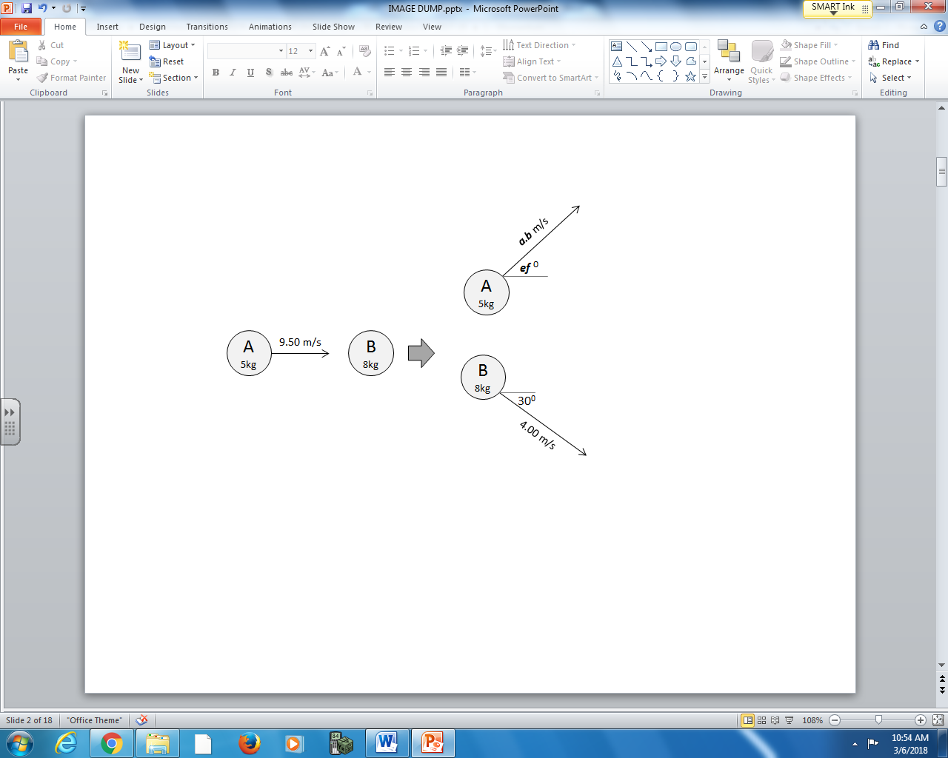

Q1: Object A rebounds with a velocity of a.b m/s [ef ⁰], where a, b, e, and f are ___, ___, ___, and ___.
(Record your four digit answer in the Numerical Response boxes below)

Use the following information to answer Q2:
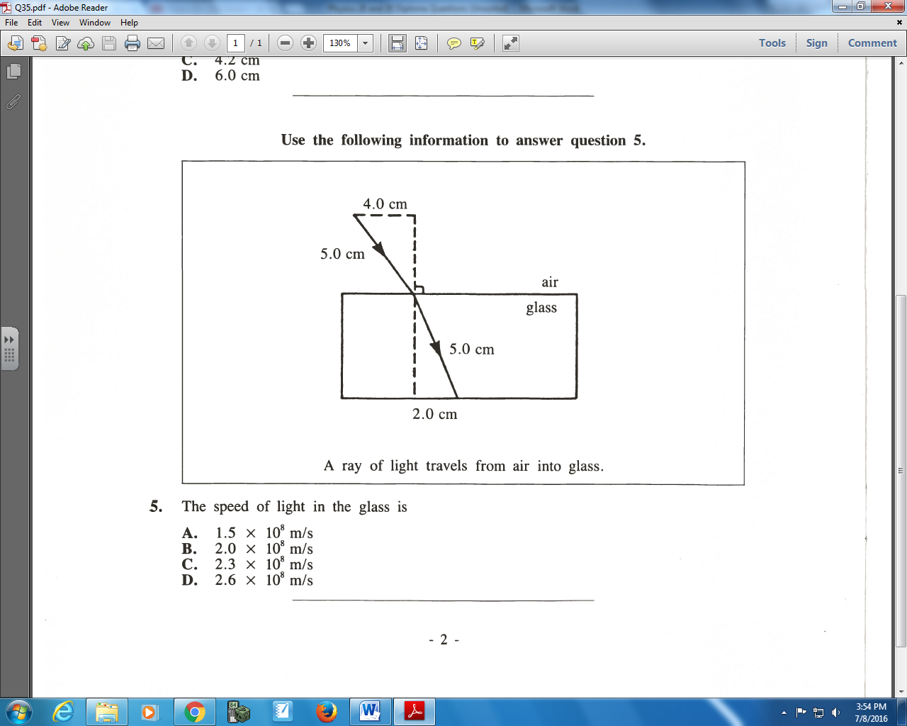

Q2: The speed of light in the glass is
- 1.5 x 10⁸ m/s
- 2.0 x 10⁸ m/s
- 2.3 x 10⁸ m/s
- 2.6 x 10⁸ m/s

Q3: An incident photon of wavelength 450nm is incident on a Sodium surface with a work function of 2.28eV. Determine the kinetic energy of the emitted electrons, measured in electronvolts.
(Record you three-digit answer in the numerical response boxes below.)

Use the following information to answer Q4-Q7:
Two positively charged spheres are held 1.00m apart. Once released, both charges electrostatically repel from each other, per the diagram below.
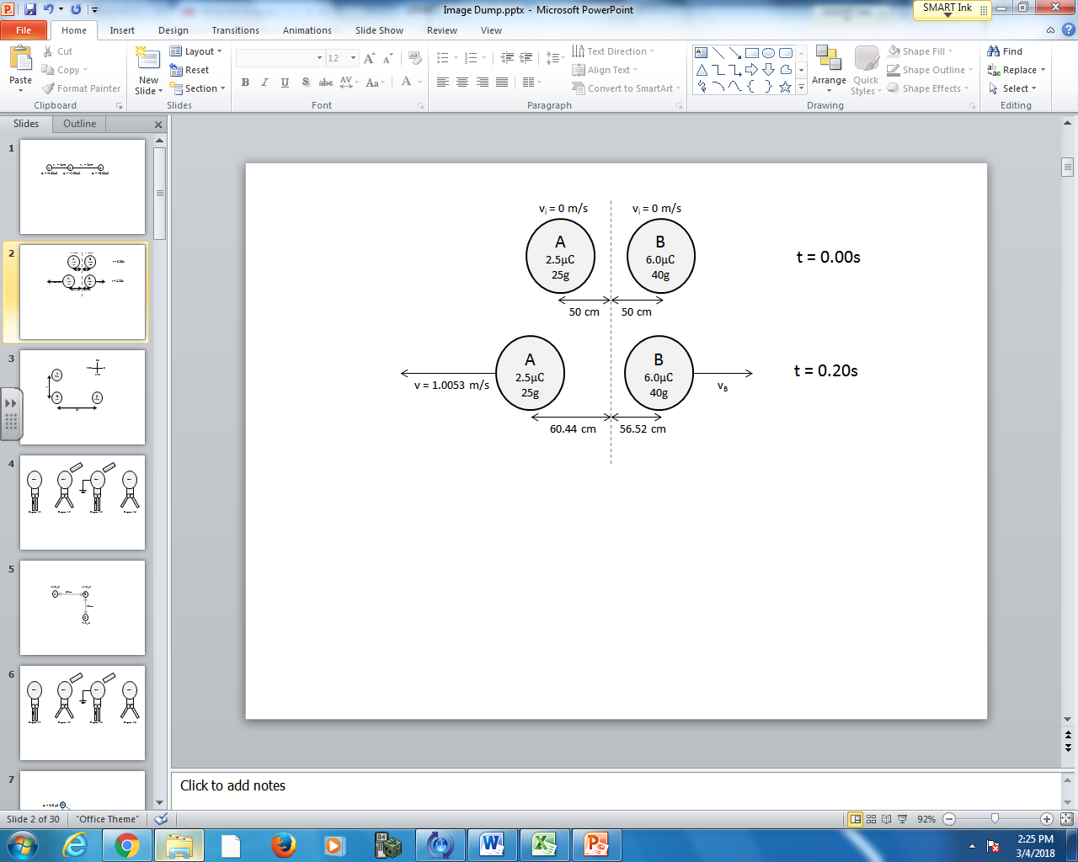

Q4: The instantaneous acceleration of Object A, the moment it is released, is
- 5.39 x 10⁻³ m/s²
- 2.16 x 10⁻² m/s²
- 5.39 m/s²
- 2.16 x 10¹ m/s²

Q5: What is the impulse experienced by Object A within the first 0.20 seconds?
- 2.35 x 10⁻² Ns
- 2.51 x 10⁻² Ns
- 2.70 x 10⁻² Ns
- 2.87 x 10⁻² Ns

Q6: What is the speed of Object B at exactly 0.20 seconds is a.bc x 10^{-d} m/s, where a, b, c, and d are ___, ___, ___, and ___.
(Record your four digit answer in the Numerical Response boxes below)

Q7: The electrostatic force between Object A and Object B, measured at exactly 0.20s, is a.bc x 10^{-d} N, where a, b, c, and d are ___, ___, ___, and ___.
(Record your four digit answer in the Numerical Response boxes below)

