First Name:______________________________ Last Name:______________________________
L07 – Worksheet – Refraction Lenses Graphing and Optics Rails
Optics Rails
Use the following information to answer Q1-Q2:
A candle, converging lens, and a screen are placed on a meter stick. The position of the screen is adjusted until an image of the candle comes into focus.
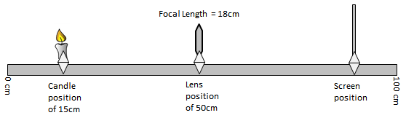

Q1: When the image of the candle is in focus, the screen is positioned at the ____ cm mark.
(Record your three digit answer in the Numerical Response boxes below)

Q2: The image formed is __i__ and __ii__.
 | i. | ii.
A. | erect | diminished
B. | erect | enlarged
C. | inverted | diminished
D. | inverted | enlarged

Use the following information to answer Q3:
A candle, converging lens, and a screen are placed on a meter stick. The position of the screen is adjusted until an image of the candle comes into focus.
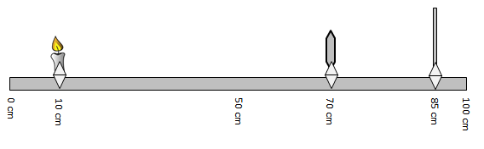

Q3: The focal length of the converging lens is _____ cm.
(Record your three digit answer in the Numerical Response boxes below)

Use the following information to answer Q4:
A candle, concave mirror, and a screen are placed on a meter stick. The position of the screen is adjusted until an image of the candle comes into focus.
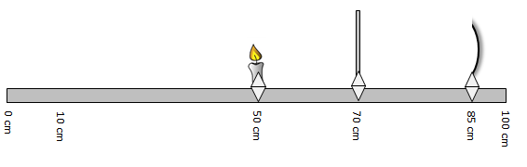

Q4: The focal length of the concave mirror is _____ cm.
(Record your three digit answer in the Numerical Response boxes below)

Refraction Lenses Graphing
Use the following information to answer Q5:
A student performing an Optics Rail experiment graphs the inverse of object distance versus the object of image distance, and plots the data below:
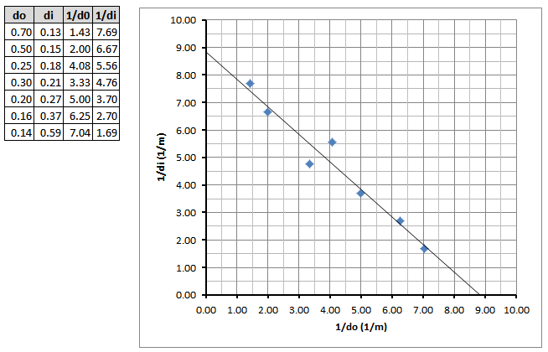

Q5: If the image were formed by a converging lens, then the focal length of the lens is _____ cm.
(Record your three digit answer in the Numerical Response boxes below)

Challenge Questions
Use the following information to answer Q6:
Students use three of the optical apparatus illustrated below to produce a focused, real image in a darkened room. One of the apparatus has a focal length of 4.50 cm.
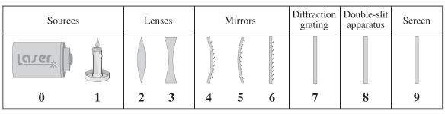
The students place one apparatus at each labelled location on an optics bench, as shown below. The optics bench is scaled in millimeters and labelled in centimeters.
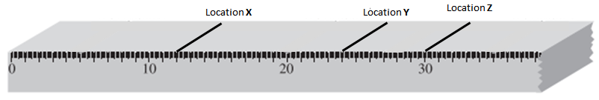
Note: The diagrams are not drawn to scale.

Q6: The apparatus placed at location
X is numbered _______ (Record in the first column)
Y is numbered _______ (Record in the second column)
Z is numbered _______ (Record in the third column)
(Record your three digit answer in the Numerical Response boxes below)

