First Name:_____________________________ Last Name:______________________________

L07 – Worksheet – Review – Power, Work and Energy /28 marks
Note: This worksheet does not cover oscillatory motion.

Pt 1: Mechanical Energy ___ / 5 marks
Pt 2: Hooke’s Law and Elastic Potential Energy ___ / 6 marks
Pt 3: Graphical Representation of Hooke’s Law ___ / 6 marks
Pt 4: Elastic Potential Energy and Conservation of Energy ___ / 4 marks
Pt 5: Work and Power ___ / 7 marks
Part 1 – Mechanical Energy
Use the following information to answer Q1:
Rollercoaster Design
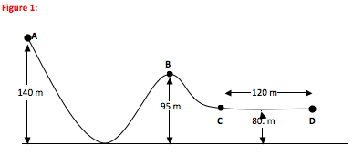

Assume that the rollercoaster is frictionless, and that the cart is stationary at Position A. The empty cart has a mass of 550 kg.

Q1: How much potential energy does the cart have while at Position A?
- 1.37 x 10³ N
- 1.37 x 10³ J
- 7.55 x 10⁵ N
- 7.55 x 10⁵ J
Q2: How fast is the cart travelling when it reaches Position B?
- 14.9 m/s
- 17.6 m/s
- 21.0 m/s
- 29.7 m/s
Q3: How long will it take the cart to get from Position C to Position D?
- 2.3 s
- 3.5 s
- 4.0 s
- 6.1 s
Q4: (Long Answer) A mass on a pendulum is raised 35⁰, as depicted below. How fast is it travelling when it reaches the very bottom of its arc? (2 marks)
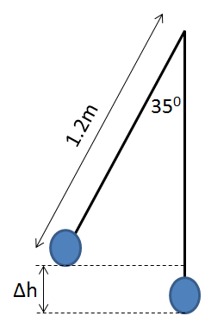
Part 2 – Hooke’s Law and Elastic Potential Energy
Q5: (Long Answer) What is the mass of the unknown mass below, in grams, if a 100g mass stretches the spring a distance of 9.5cm? (2 marks)
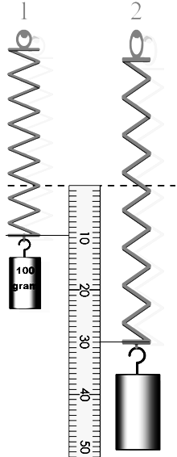

Use the following information to answer Q6 and Q7:
Diagram 1 Diagram 2
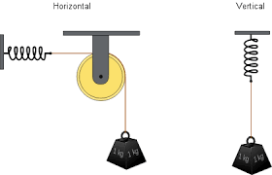
The 1kg mass stretches the spring in Diagram 2 from 15.0 cm to 17.2 cm long.
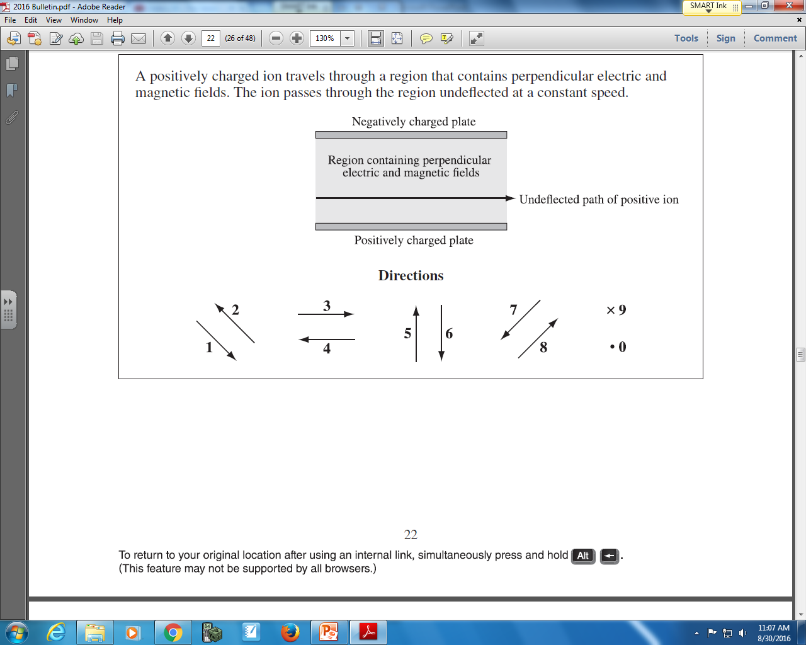

Q6: The directions of forces acting on mass B can be described using the numbers given above.
Direction: __________ __________ __________ __________
Force: Gravity on mass Restoring Force Gravity on mass Restoring Force
in Diagram 1 on spring in in Diagram 2 on spring in
Diagram 1 Diagram 2
(Record your four digit answer in the Numerical Response boxes below)

Q7: The spring constant of the spring in Diagram 2 is
- 5.7 x 10⁻¹ N/m
- 4.5 N/m
- 5.7 x 10¹ N/m
- 4.5 x 10² N/m

Use the following information to answer Q8 and Q9:
A spring of spring constant 27.0 N/m is stretched by a hanging mass, as depicted below.
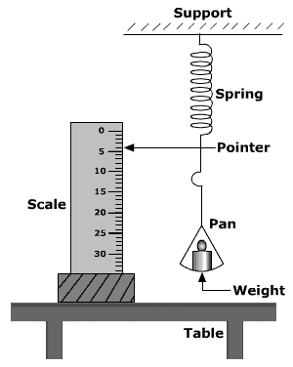
The scale measures in centimeters.

Q8: What is the mass of the hanging weight?
- 0.09 kg
- 0.11 kg
- 9.08 kg
- 11.00 kg

Q9: The spring has a.bc x 10^{-d} Joules of elastic potential energy stored, where a, b, c, and d are ___,___,___, and ___.
(Record your four digit answer in the Numerical Response boxes below)

Part 3 – Graphical Representations of Hooke’s Law
Use the following information to answer Q10 and Q11:
Graph of Force versus Distance for a Spring
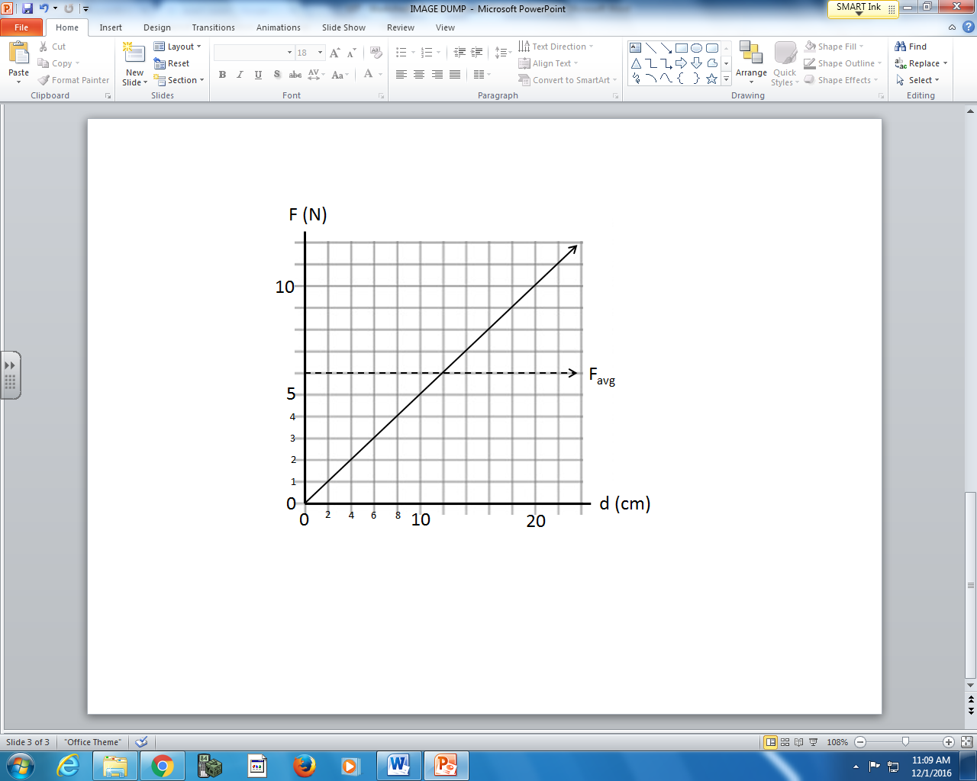

Q10: What is the spring constant of this spring?
- 0.5 N/m
- 2.0 N/m
- 50.0 N/m
- 200.0 N/m

Q11: When stretched 12 cm, there is a.bc x 10^{-d} Joules of elastic energy stored in the spring, where
a, b, c, and d are ___, ___, ___, and ___.
(Record your four digit answer in the Numerical Response boxes below)

Use the following information to answer Q12-14:
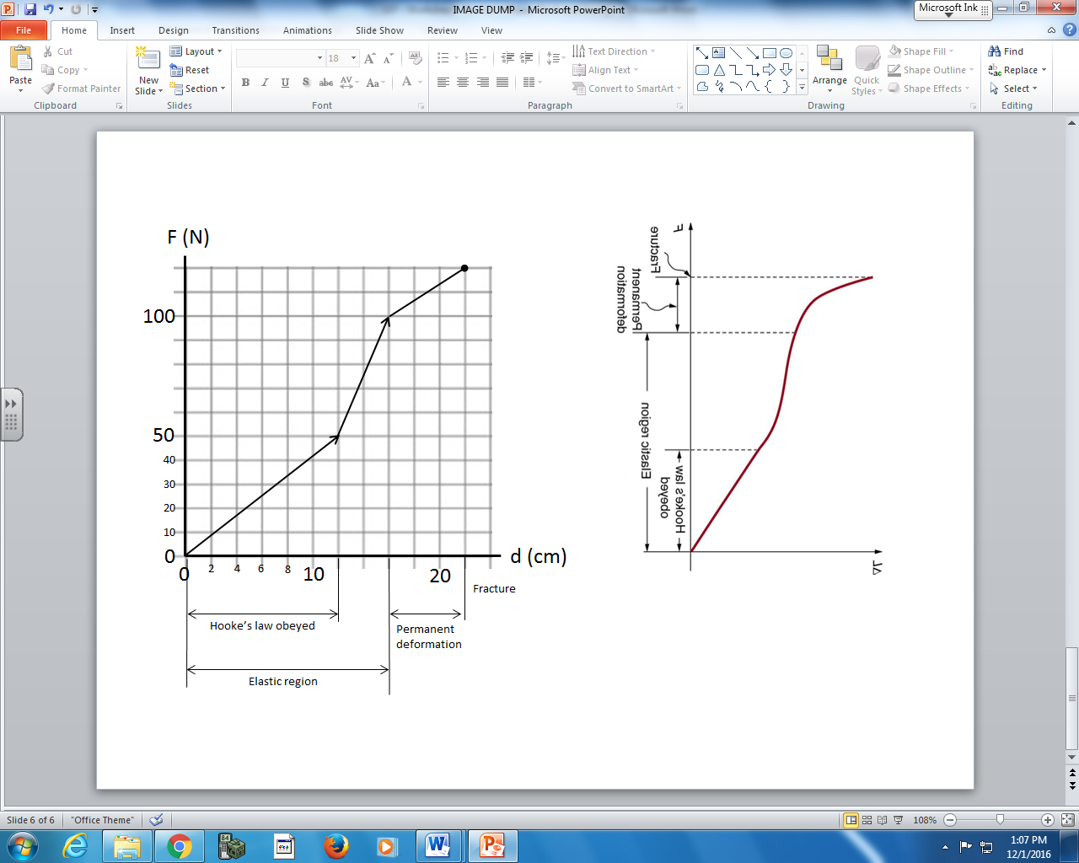

Q12: The spring constant of this spring is
- 4.17 N/m
- 5.45 N/m
- 4.17 x 10² N/m
- 5.45 x 10² N/m

Q13: How much force is required to stretch this spring to 12 cm?
- 50 N
- 51 N
- 60 N
- 75 N

Q14: (Long Answer) How much elastic potential energy is stored in the spring when it is stretched to
16 cm? (2 marks)

Part 4 – Elastic Potential Energy and Conservation of Energy
Use the following information to answer Q15:
A mass of 2kg on a spring on constant 15 N/m is stretched 40cm to the right, then released.
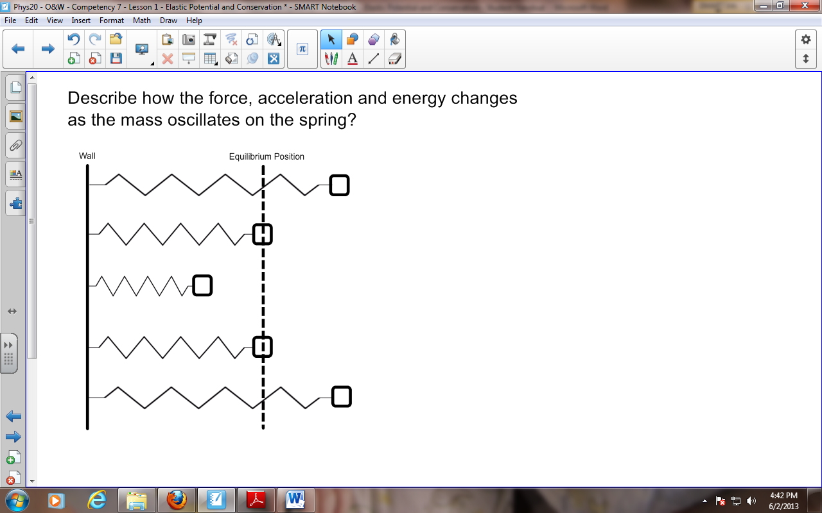

Diagram 1

Diagram 2

Q15: How fast is the mass travelling when it reaches the equilibrium position?
- 1.20 x 10⁻¹ m/s
- 1.10 m/s
- 1.73 m/s
- 3.00 m/s

Use the following information to answer Q16 and Q17:
Bow and Arrow
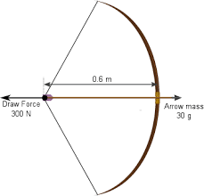
300 Newtons of force is required to draw a bow & arrow back 0.6 meters.

Q16: (Long Answer) If a 30 g arrow is pointed vertically and released, what is the maximum height the arrow can achieve? (2 marks)

Q17: How fast is the arrow travelling when it is released from the bow?
- 50.35 m/s
- 66.67 m/s
- 77.46 m/s
- 141.42 m/s

Part 5 – Work and Power
Use the following information to answer Q18:
Below is a side-by-side comparison of two popular 2015 motorcycles.
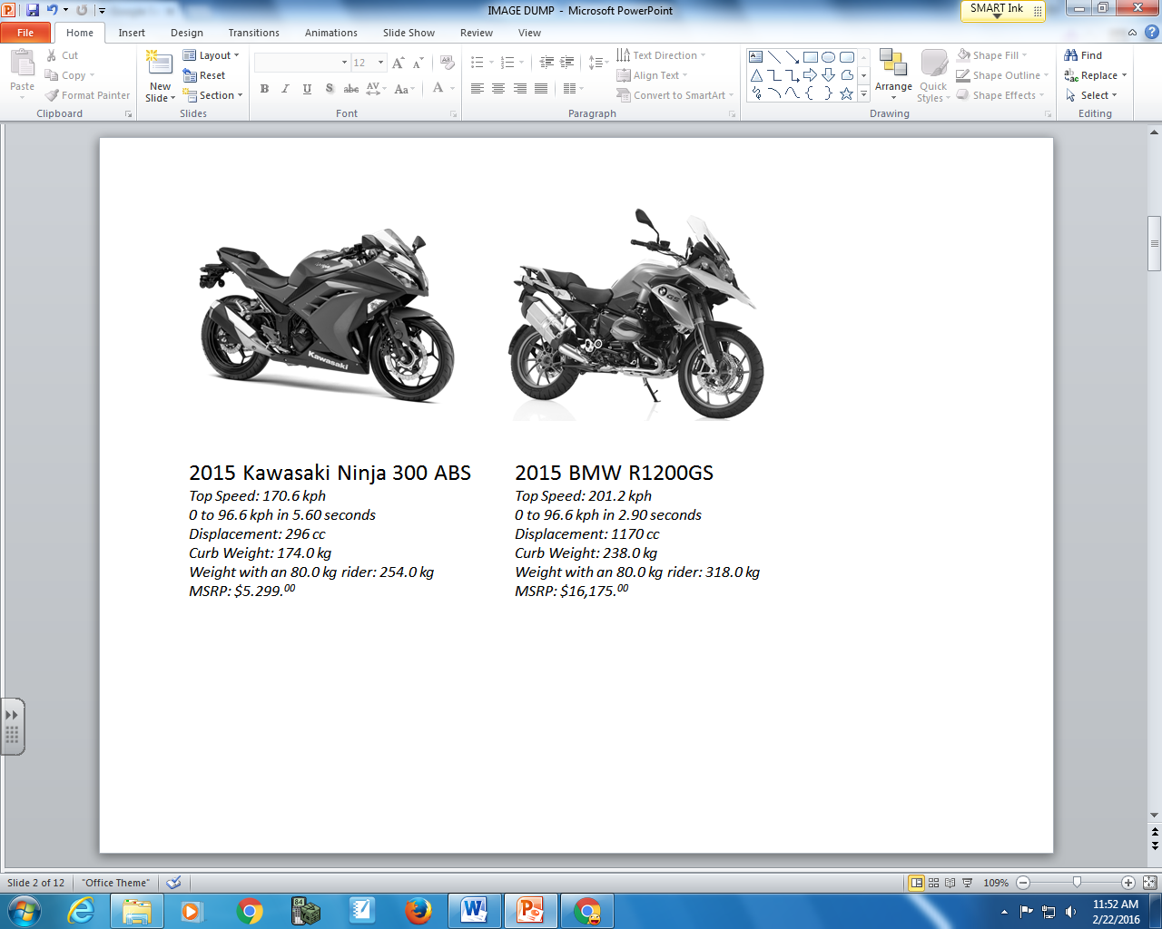
Assume that the 0 to 96.6 kph times were measured with an 80.0 kg rider on the motorcycle.

Q18: (Long Answer) How powerful, in Watts, is each motorcycle? (4 marks)

Q19: Renatta Gass is out with her friends. Misfortune occurs and Renatta and her friends find themselves getting a workout. They apply a cumulative force of 1080 N to push the car 218 m to the nearest fuel station. Determine the work done on the car.
- 4.95 J
- 7.30 x 10¹ J
- 1.30 x 10³ J
- 2.35 x 10⁵ J

Q20: Hans Full is pulling on a rope to drag his backpack to school across the ice. He pulls upwards and rightwards with a force of 22.9 Newtons at an angle of 35 degrees above the horizontal to drag his backpack a horizontal distance of 129 meters to the right. Determine the work (in Joules) done upon the backpack.
- 2419.9 N
- 2419.9 J
- 2954.1 N
- 2954.1 J

Q21: Lamar Gant, U.S. powerlifting star, became the first man to deadlift five times his own body weight in 1985. Deadlifting involves raising a loaded barbell from the floor to a position above the head with outstretched arms. The work done by Lamar in deadlifting 300 kg to a height of 0.90 m above the ground is a.bc x 10^{d} J, where a, b, c, and d are ___, ___, ___, and ___.
(Record your four digit answer in the Numerical Response boxes below)

