First Name:____________________________ Last Name:______________________________

L08 – FQ – Collisions in 2-Dimensions

Use the following information to answer Q1-Q2:
A stationary 0.50kg firework explodes into three pieces. The first piece has a mass of 0.25kg and a velocity of 3.0 m/s [90⁰]. The second piece has a mass of 0.10kg and a velocity of 2.0 m/s [0⁰].

Q1: The speed of the third fragment is ____ m/s.
(Record your three digit answer in the Numerical Response boxes below)

Q2: The magnitude of the momentum of the system immediately after the explosion is
- 0.00 kg*m/s
- 0.17 kg*m/s
- 1.73 kg*m/s
- 5.09 kg*m/s

Use the following information to answer Q3:
Two balls of clay on a frictionless surface collide, sticking together.
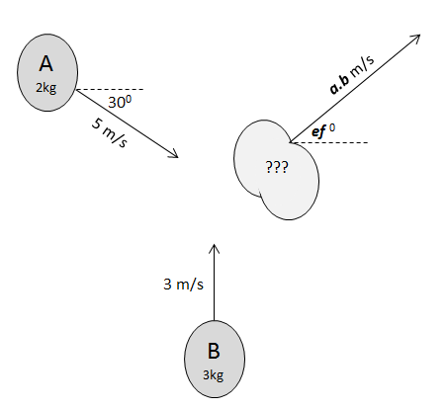

Q3: The velocity of the combined object immediately after the collision is a.b m/s [ef ⁰ N of E], where
a, b, e, and f are ___, ___, ___, and ___.
(Record your four digit answer in the Numerical Response boxes below)

MARKING:
Beginning 0.0 – 1.0
Progressing 1.5 – 2.0
Competent 2.5
Exemplary 3.0

