First Name:___________________________ Last Name:______________________________

L08 - Formative Quiz – Graphing Lenses and Mirrors

Q1: Linearize the equation $\frac{1}{f}=\frac{1}{d_{i}}+\frac{1}{d_{0}}$ and sketch a quick graph of it below. Explain the significance of the y-intercept. (1 mark for linearizing equation, 1 mark for graph, 1 mark for y-intercept significance; 3 marks total)


TURN OVER PAGE TO CONTINUE
Use the following information to answer Q2:
Students use three of the optical apparatus illustrated below to produce a focused, real image in a darkened room. One of the apparatus has a focal length of 7.5 cm.
Optical Apparatus
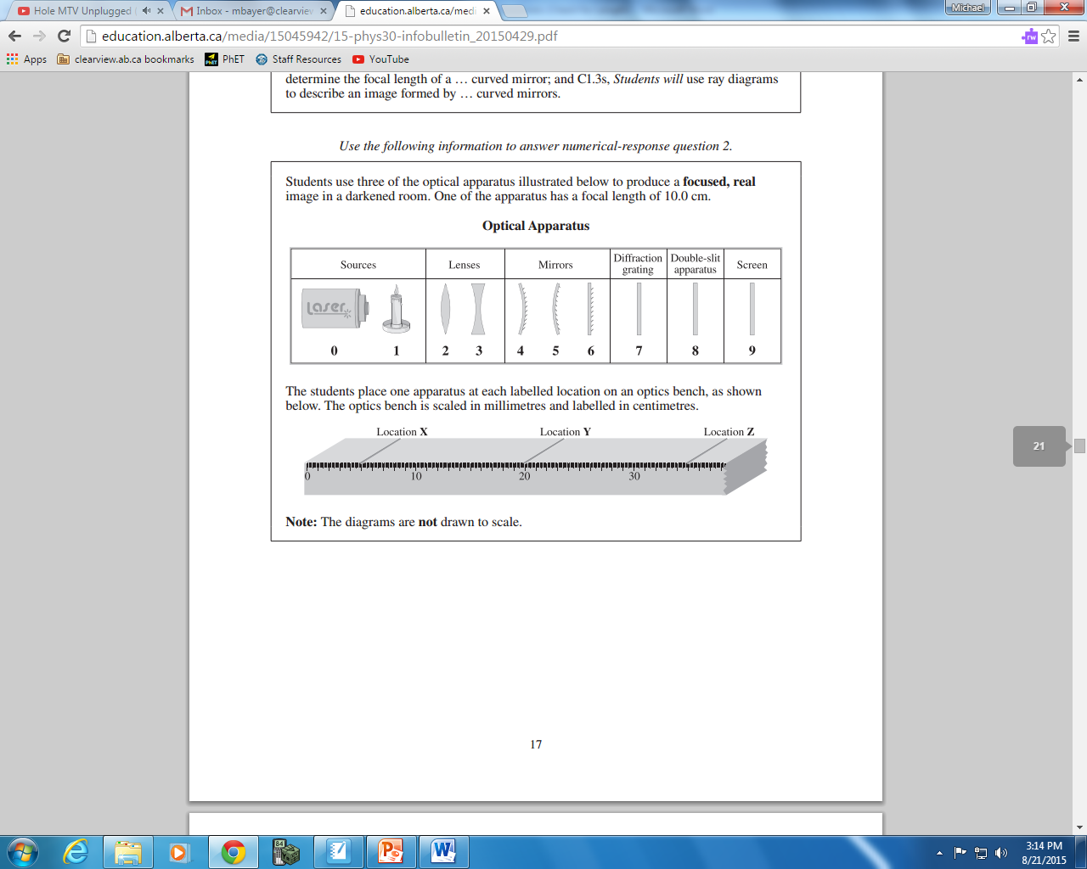
The students place one apparatus at each labelled location on an optics bench, as shown below. The optics bench is scaled in millimeters and labelled in centimeters.
Note: The diagrams are not drawn to scale.

Q2: The apparatus placed at location
X is numbered _______ (Record in the first column)
Y is numbered _______ (Record in the second column)
Z is numbered _______ (Record in the third column)
(Record you three-digit answer in the numerical response boxes below.)

MARKING:
Beginning 0-1
Progressing 2
Competent 3
Exemplary 4

