First Name:__________________________________ Last Name:______________________________

L08 – Formative Quiz – Parallel Plates
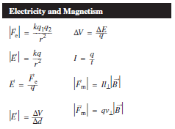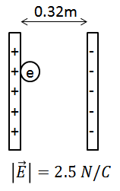
Q1: Two parallel plates are 0.32m apart, with a uniform electric field of 2.5 N/C, as depicted above. If an electron is moved from the positively charged plate to the negatively charged plate, how much Electric Potential Energy, in electron-volts (eV), does the electron gain? (3 mark)

MARKING:
Beginning 0.0 – 1.0
Progressing 1.5 – 2.0
Competent 2.5
Exemplary 3

