First Name:____________________________ Last Name:______________________________

L08 - FQ – Radioactive Decay
Use the following information to answer Q1 and Q2:
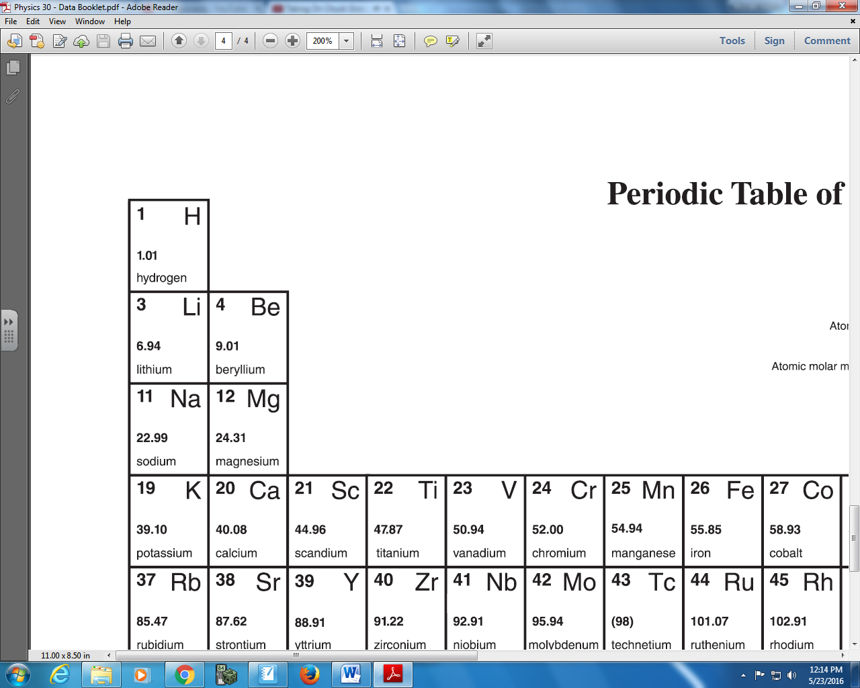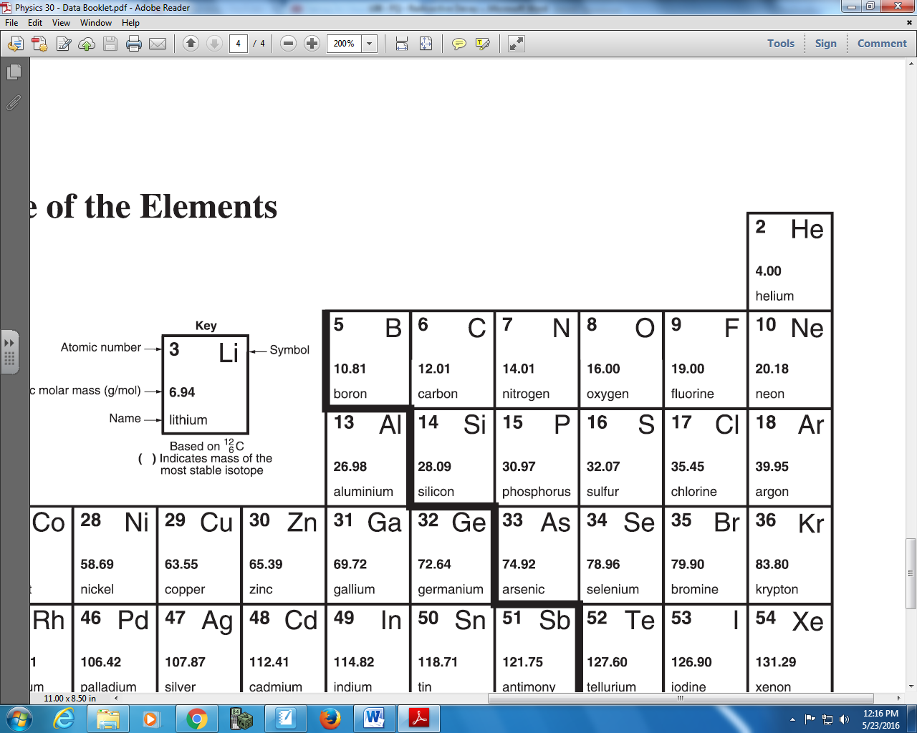

Q1: Potassium-39 has ab protons and cd neutrons, where the values of a, b, c, and d are ___, ___, ___, and ___.
(Record your four digit answer in the Numerical Response boxes below)

Q2: Carbon-14 has a protons, b neutrons, and cd nucleons, where the values of a, b, c, and d are ___, ___, ___, and ___.
(Record your four digit answer in the Numerical Response boxes below)

Q3: Polonium-218 undergoes alpha decay as follows:
$${}_{84}^{218}{Po}→{}_{ab}^{214}X+{}_{c}^{d}α$$
The values of a, b, c, and d are ___, ___, ___, and ___.
(Record your four digit answer in the Numerical Response boxes below)

Q4: Long Answer – Write the beta-negative decay of Bismuth-214.

Q5: Which two Physics Principles are required to determine the daughter products of a radioactive decay?
(Record your two digit answer in the Numerical Response boxes below)

Use the following information to answer Q6:
Radiation Source Experiencing a Magnetic Field
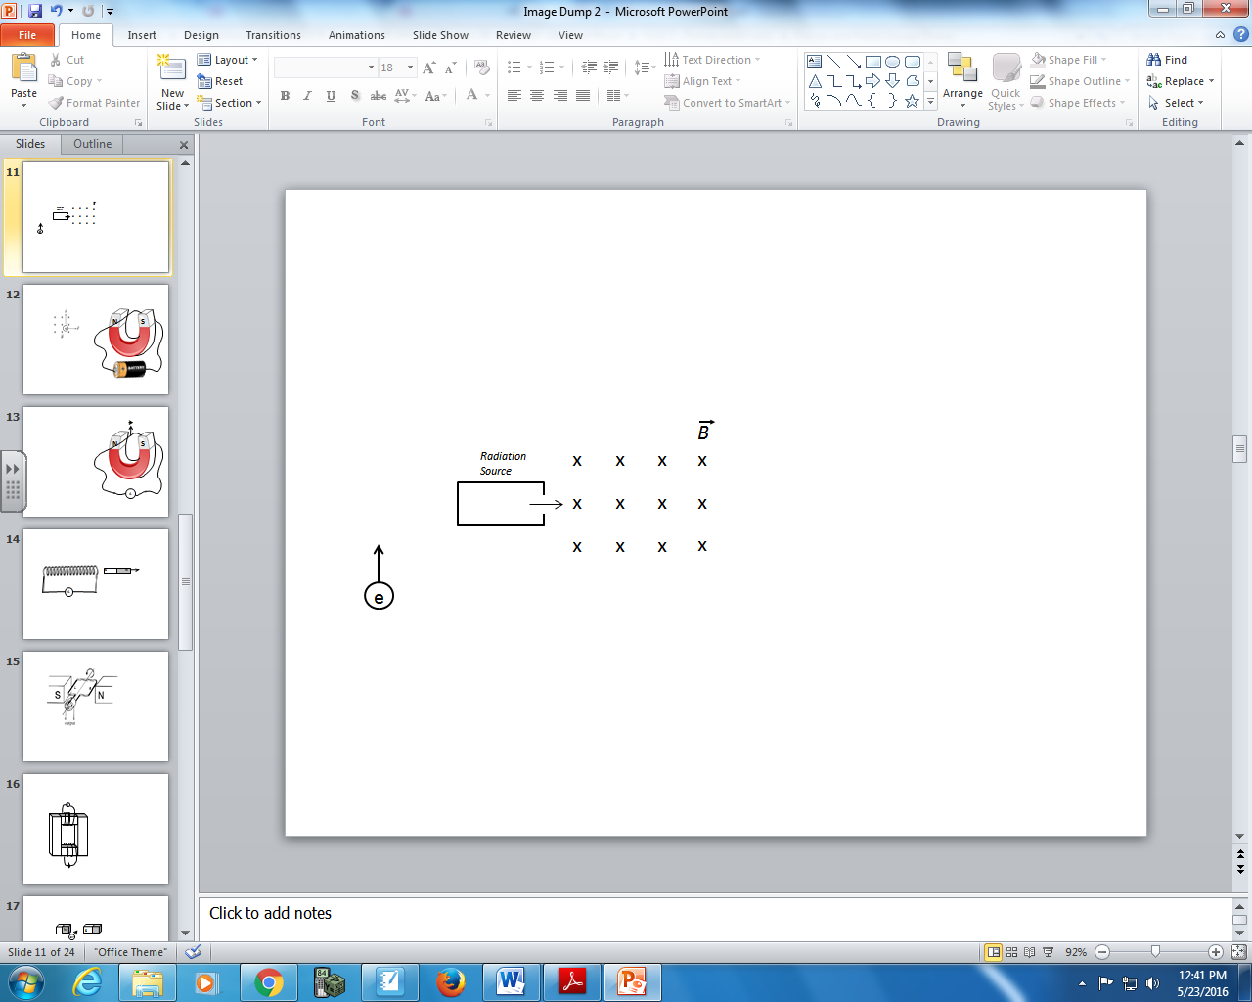
Deflecting Direction
1 – Upward
2 – Downward
3 – No deflection

Q6: A magnetic field is directed into the page. Alpha radiation, beta-negative radiation, beta-positive radiation, and gamma radiation are emitted into the magnetic field. Using the Numerical Response numbers above, which deflection direction will each experience?
__________ __________ __________ __________
Alpha Radiation Beta-Negative Beta-Positive Gamma Radiation
Deflection Deflection Deflection Deflection
Direction Direction Direction Direction
(Record your four digit answer in the Numerical Response boxes below)

Q7: Both protons and neutrons are made up of Up quarks and Down quarks.
_______ _______ _______ _______
Number of Number of Number of Number of
Up-Quarks Down-Quarks Up-Quarks Down-Quarks
in a Proton in a Proton in a Neutron in a Neutron
(Record your four digit answer in the Numerical Response boxes below)

Q8: Which of the following statements is true about stable isotopes?
- $N≤Z$
- $N≥Z$
- $N=Z$
- $N≠Z$

MARKING
Beginning 0.0 – 3.5
Progressing 4.0 – 5.5
Competent 6.0 – 7.5
Exemplary 8.0

