Name:_______________________ Physics 30
Lesson L08 Unit A - Momentum

Lab #1a: Momentum Cars /36 marks

Students are going to simulate four different collision conditions, as depicted below, using the Pasco PASCar ME-9650 momentum cars. In each condition, the moving blue car will strike the stationary red car from behind.

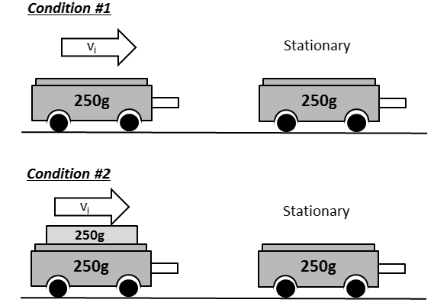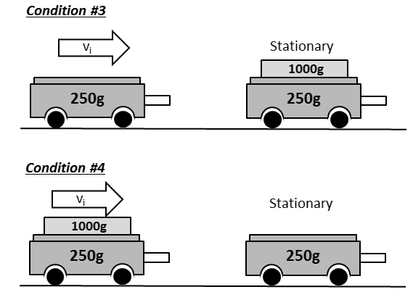

For each condition, students will need to determine the initial and final velocities of each car using distance markers and stopwatches. The momentum cars have very little friction, and we can assume that their velocities are constant over short distances.
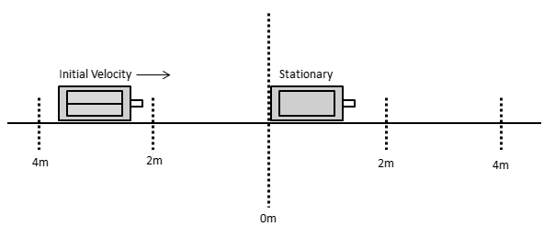
For each condition, students will determine if (a) momentum is conserved, and (b) the collision is elastic or inelastic. Data will be entered into Google Forms.

“Initiating and Planning”

Make a prediction as to the final velocity of each car in each condition, using phrases like “forward/backward” and “slow/fast/very fast”. Hint: The cars do not “stick together” in any of the cases. Predictions must be completed prior to starting the lab.

Condition | Car 1 –Blue Car | Car 2 – Red Car
1
2
3
4

 | Total | Weighting Multiplier | 3 | 2 | 1 | 0
State a prediction and a hypothesis based on available evidence, background information or theory. |  | x2 | Student is able to articulate and mathematically justify a possible result. | Student is able to articulate a probable result. | Student is able to articulate a possible, but highly improbable, result. | Student shows a conceptual misunderstanding of conservation of momentum.

“Performing and Recording”

Record all distance and time measurements for each condition in the table provided in this handout.

“Analyze and Interpret” Marking Rubric

Using the collected distance and time measurements, students will need to calculate:
- Velocities (Vector quantity) of all cars before and after impact.
- Momentums (Vector quantity) of all cars before and after impact.
- Kinetic Energy of all cars before and after impact.
- Initial momentum (Vector quantity) and kinetic energy of the system.
- Final momentum (Vector quantity) and kinetic energy of the system.
The table provided in this handout has room for all of these values.

Students will then need to draw conclusions about whether momentum and kinetic energy are conserved. For the purposes of this lab we will assume the following:
- If the percent loss is less than 20%, the quantity is conserved.
- If the percent loss is greater than 20%, the quantity is not conserved.
- If there is an increase in the quantity, this is due to a measurement error.

$$Percent Difference \left(\%\right)=\frac{(Initial-Final)}{Initial}x100\%$$

All data needs to be entered into the appropriate Google Form, found in the “Physics 30: The History of Chemistry explained through Mathematics” Google Classroom.

Total | Weighting Multiplier | Sum | Condition #1 | Condition #2 | Condition #3 | Condition #4
/30 | x0.5 | /60 | /15 | /15 | /15 | /15

Condition #1: Blue car = 0.250kg, Red car = 0.250kg

Initial |  |  |  | Final
Blue Car 1 |  | Red Car 2 |  | Blue Car 1 |  | Red Car 2
d (m) |  | d (m) | 0 | d (m) |  | d (m)
t (s) |  | t (s) | 0 | t (s) |  | t (s)
v (m/s) |  | v (m/s) | 0 | v (m/s) |  | v (m/s)
p (kg*m/s) |  | p (kg*m/s) | 0 | p (kg*m/s) |  | p (kg*m/s)
Ek (J) |  | Ek (J) | 0 | Ek (J) |  | Ek (J)
p-sys-initial |  |  |  | p-sys-final
Ek-sys-initial |  |  |  | Ek-sys-final
p-conserved?
Ek-conserved?

Condition #2: Blue car = 0.500kg, Red car =0.250kg

Initial |  |  |  | Final
Blue Car 1 |  | Red Car 2 |  | Blue Car 1 |  | Red Car 2
d (m) |  | d (m) | 0 | d (m) |  | d (m)
t (s) |  | t (s) | 0 | t (s) |  | t (s)
v (m/s) |  | v (m/s) | 0 | v (m/s) |  | v (m/s)
p (kg*m/s) |  | p (kg*m/s) | 0 | p (kg*m/s) |  | p (kg*m/s)
Ek (J) |  | Ek (J) | 0 | Ek (J) |  | Ek (J)
p-sys-initial |  |  |  | p-sys-final
Ek-sys-initial |  |  |  | Ek-sys-final
p-conserved?
Ek-conserved?

Condition #3: Blue car = 0.250kg, Red car = 1.250kg

Initial |  |  |  | Final
Blue Car 1 |  | Red Car 2 |  | Blue Car 1 |  | Red Car 2
d (m) |  | d (m) | 0 | d (m) |  | d (m)
t (s) |  | t (s) | 0 | t (s) |  | t (s)
v (m/s) |  | v (m/s) | 0 | v (m/s) |  | v (m/s)
p (kg*m/s) |  | p (kg*m/s) | 0 | p (kg*m/s) |  | p (kg*m/s)
Ek (J) |  | Ek (J) | 0 | Ek (J) |  | Ek (J)
p-sys-initial |  |  |  | p-sys-final
Ek-sys-initial |  |  |  | Ek-sys-final
p-conserved?
Ek-conserved?

Condition #4: Blue car = 1.250kg, Red car = 0.250kg

Initial |  |  |  | Final
Blue Car 1 |  | Red Car 2 |  | Blue Car 1 |  | Red Car 2
d (m) |  | d (m) | 0 | d (m) |  | d (m)
t (s) |  | t (s) | 0 | t (s) |  | t (s)
v (m/s) |  | v (m/s) | 0 | v (m/s) |  | v (m/s)
p (kg*m/s) |  | p (kg*m/s) | 0 | p (kg*m/s) |  | p (kg*m/s)
Ek (J) |  | Ek (J) | 0 | Ek (J) |  | Ek (J)
p-sys-initial |  |  |  | p-sys-final
Ek-sys-initial |  |  |  | Ek-sys-final
p-conserved?
Ek-conserved?

