First Name:_______________________________ Last Name:______________________________

L08 – Worksheet –Horizontal Systems /10 marks

Part 1: Basic Concepts and Algebra
Q1: An orbiting planet, m₁, is travelling around a star, m₂. It is orbiting at a radius of r. When solving for the orbital speed, which variable is not necessary?
- m₁
- m₂
- r
- All variables are necessary to solve this problem.

Q2: A car is making a horizontal turn around a corner. Which is the proper setup for this question?
- $\frac{v^{2}}{r}=g$
- $\frac{v^{2}}{r}=u_{s}g$
- $\frac{mv^{2}}{r}=mg$
- $\frac{mv^{2}}{r}=\frac{Gm_{1}m_{2}}{r^{2}}$

Q3: An object of mass m₁ is orbiting around a second object of mass m₂ at a distance of r. Solve for the speed of the orbiting object, v. (1 mark)

Part 2: Gravity in Space
Use the following information to answer Q4-Q6:
A satellite is in orbit above the surface of the Earth, as depicted below:
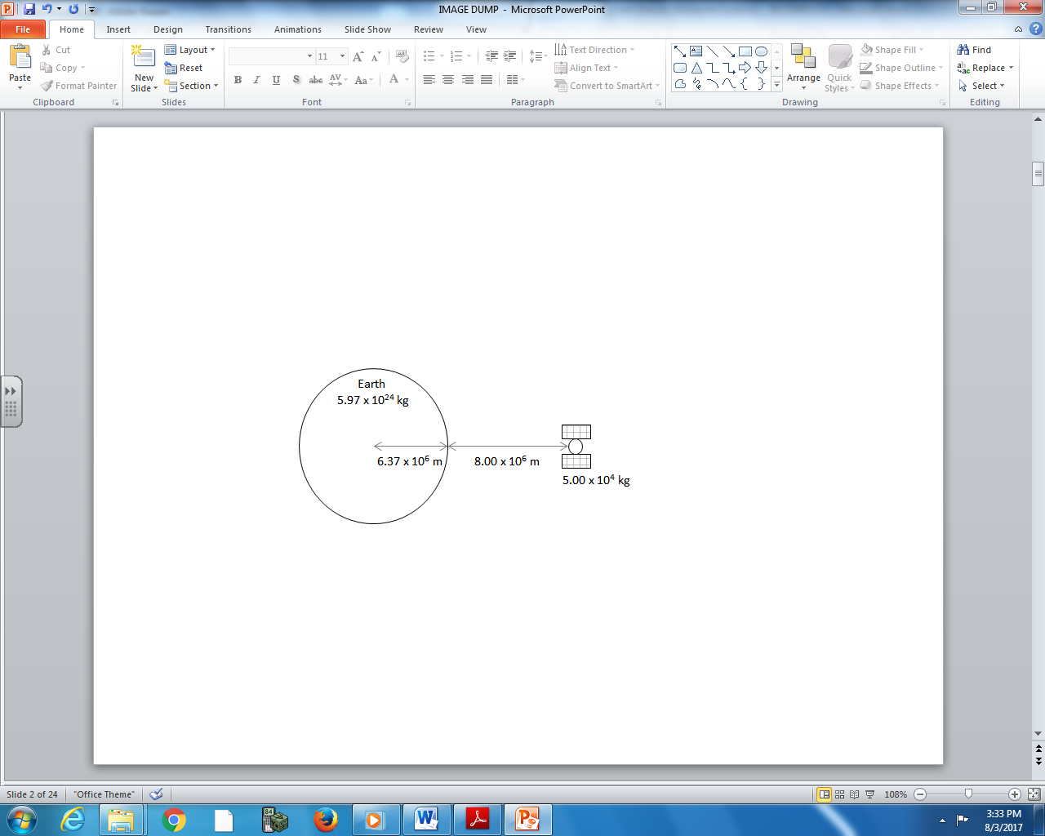

Q4: What is the gravitational force acting on the satellite?
- 9.64 x 10⁴ N
- 3.11 x 10⁵ N
- 1.39 x 10¹² N
- 2.04 x 10²³ N

Q5: The rotational speed of the satellite is a.bc x 10^{d} m/s, where a, b, c, and d are ___, ___, ___, and ___.
(Record your four digit answer in the Numerical Response boxes below)

Q6: If the Town of Stettler decided to launch their own satellite, and wanted it to always be directly above the high school, at what height above the surface of the Earth would the satellite need to be positioned? (3 marks)

Part 3: Friction on a Road
Use the following information to answer Q7:
A 2500kg car is going around a horizontal curve of radius 25 meters, at a constant speed of 50kph.

Q7: If the car is barely able to keep from slipping, what is the coefficient of friction between the car and the ground?
- 0.79
- 1.16
- 10.2
- 132

Use the following information to answer Q8:
A truck is going around a turn at a speed of 15m/s when he feels his tires begin to slip.
Q8: If the coefficient of friction between the tires and the road is 0.95, what is the radius of the turn, in meters?
(Record your three digit answer in the Numerical Response boxes below)

