First Name:______________________________ Last Name:______________________________
L08 – Worksheet – Parallel Plates and Projectile Motion
Introductory Questions
Q1: An electron (beam) is projected horizontally between vertical plates. The electron doesn’t make it all of the way through, and instead smashes into one of the plates. What is its horizontal displacement, in meters?
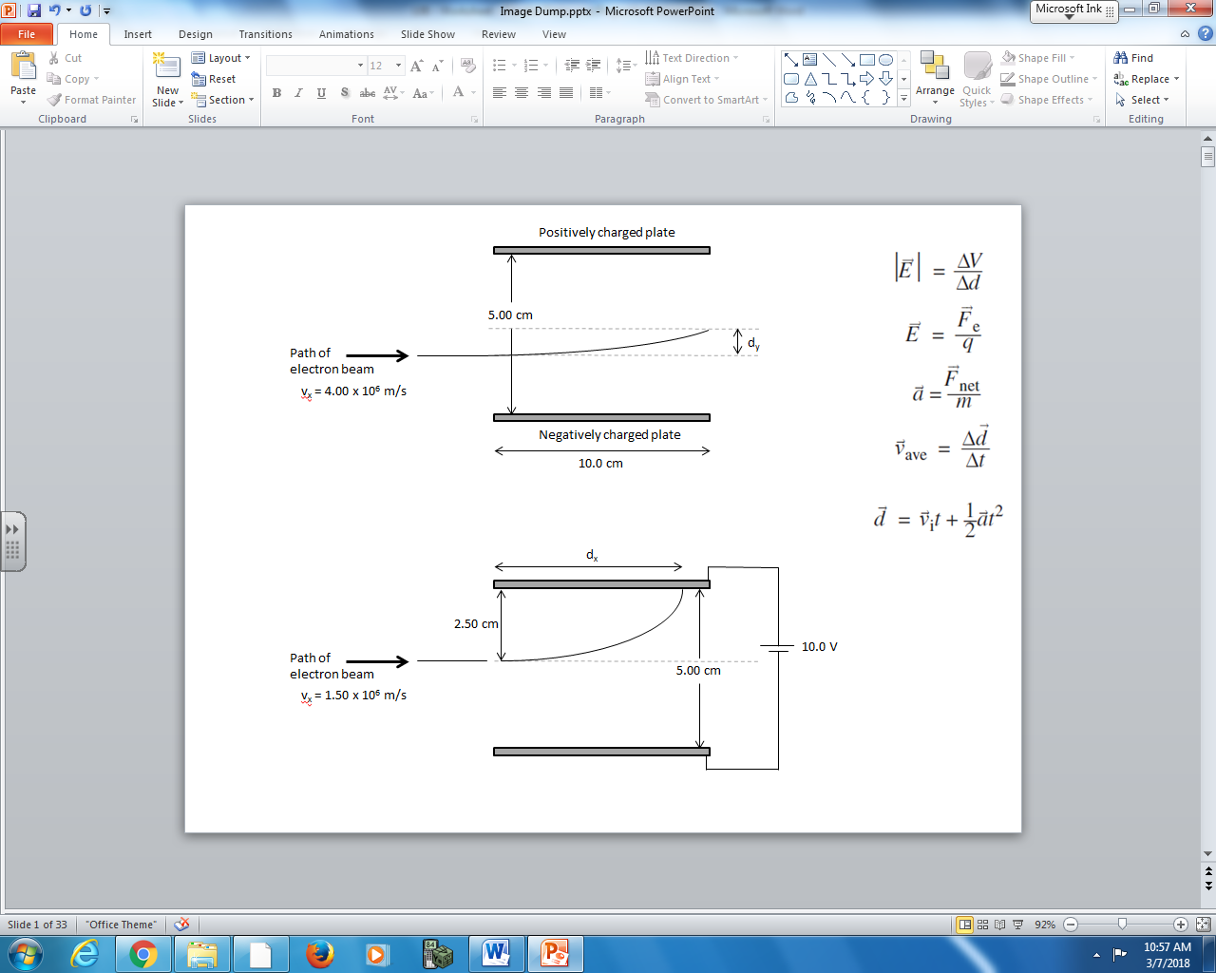
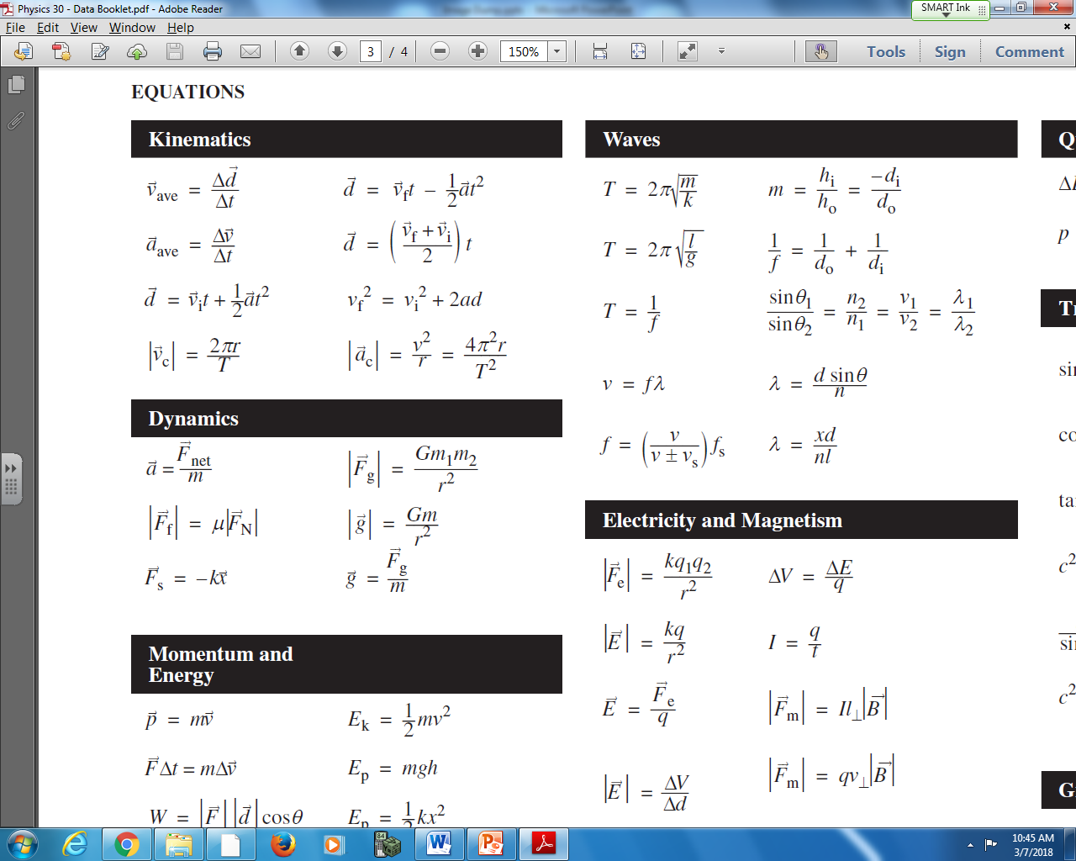
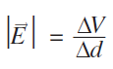
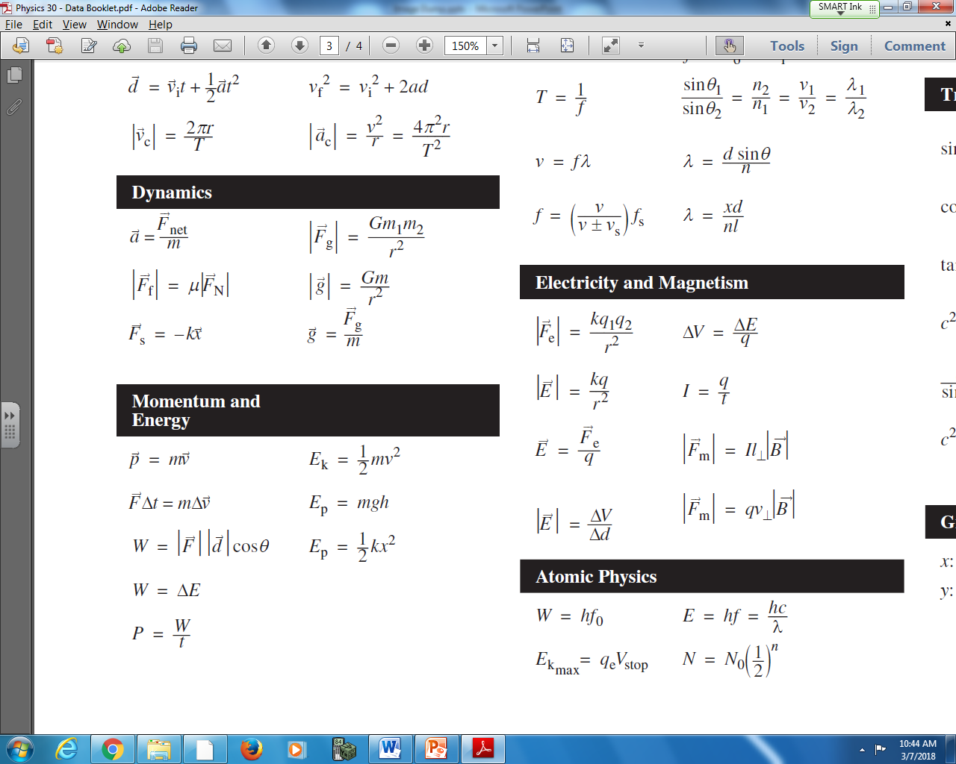
Q2: An electron (beam) is projected horizontally between vertical plates with a uniform electric field of 350 N/C. The electron successfully makes it through the plates. What is its vertical deflection, in meters?
Textbook Questions
Pg 574 #1: Two horizontal parallel plates, 1.2 x 10⁻² m apart, are connected to a DC power supply, as shown in the figure below. The electric field between the plates is 1.7 x 10⁵ V/m. A sphere of mass
3.0 x 10⁻¹⁵ kg with a positive charge of 2.6 x 10⁻¹² C is injected into the region between the plates, with an initial speed of 3.3 x 10³ m/s, as shown. It accelerates toward the negative plate. Sketch the motion of the positive charge through the region between the plates, and determine the distance the positive charge moves towards the negative plate after 6.0 x 10⁻⁶s have elapsed. Gravitational effects may be ignored in this case.
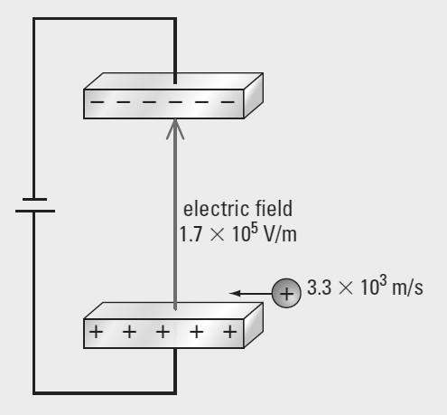

Pg 574 #2: An electron, travelling at 2.3 x 10³ m/s, enters perpendicular to the electric field between two horizontal charged parallel plates. If the electric field strength is 1.5 x 10² V/m, calculate the time taken for the electron to deflect a distance of 1.0 x 10⁻² m towards the positive plate. Ignore gravitational effects.

Pg 576 #10: An electron, travelling horizontally at a speed of 5.45 x 10⁶ m/s, enters a parallel plate capacitor with an electric field of 125 N/C between the plates, as shown in the figure below.
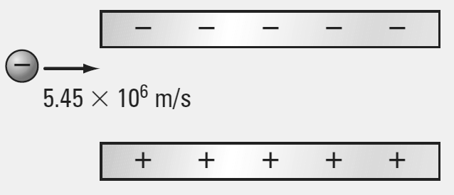
- Sketch the electric field lines between the plates, and the motion of the electron through the capacitor.
- Determine the force due to the electric field on the electron.

- Ignoring gravitational effects, calculate the acceleration of the electron.

- If the electron falls a vertical distance of 6.20 x 10⁻³ m towards the positive plate, how far will the electron travel horizontally between the plates?

Diploma Worksheet Questions – Parallel Plates (Basic Definitions)
Q205: A 9.0 V potential difference exists between two metal plates which are 1.8 x 10⁻³ m apart. The acceleration of an electron that enters the region between these plates will be
- 8.0 x 10¹⁶ m/s²
- 8.8 x 10¹⁴ m/s²
- 1.6 x 10⁷ m/s²
- 5.0 x 10³ m/s²

Use the following information to answer Q206:
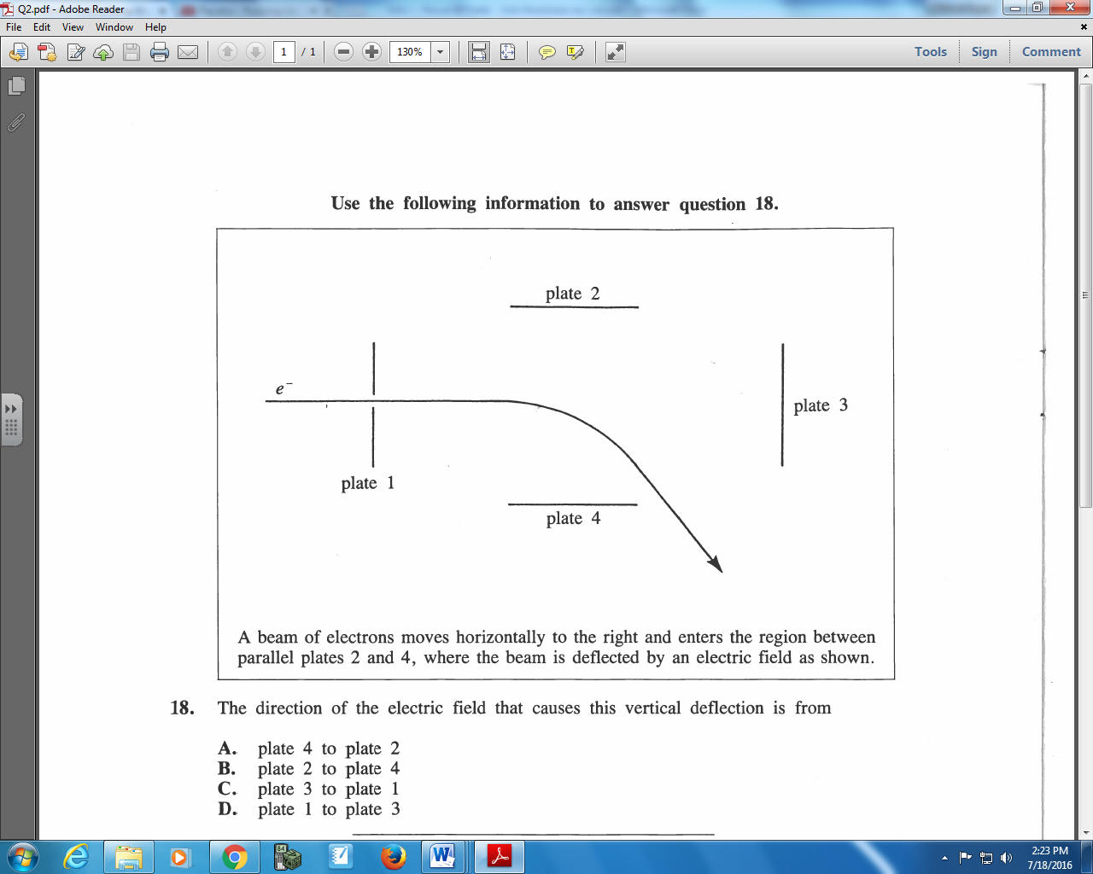

Q206: The direction of the electric field that causes this vertical deflection is from
- Plate 4 to plate 2
- Plate 2 to plate 4
- Plate 3 to plate 1
- Plate 1 to plate 3

Use the following information to answer Q207:
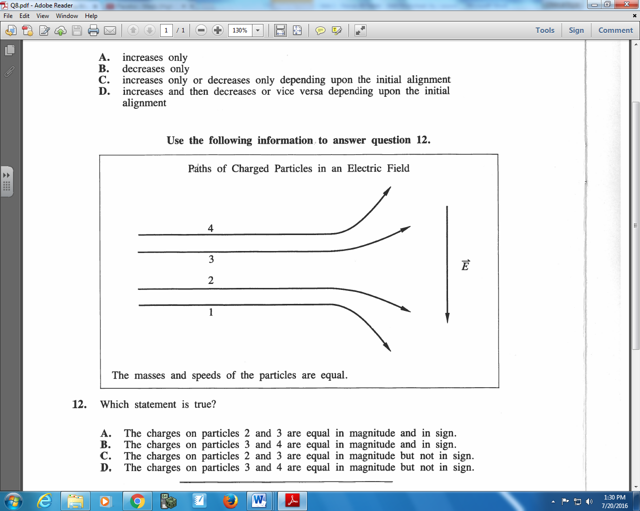

Q207: Which statement is true?
- The charges on particles 2 and 3 are equal in magnitude and in sign.
- The charges on particles 3 and 4 are equal in magnitude and in sign.
- The charges on particles 2 and 3 are equal in magnitude but not in sign.
- The charges on particles 3 and 4 are equal in magnitude but not in sign.
Q208: The acceleration of an electron in a uniform electric field of magnitude 5.0 x 10⁻⁴ N/C is
- 5.5 x 10²⁶ m/s²
- 8.0 x 10⁻²³ m/s²
- 8.8 x 10⁷ m/s²
- 9.0 x 10⁶ m/s²

Challenge Questions
None
Cumulative Review from Previous Units
None

